Information sheet on stakeholder engagement and adaptation options for the coastal case studies: Gulf of Gabès, Tunisia

Summary
- Most stakeholders are informed on climate change issues at the national level through consultants, NGOs, the media and through the use of available data bases.
- Risk assessment suggests that adaptation activity in the Gulf of Gabès should focus on negative impacts in the tourism and fishing economic sectors and on littoral and marine ecosystems.
- Improving awareness and management are the two most important actions that should be taken to reduce climate change impacts. At all levels there should be concerted adaptation actions with complementary adaptation measures. Policy and decision makers are responsible for these actions. Adaptation risk management allows planning decisions to be translated into action.
- Institutions track progress on the implementation of actions through scientific and expert management surveys, controlled at the mid-term. Adaptation planning time frames are geared towards the mid- and long-term horizons; administered at the managerial level and also at official and executive levels.

  - Background

This information sheet shows the stakeholder’s involvement in the problem of vulnerability and adaptation to climate change impacts in the Gulf of Gabès. The content of this information sheet is based on the participation of the stakeholders that belong mainly to public institutions but also to governmental and non-governmental organisations (NGOs). Most of them are involved in climate change issues at the national level and only a few are involved at the local level. External opinions mostly given by consultants are considered in the climate change discussion. Opinions of the persons affected by climate change and of the NGOs, the Medias and the local communities are also considered.

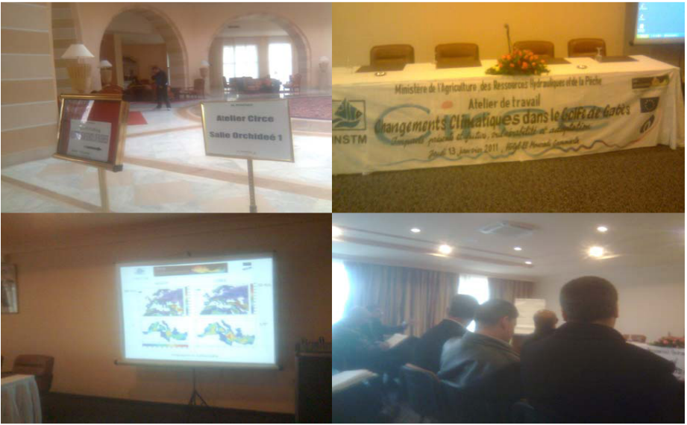

Photographs from the stakeholder workshop for the Gulf of Gabès case study

Approach

Stakeholder interaction
Stakeholders involved in the Gulf of Gabès represent mainly two key sectors, tourism and fishing but also people who are interested in problems of the marine and littoral environment. They were contacted first through regular mail and then through formal and informal meetings. As planned in the CIRCE project, a national stakeholder’s workshop was organised by INSTM (Institut National des Sciences et Technologies de la Mer, Tunisia). The workshop brought together nearly thirty stakeholder participants and took place in a conference room in Tunis. Most of the participants belong to national institutions but also to non governmental organisations. A questionnaire was distributed to participants, and the CIRCE project results were presented during the workshop
Communication tools
A summary presentation of the CDROM of the Gulf of Gabès including the GIS component was also presented. A discussion session on vulnerability and adaptation to climate change impacts on the Gulf of Gabès took place after the oral presentations. The discussion was divided into two parts. The first part comprised a question-and-response session for the CIRCE results. In the second part, participants presented their opinion on vulnerability and adaptation to climate change impacts. Discussions continued within small groups during the break. The workshop ended with the response of the participants to the questionnaire.

Stakeholder perception

Access to information and attitude to risk
Environmental problems linked to stakeholders’ activities revolve around the coastal characteristics of the Gulf of Gabès and how these are changing through time. Sea-level rise and erosion present major problems; other problems include desertification, drought and salinisation. Interestingly, there is no evident risk perception of changes in the carbon-cycle. This suggests that stakeholders are concerned mainly with climate change impacts and have only a passing interest in the causes of climate change.
Extreme events are among the most important perceived hazards for stakeholder’s activities. Specific examples of extremes of temperature and precipitation are frequently given. Inundation and coastal erosion, alien species and drought are among the most cited impacts. Other areas of concern include marine biodiversity, biological cycle change and the increase in frequency of very hot days. Changes in climate variability (such as seasonal shift, and long term change) are also given as important impacts. The sectors affected are tourism, agriculture and fishing. Destruction of marine resources, infrastructure, and ecosystems are cited as the most affected systems.
Workshops and conferences as well as the media are the sources of information on climate change problems most widely accessed. Few stakeholders are informed through their professional contacts and very few through personal contacts. However, technical and scientific information constitute the climate information most needed by stakeholders. Socio-economic information is also required, and there is also a need for political information and international debate.
Weather forecasts constitute the principal source of meteorological and climate information used by stakeholders. Climate reports and severe weather forecasts and advisories are also utilised. However, access to local or regional climate change impact scenarios is not evident for all stakeholders, and most stakeholders are not involved in a risk management team.
Perception of climate change
Compared to other problems, the awareness of climate change is very high, particularly of the high risks encountered along the coast of the Gulf of Gabès and in marine ecosystems. This level of awareness is related to the perceived high impact of climate change on key economic sectors, such as tourism.
According to stakeholders, an increase in air temperature of 2 to 3°C is considered unfavourable for the local people and also for those visiting the Gulf of Gabès for leisure and recreation. For the marine conditions, an increase in water temperature is thought to be universally unfavourable despite the fact that a moderate water temperature increase may be favourable for the tourism sector. Weather conditions characterised by too humid and too warm air temperatures together with strong winds constitute the most uncomfortable conditions for the local community. According to stakeholders, weather that is too warm and is accompanied by strong winds are the leading factors for uncomfortable conditions for visitors.
Some impacts on the Gulf of Gabès marine resources have been attributed, among other things, to the water temperature increase cited by stakeholders. Examples of such impacts are reflected in changes in marine ecosystems: changes in the biological cycle of some marine species, algal proliferation, changes in the southern lagoon ecosystem, fish stock reduction, appearance of alien species and jellyfish blooms. According to stakeholders, the major impact of sea water warming is the appearance and disappearance of some species through changes in biodiversity and biological cycles. It is noted that a few alien species have occasionally been observed in the markets. Some crustaceans, such as Metapenaeus monoceros “Speckled shrimp” have expanded rapidly and may be a threat for penaeus kerathurus “Caramote prawn” fisheries in the Gulf of Gabès. This commercial shrimp is well adapted to the Gulf of Gabès condition. The bivalve Pinctada radiata “pearl oyster” is also consumed in the area. In the eastern Mediterranean Sea some alien species have caused damage to local economies (e.g., fisheries, tourism, and health); with the rise of this phenomenon in the Gulf of Gabès there are fears that these negative impacts could be observed in the local area. The issue concerning venomous fish species and its impact on many aspects of the community, such as public health and damage to fisheries needs to be thoroughly investigated. Public awareness campaigns through posters or leaflets should be launched, focussed in the Gulf of Gabès region. Aside from increasing temperature, the appearance of alien species is also related to overfishing stocks and to the nature of the fishing industry in general.
According to stakeholders, they have already observed an increase in sea level. Most of the related impacts are associated with tourism (beach erosion and loss of coastal infrastructure). For future projections, major negative impacts will be: further infrastructure loss, salinisation of coastal aquifers, change in the coastal landscape in addition to social and economic changes (tourism, agriculture, and fishing) and ‘knock-on’ effects on the wellbeing of the local community in the Gulf of Gabès.

Adaptation options

Evaluating adaptation options
According to stakeholders, raising awareness and improving management are the two most important actions or measures that should be taken to reduce negative impacts of climate change. For coastal zones in the Gulf of Gabès, this can be done by adapting the infrastructure according to observed or projected coastal changes. Such measures should be concerted actions between all the persons involved. Several complementary adaptation actions are needed to mitigate impacts of the climate change. For example, to encourage greater use of renewable energy, to adapt to an increase in energy demand resulting from projected warmer conditions. Adaptation action should be implemented at all levels, local, regional and especially national. Policy and decision makers are responsible for adaptation to climate change impacts based on the information from current observations and projections provided by scientists.
Adaptation enablers
Risk management followed and adapted to regional social and economic conditions and processes allow planning decisions to be translated into action. Communication and meetings could be used, with institutions tracking (regularly or occasionally) progress on the implementation of actions through scientific and management expert surveys. Reports and actions can then be provided to stakeholders. Adaptation planning time-frames tend towards the mid-term (3-15 years) and the long-term (16 years and longer). These actions are planned at the managerial level, but are also planned at official and executive levels.
Barriers to adaptation
Overfishing and intense building construction along vulnerable coasts are examples of human actions that could exacerbate the negative impacts of climate change. Such actions are thought to be controlled only at the mid-term. Fisherman, financially disadvantaged people, people living close to the coast, and the tourism industry are the social groups and services most likely to be affected by climate change.
Implementation of adaptation actions
Examples of adaptation actions already implemented include adaptation strategy reports comprising concrete action plans prepared and adopted for key sectors. These actions are prepared for the entire country of Tunisia but include regional details for key zones, such as for the Gulf of Gabès. Tourism, agriculture, ecosystems and costal zones are among the sectors and services considered. For example based on adaptation measures for the coastal zones, projected sea-level rise is now taken into account in all coastal constructions (such as harbours, and tourism infrastructure). Adaptation strategies for additional economic sectors and services are currently being prepared.

Table 1: Overview of stakeholder perceived climate risks and adaptation options, by sector
Thematic sector | Perceived climate-related risks | Adaptation options
Fishing | Loss of habitat, overfishing, biodiversity loss, harbour sedimentation | Fishing regulations (fishing time and duration limitation, net size limitations, lower size limit for some fish catch species), harbour management, advertising of certain low-cost pelagic fish species to reduce consumption of overfished ones, rigorous control of alien species phenomenon.
Tourism | Beach retreat, loss of landscape, more frequent heat waves | Use of buffer zones for tourism infrastructure, Artificial beach nourishment, Encouraging domestic tourism (support excessive warm weather), Encouraging winter and intermediate season tourism (reducing prices).
Littoral zone | Erosion, inundation of low-lying land, saline intrusion in coastal aquifers | Coastal management and protection, Awareness for water conservation, construction of desalination units for sea water, Dune conservation using artificial barriers.
Cross-cutting themes (regional policy makers) | Heat stress; sea-level rise, erosion | Investment in raising climate awareness, monitoring programmes; including adaptation planning in regulatory processes  Elaboration of strategy plans at the national level to include wider collaboration of participants (experts, stakeholders, policymakers, etc.).

Acknowledgements
CIRCE (Climate Change and Impact Research: the Mediterranean Environment) is funded by the Commission of the European Union (Contract No 036961 GOCE) http://www.circeproject.eu/. This information sheet forms part of the CIRCE deliverable D11.5.8.
Authors: Ali Harzallah, Mohamed Nejmeddine Bradai, Scander Ben Salem and Abdallah Hattour
Contact: Ali Harzallah: ali.harzallah@instm.rnrt.tn
Editors: Maureen Agnew (m.agnew@uea.ac.uk) and Clare Goodess (c.goodess@uea.ac.uk), Climatic Research Unit, School of Environmental Sciences, University of East Anglia, Norwich, UK
Date: June 2011

