Information sheet on biogeophysical and social vulnerability indicators for the CIRCE rural case studies: Apulia, Italy

Summary
- Apulia has a permanent water budget deficit (about 350mm/year), which requires water imports from nearby regions and exploitation of aquifers. Large inter-annual variability prevents identification of long-term trends, but the decrease of precipitation and increase of temperature during the last part of the 20th century has produced a large deficit in the last year of the records.
- Wheat, olive oil and wine production (the three main agricultural products in Apulia) show large inter-annual variability, which for wheat and oil has a statistically significant link to seasonal temperature and precipitation. Records support that climate is responsible for a proportion of the inter-annual variability (16% for wheat and 15% for olive oil) and suggest that future climate change could have a negative impact on these products. Future droughts may have a major impact on yields of rain-fed crops, while increased water demand by irrigated crops could pose problems of water resource sustainability.
- Tourists have increased 68% from 1998 to 2007, reaching almost two million visitors. Climate change may have negative and positive impacts on tourism, with higher temperature acting as a deterrent in summer and, in contrast, favouring visits in other seasons.
- Population growth has been slowing down during the last few decades. However, there is an ongoing large effort by municipalities at the regional scale to further regulate and reduce water consumption.
- More than 80% of land in Apulia is used for agro-ecosystems. Forests areas (7%) are concentrated in the Gargano peninsula, and there are only small remnants of xeric oak forests, which are interspersed with olive groves, shrub and herbaceous vegetation associations (~1.5%) and permanent pasture (5%). Summer fires are threatening the small and sparse residual natural areas. According to the size of area affected, Apulia is the second region in Italy most impacted by fires each year.

1. Introduction
The economy of Apulia is characterised by a large emphasis on agriculture and services with a smaller part played by industry. The share of gross domestic product generated by the agricultural and service sectors in Apulia is above the national average (about €2300 million in 2006). This information sheet presents available time series as key indicators of climate impacts (water budget, crop production) and vulnerability (population growth, tourism, water consumption, landuse) over the last 20 years. These indicators are also strongly affected by other factors (mainly economic and social drivers) which can dominate the climate forcing. Biogeophysical and social indicators for Apulia are discussed in relation to the observed climate indicators presented in the previous information sheet.

2. Impact indicators
- Water budget
- Wheat production
- Olive oil production
- Wine production
The water budget indicator is based on the difference between precipitation and evapotranspiration. Apulia is characterized by a permanent water deficit (about -350 mm/year). Annual values of water deficit can be computed since 1950 on the basis of available climate data. Data for the crop indicators were obtained from ISTAT, Italian Institute of STATistics, ISMEA, Italian Institute of Services for the agricultural and food market, and EUROSTAT, European institute of Statistics.

Impact indicator:
Environmental water budget in Apulia
What is it?
The water budget is the difference between the positive contribution of precipitation (see the information sheet on observed climate indicators for further details) and the loss due to evapotranspiration. Evapotranspiration is derived from the temperature time series (Hargreaves and Samani, 1982) and specifically calibrated for Apulia.

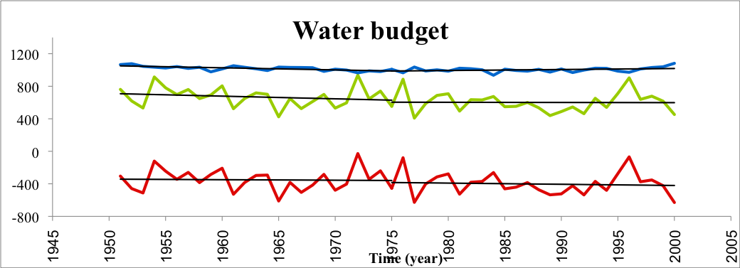

Figure 1: Potential evapotranspiration (blue line, in mm/year), total amount of precipitation (green line, in mm/year) and total water budget (red line, in mm/year) in Apulia, for the period 1950-2000. The black straight lines show the linear trend computed separately for the periods 1950-1975 and 1975-2000. None of these trends are statistically significant.

What does this show?
Figure 1 shows a weak positive trend (about 14 mm/decade of evapotranspiration in the last thirty years of 20th century, which when combined with decreasing precipitation (about -16 mm/decade) implies a progressively larger water deficit. However, because of very large interannual variability the trend of the water deficit is not significant at the 90% significance level, neither for the whole 50-year period, nor for the two 24-year long sub-periods.
Why is it relevant?
Apulia is characterized by a permanent water deficit (approximately -350 mm/year) and requires imports of water from nearby regions and extraction of water from aquifers for irrigating crops. A further increase in the deficit would not be sustainable and would have a large negative impact on the environment and the agricultural sector. Overexploitation of aquifers is already an issue at a regional scale, particularly in the southern area of Apulia (Salento).

Impact indicator:
Wine production in Apulia
What is it?
Total annual wine production (provided by ISTAT and EUROSTAT) is shown as a function of average minimum summer temperature, average maximum temperature in summer and winter, and spring precipitation. These variables have been chosen because they show a statistically significant (at the 90% level) association with wine production.

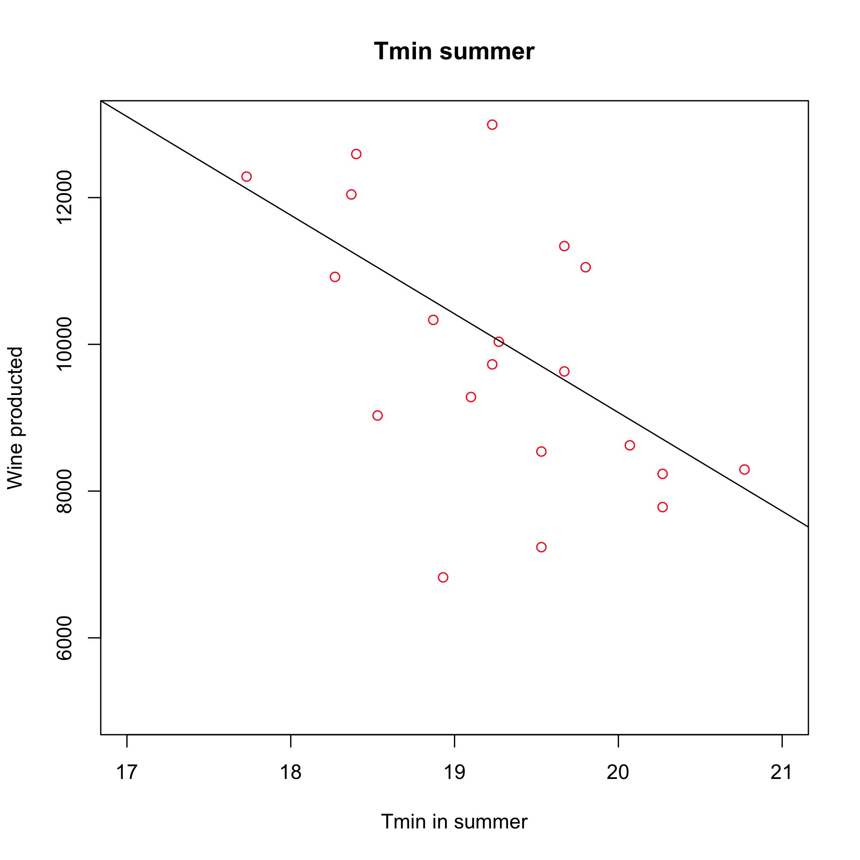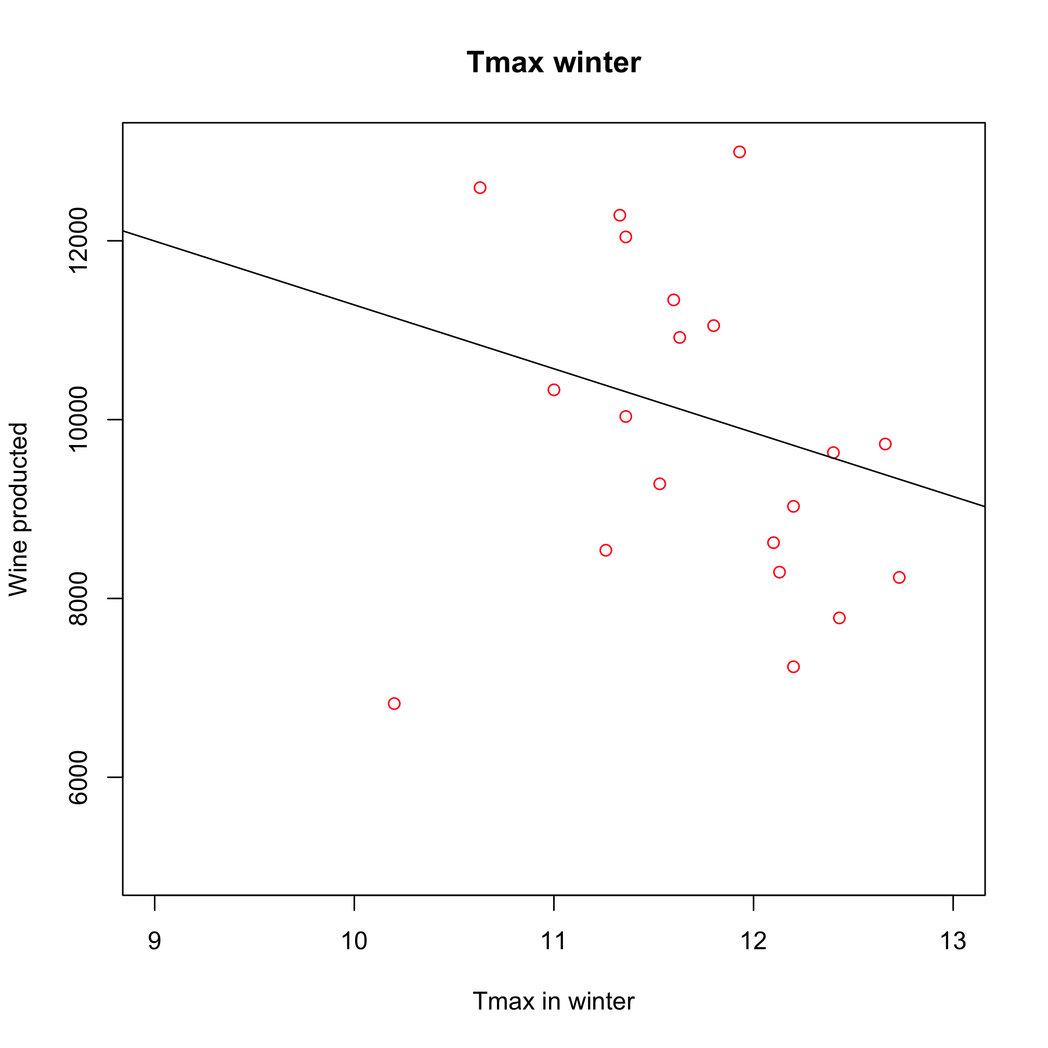
(a) (b)
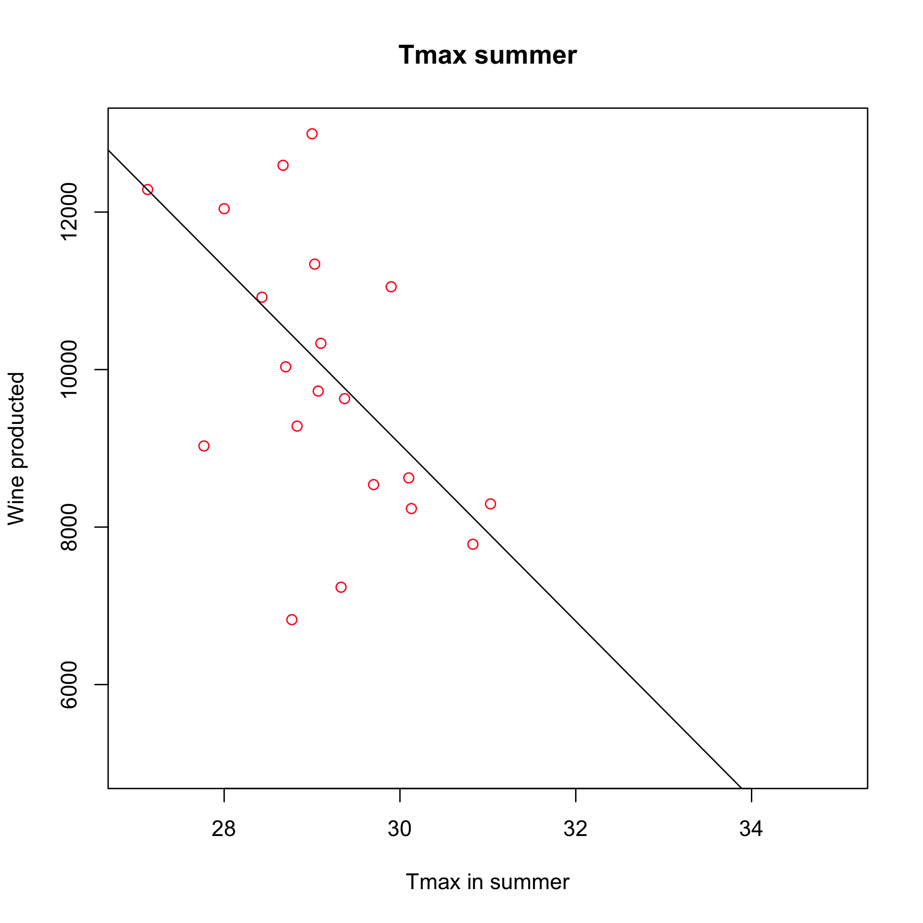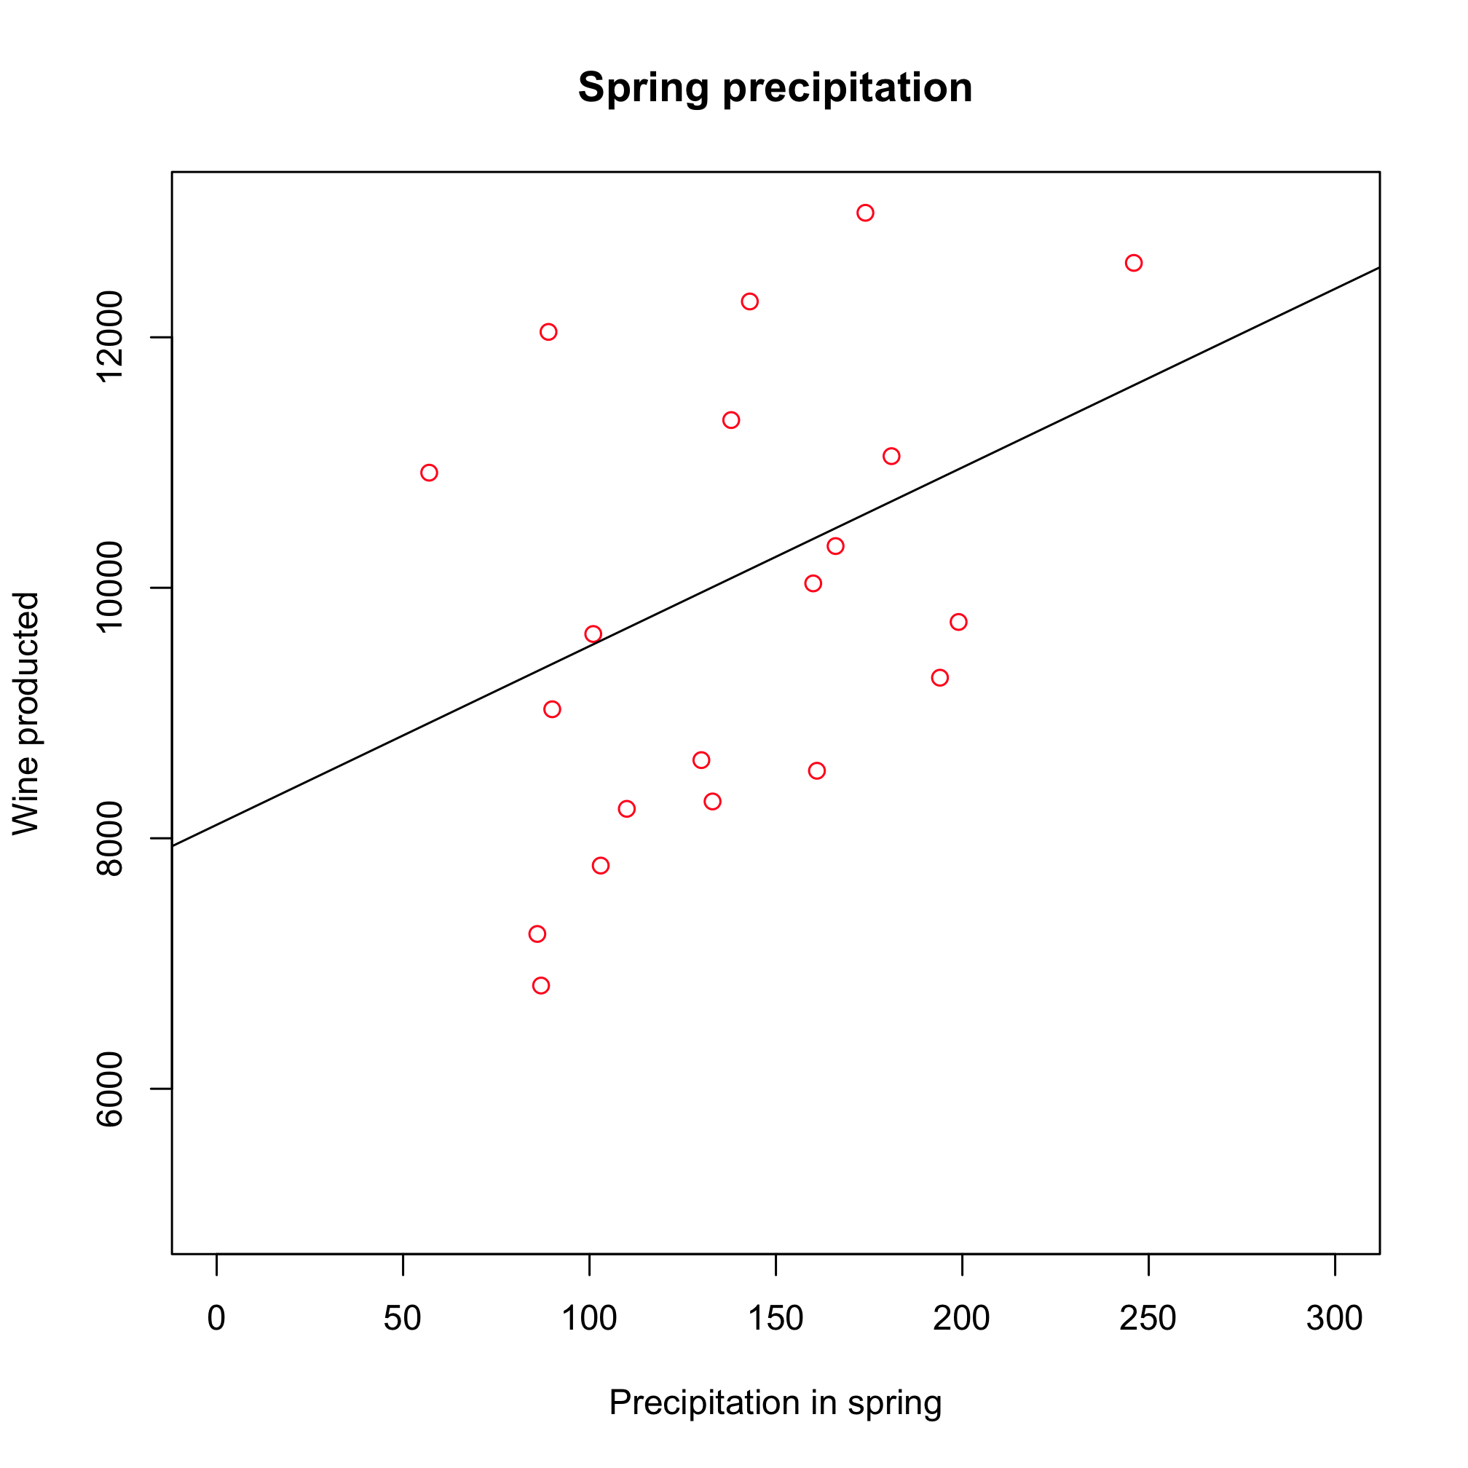
(c) (d)
Figure 2: Linear regression between wine production (thousands of hl) and average minimum temperature (°C) in summer (a), maximum temperature in winter (b) and summer (c) and total amount of precipitation(mm) in spring (d) in Apulia, 1980-2000. The fraction of explained variance is 0.25, 0.05, 0.28, 0.1, respectively.

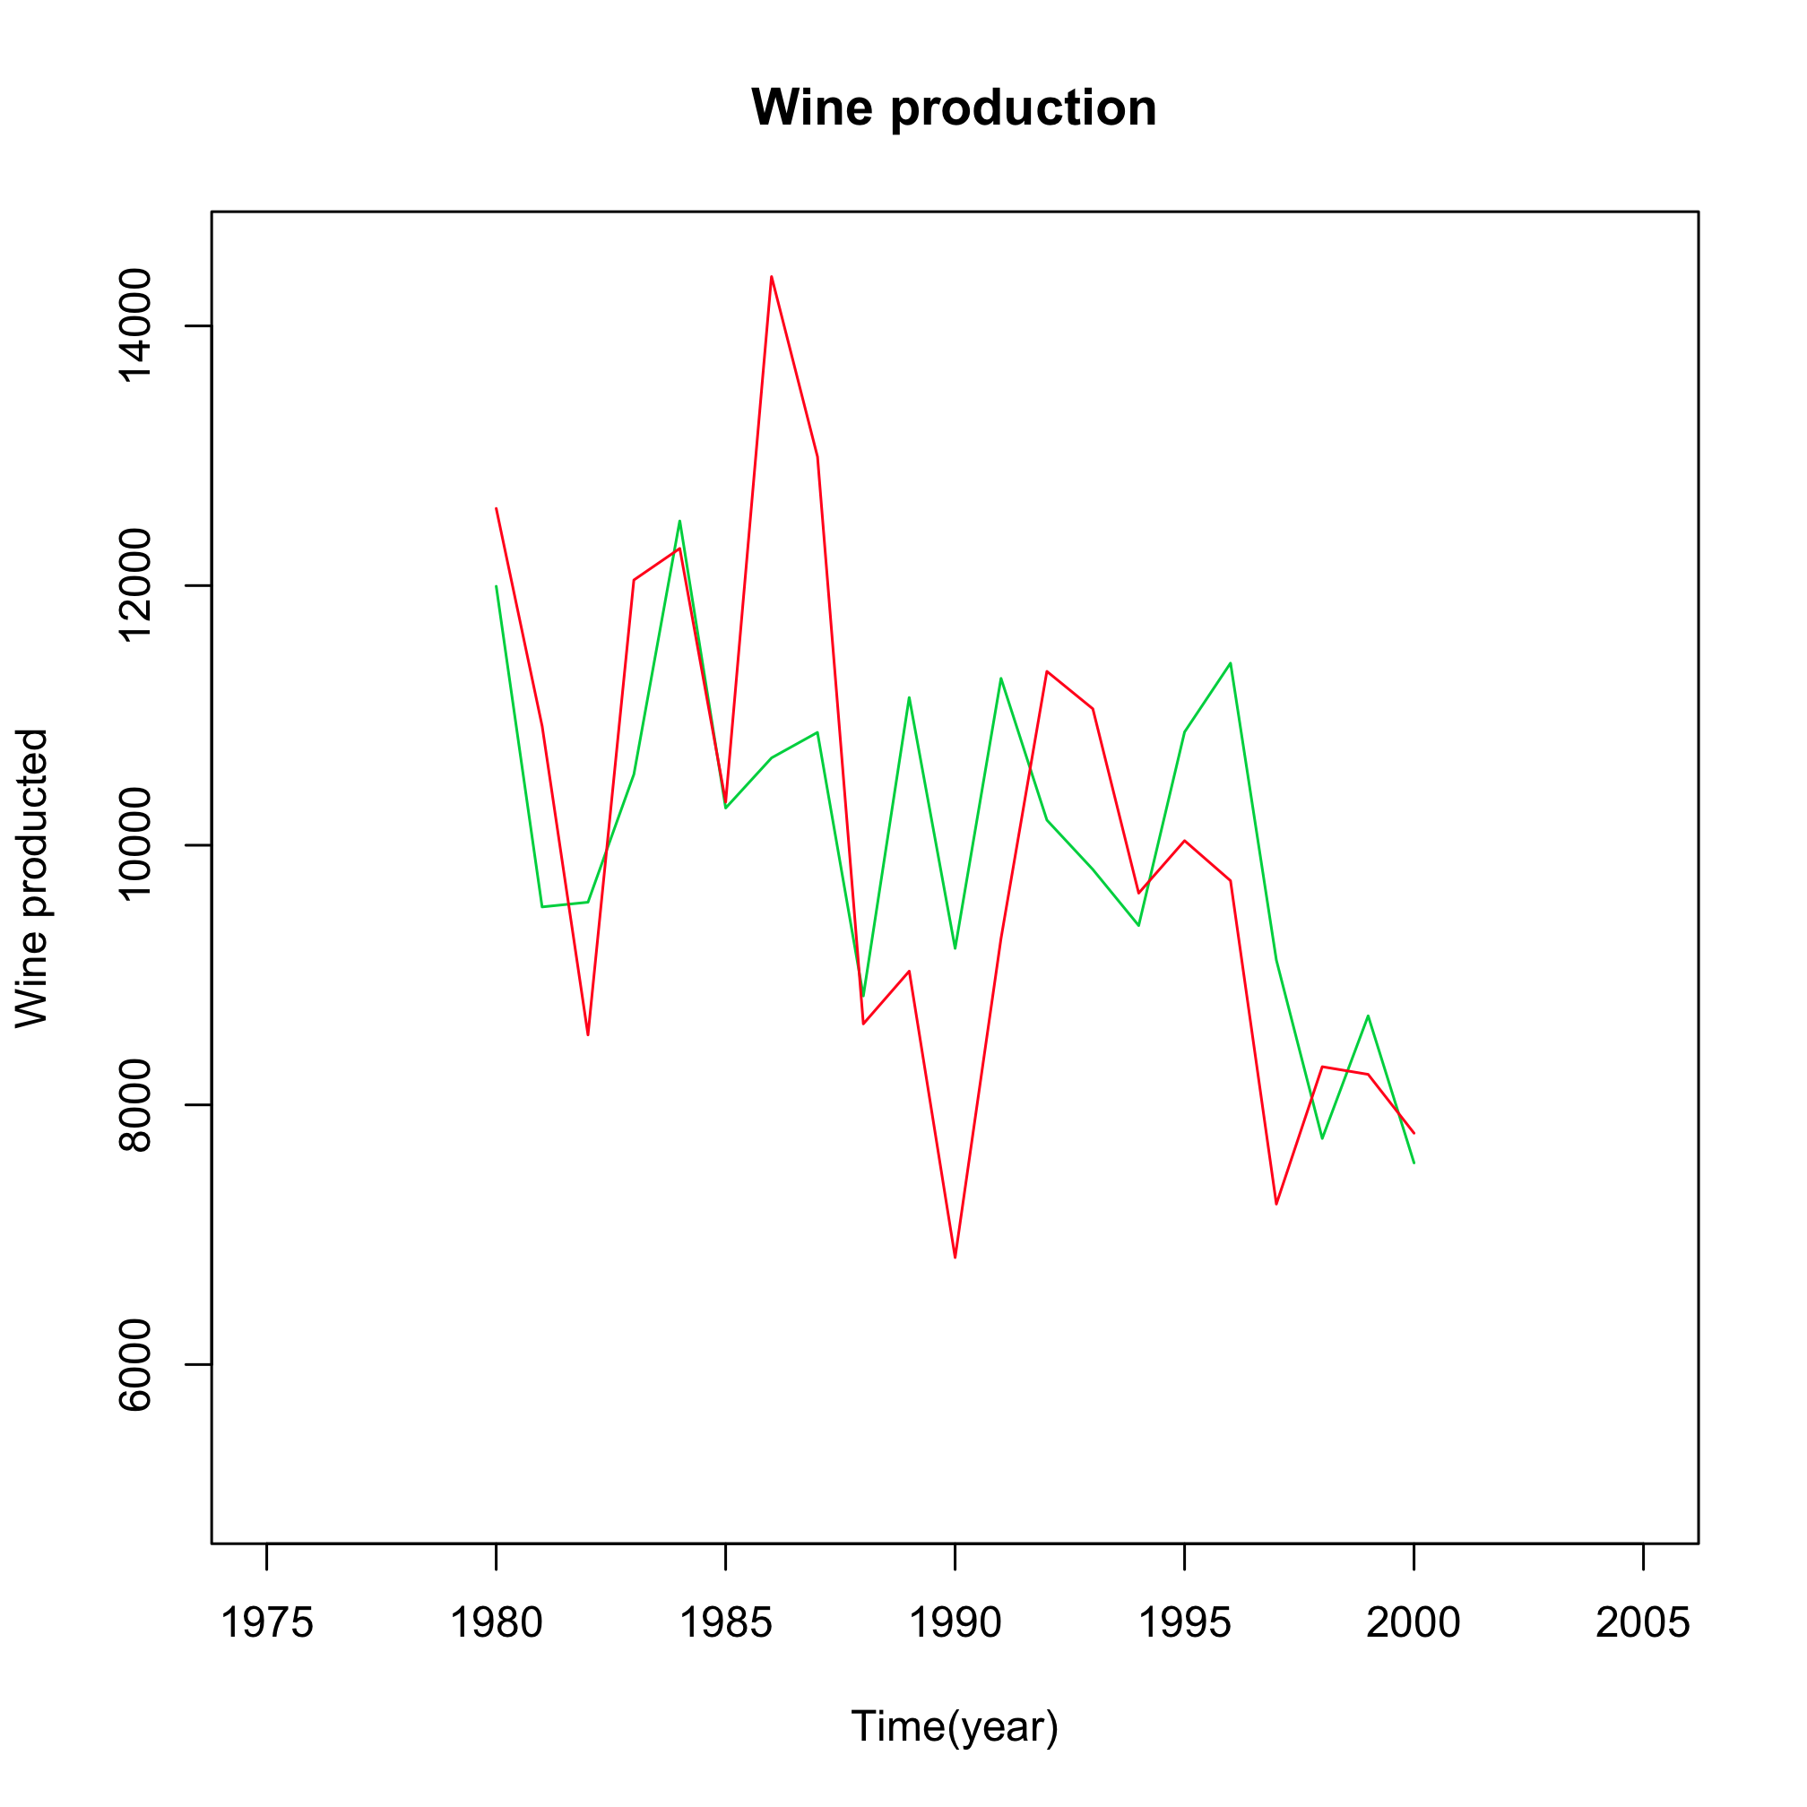
Figure 2e: Observed wine production (red line) and wine production estimated (green line) using a multiple linear regression based on winter/summer maximum temperature, minimum temperature in summer and spring precipitation in Apulia, 1980-2000

What does this show?
Years with higher than average temperature are characterized with lower than average production (Figure 2). Linear regression shows that summer daily minimum (Figure 2a) and maximum temperature (Figure 2b) have respectively, the largest effect on wine production. In contrast, precipitation is positively and weakly correlated to wine production. Combining these variables in a multivariate regression explains about 41% of the total variation in wine production (Figure 2e).

Why is it relevant?
Wine is very important to the economy of Apulia (production was worth €270 million in 2008), with on average 9800 million hl per annum produced during the last 25 years, representing approximately 15% of Italian national production. A future with higher temperatures and lower precipitation could result in lower quantities of wine being produced. However, the economic consequences are less clear, because in hot and dry years the actual economic value of wine production is often higher because of a better quality of wine produced and factors concerning supply and demand.

Impact indicator:
Olive oil production in Apulia
What is it?
Total annual olive oil production (provided by ISTAT) is shown as a function of three different climate variables (average minimum summer and winter temperature, total precipitation in summer. These variables have been chosen because they show a statistically significant (at the 90% level) association with olive oil production.

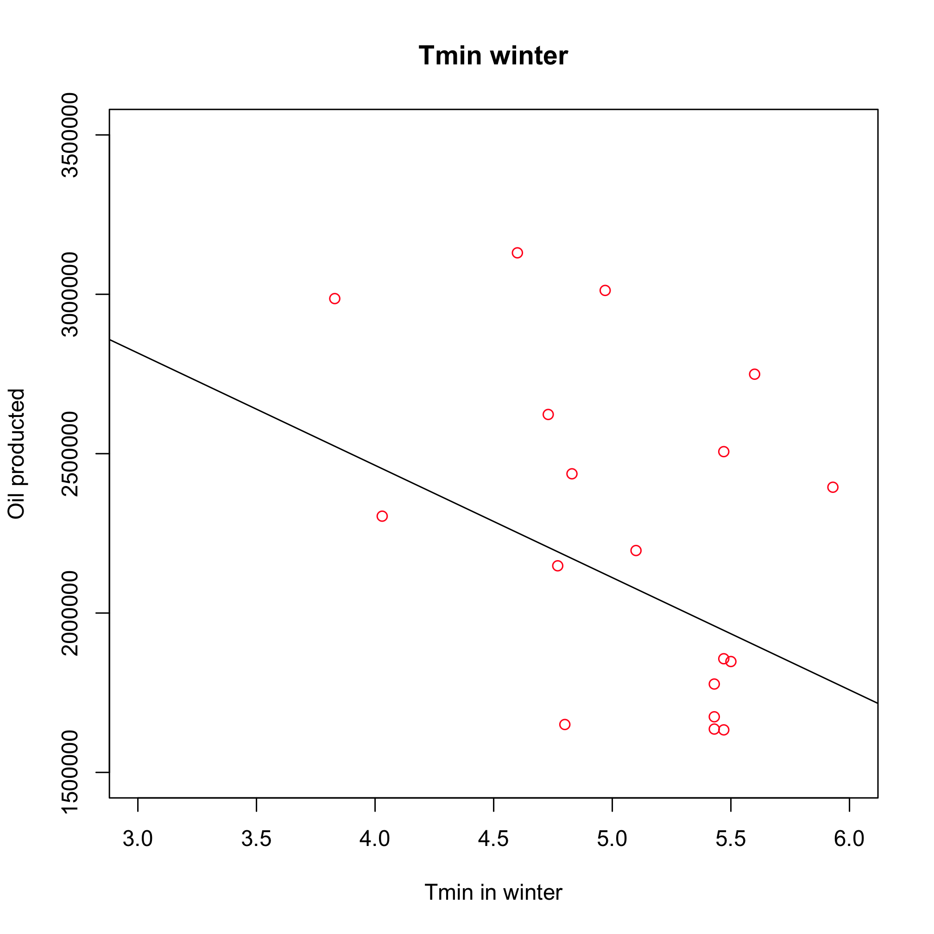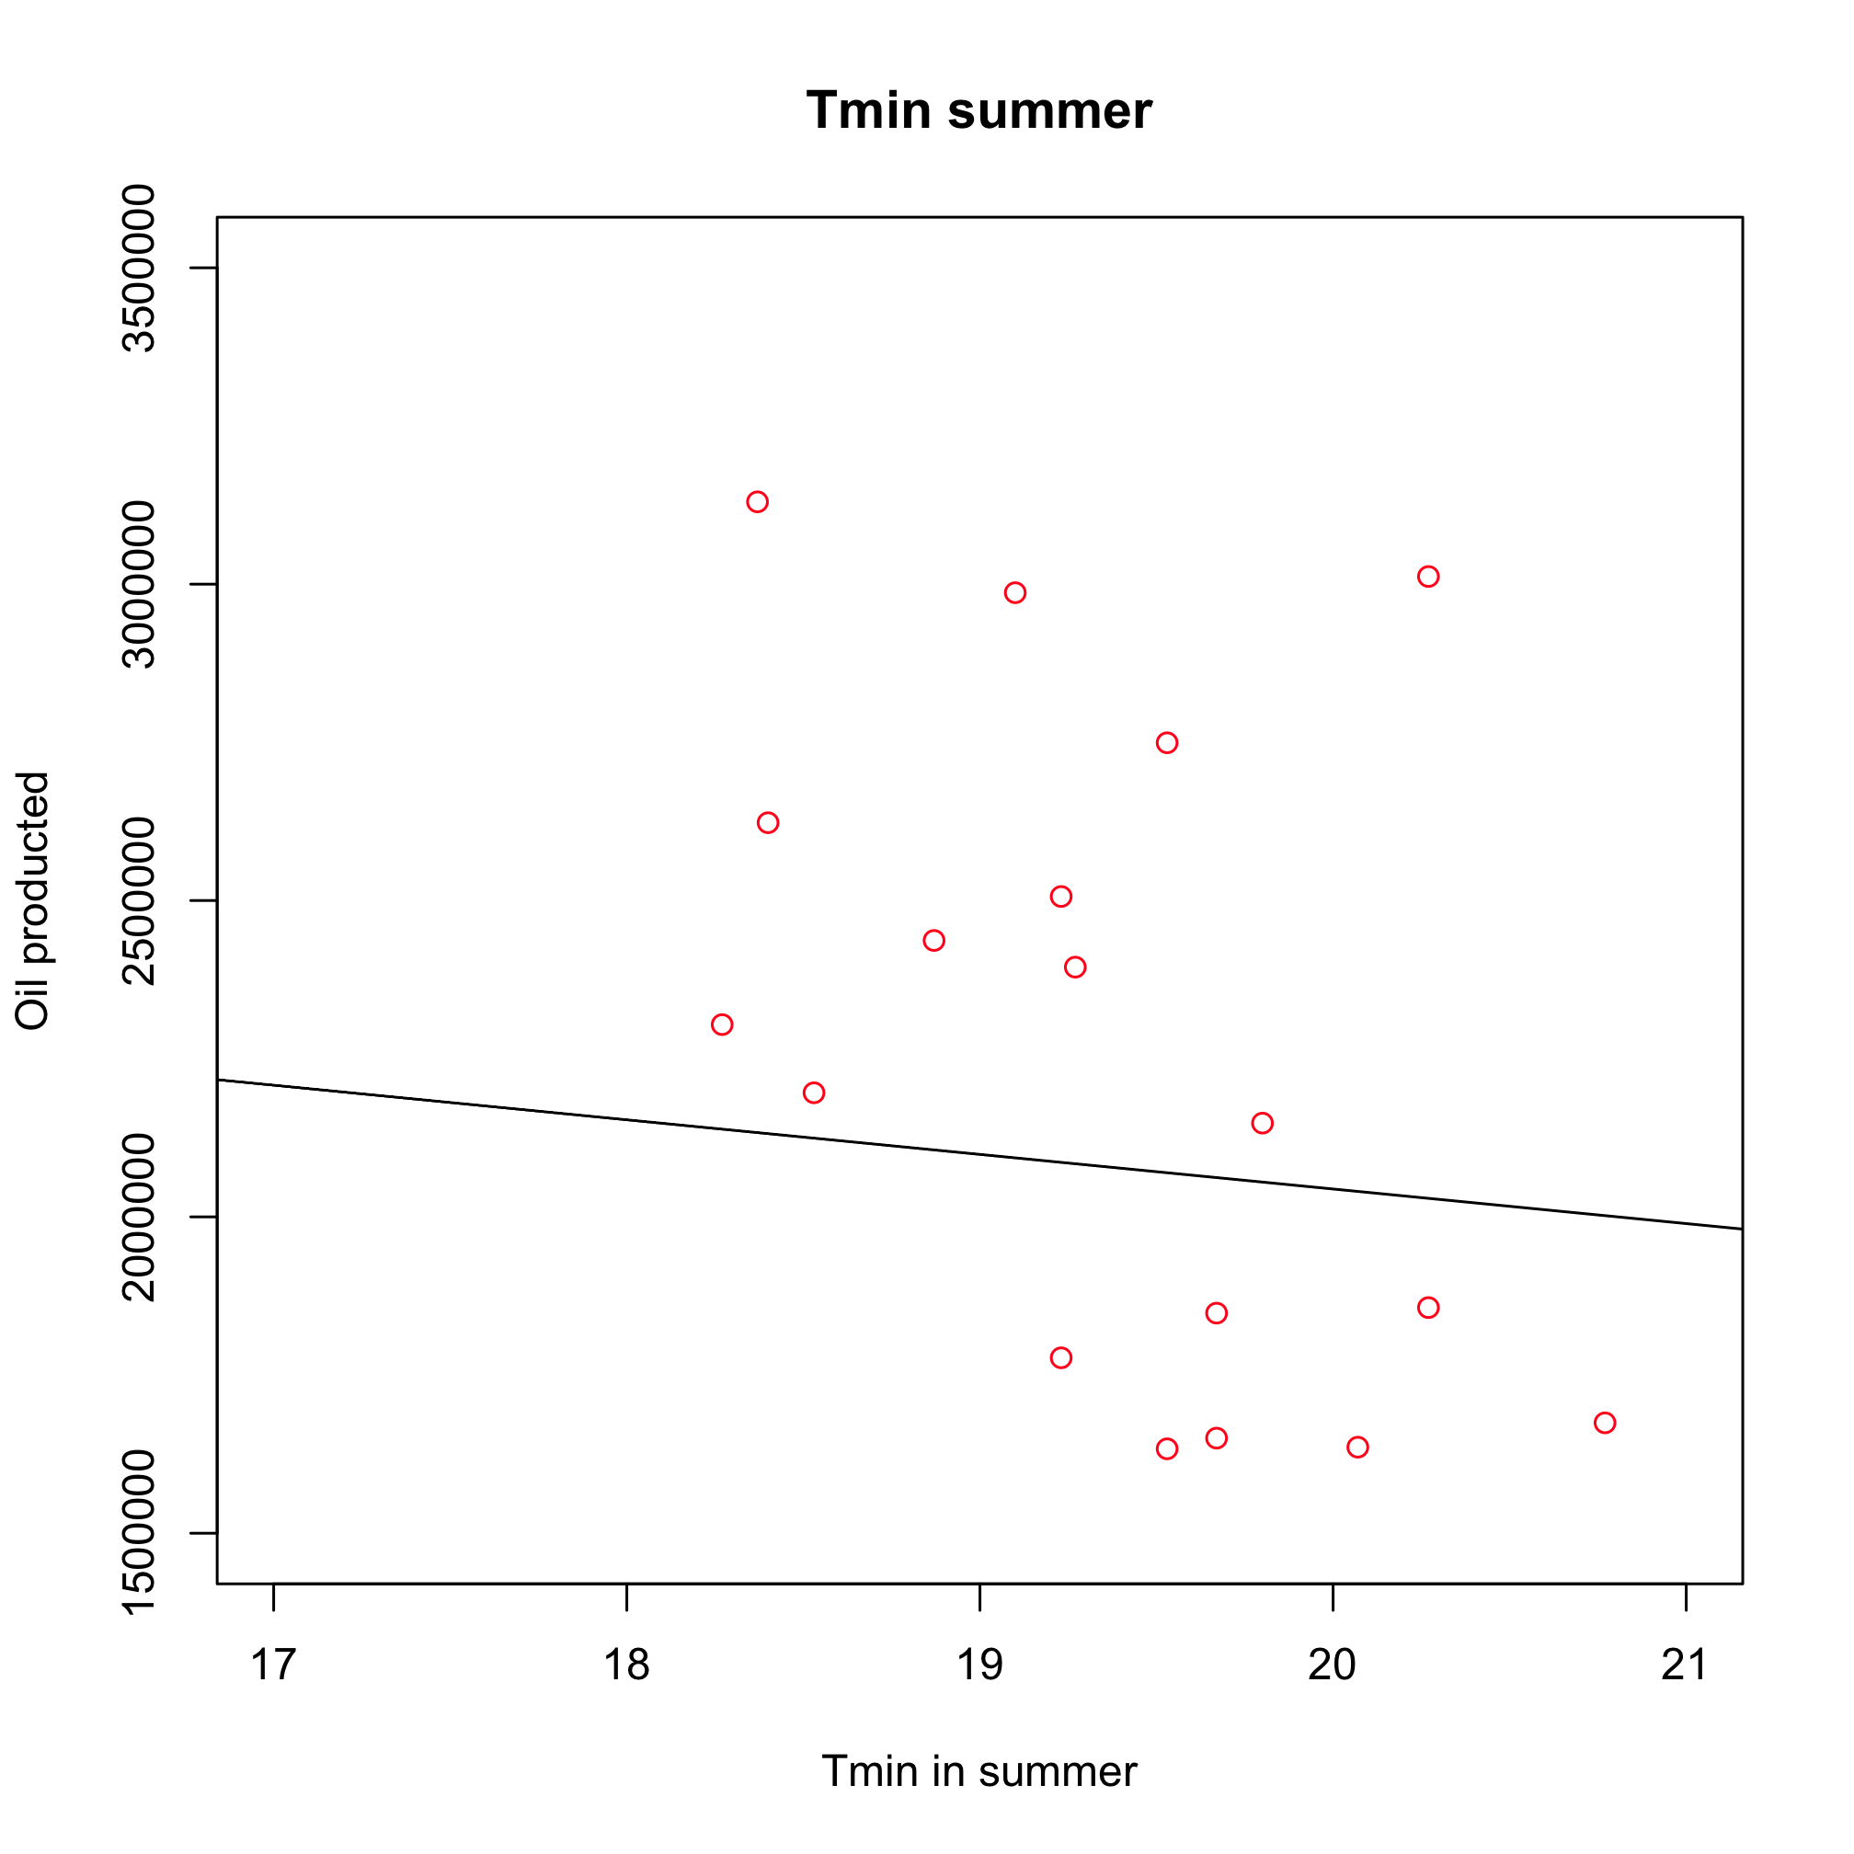
(a) (b)
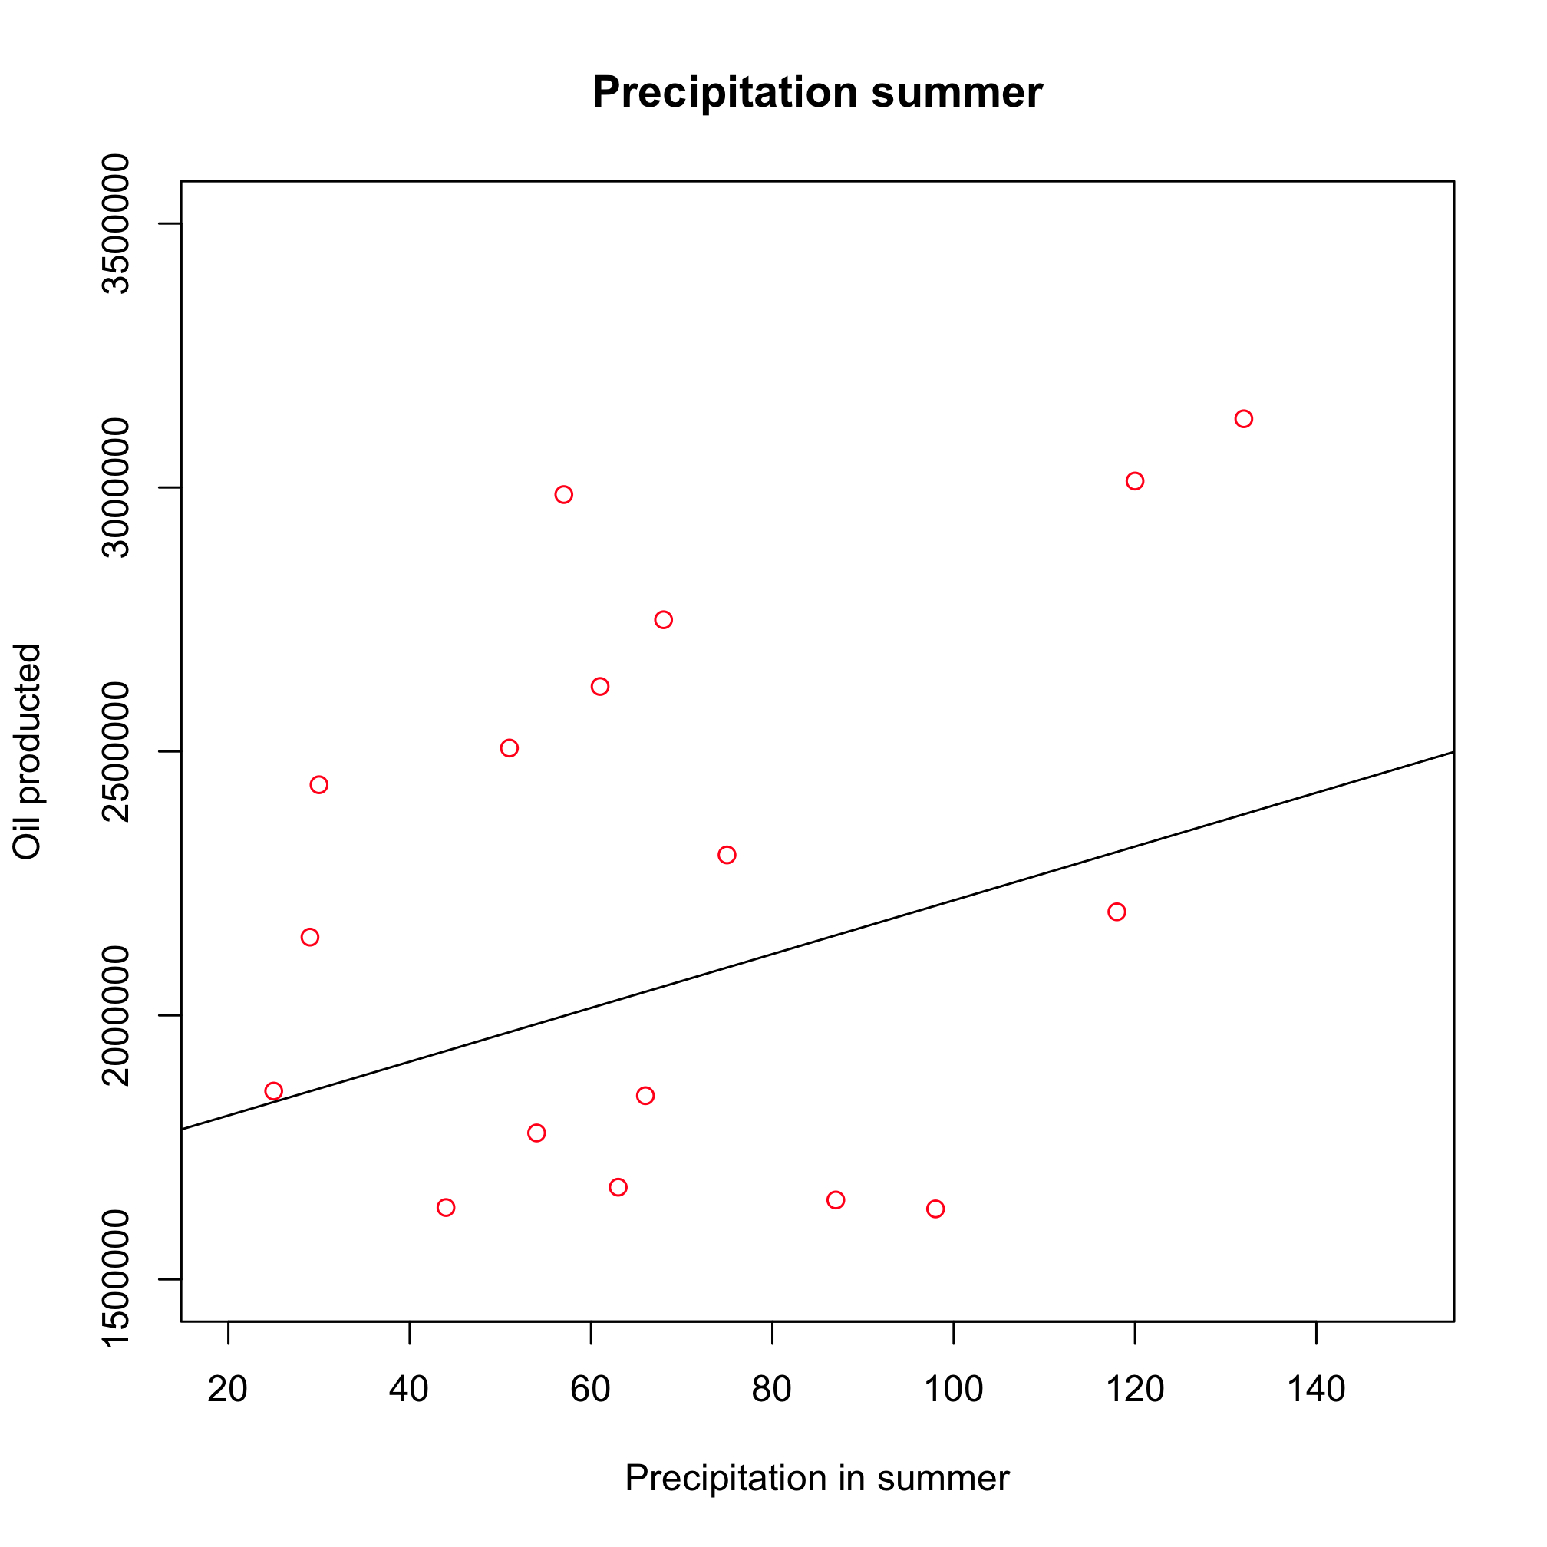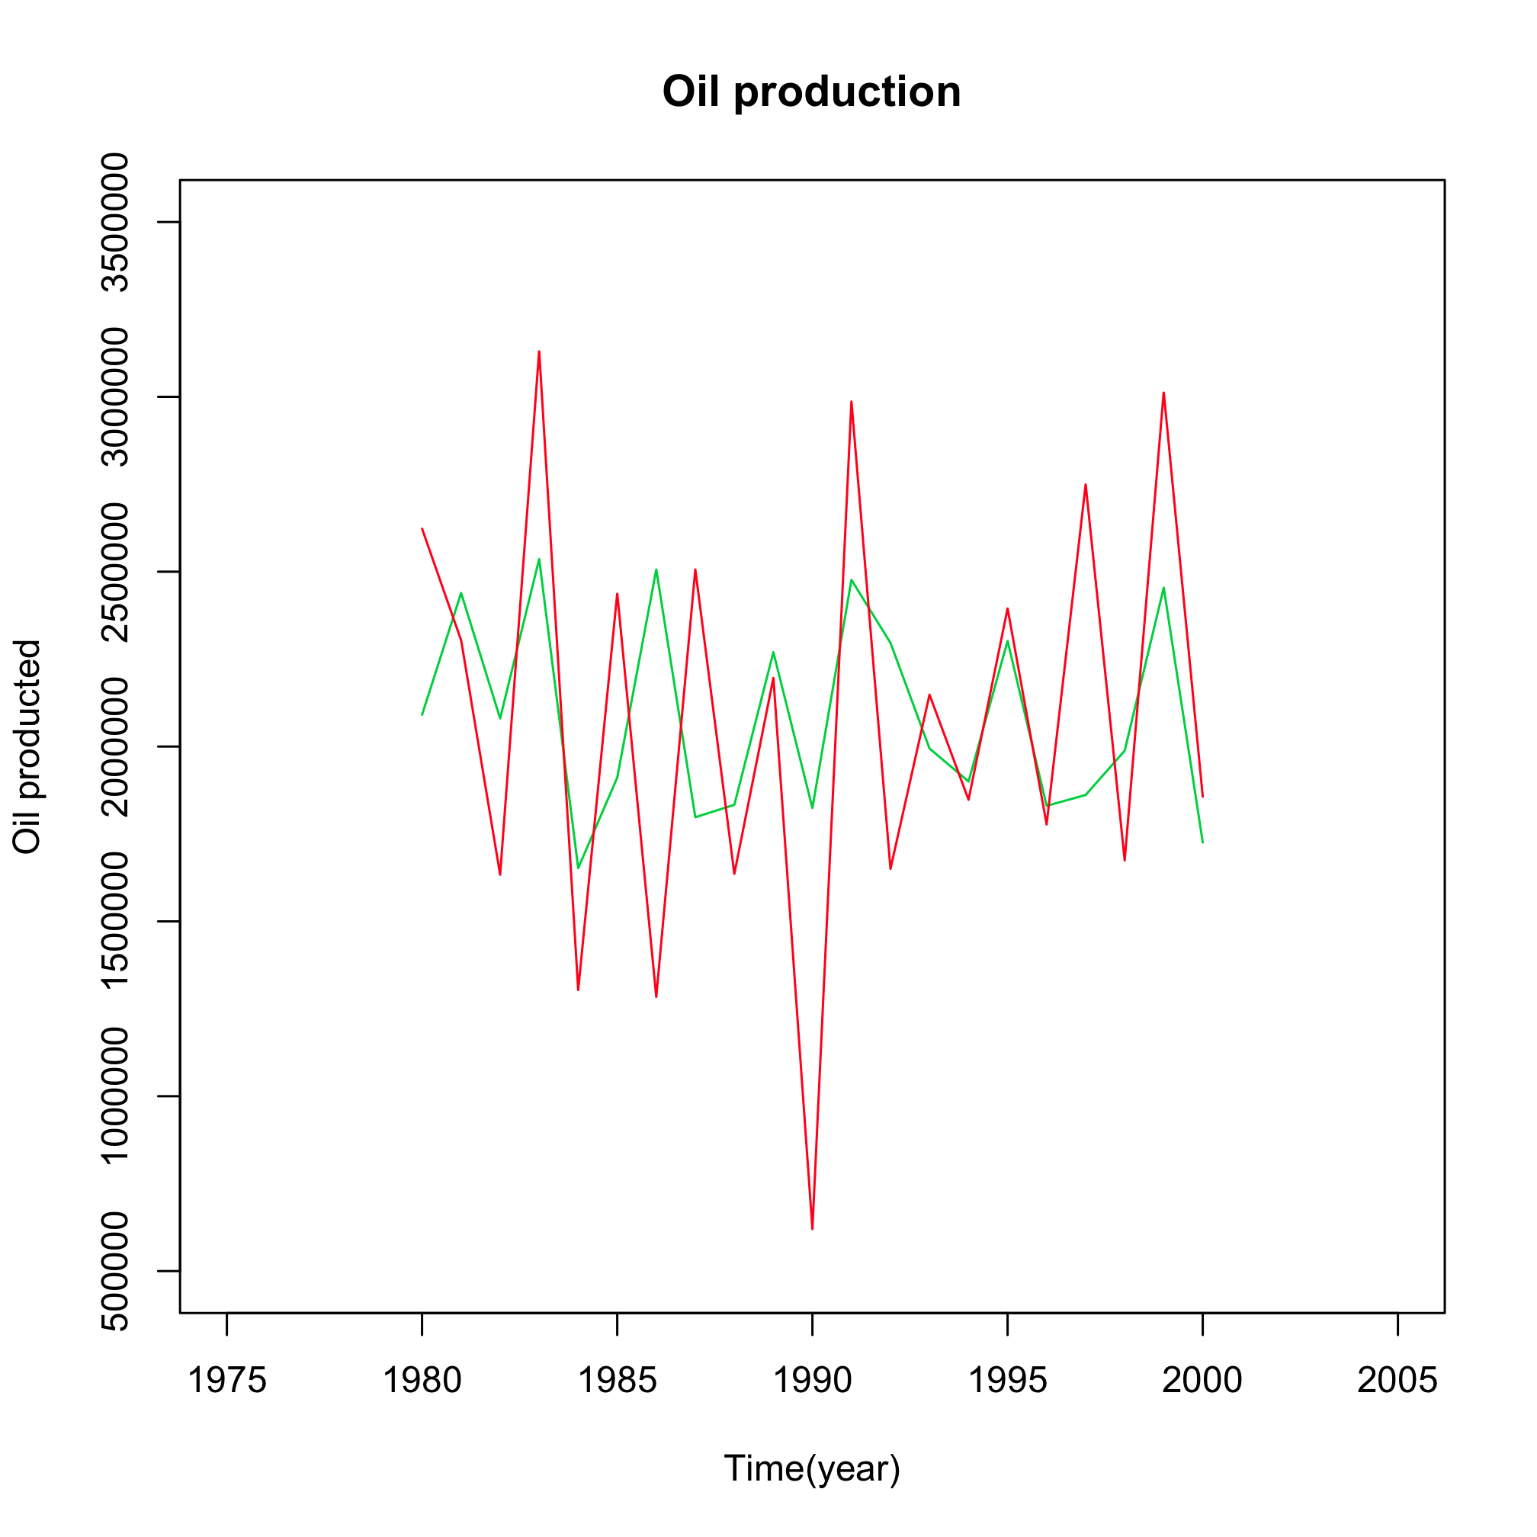
(c) (d)
Figure 3: Linear regression between olive oil produced (units =10⁵kg) and average minimum winter (a) and summer (b) temperature (°C) and total summer precipitation (c, mm), explaining 0.09, 0.04, 0.9 of total variance, respectively. (d) Observed olive oil production (red line), olive oil production (green line) estimated using a multiple linear regression based on winter/summer minimum temperature and summer precipitation in Apulia, 1980-2000

What does this show?
Olive oil production shows a weak negative correlation with winter and summer minimum temperature (Figure 3 a, b, c). There is also a marginal (not significant) positive correlation with summer precipitation. Linear regression suggests that daily minimum temperature in winter has the largest effect on the variability in production. A multivariate regression model (Figure 3d) using all these climate variables shows that together they explain about 20% of the annual variability in olive oil production.

Why is it relevant?

Economically, olive oil is even more important than wine (€377 million in 2008) for Apulia which produces on average 2.15 millions qt of oil during the last 20 years, corresponding to about 38% of Italian production. It is important because there is a detectable effect of climate variability on olive oil production, in spite of the influence of other dominant non-climate factors, such as socioeconomic drivers. This suggests that future climate change could negatively impact the amount of olive oil produced in Apulia.

Impact indicator:

Wheat production in Apulia
What is it?
Annual wheat production is plotted against average minimum and maximum temperature in summer, and the total amount of precipitation in winter and spring. As in previous figures, these variables are shown because they have an association with wheat production that is statistically significant at the 90% significance level.

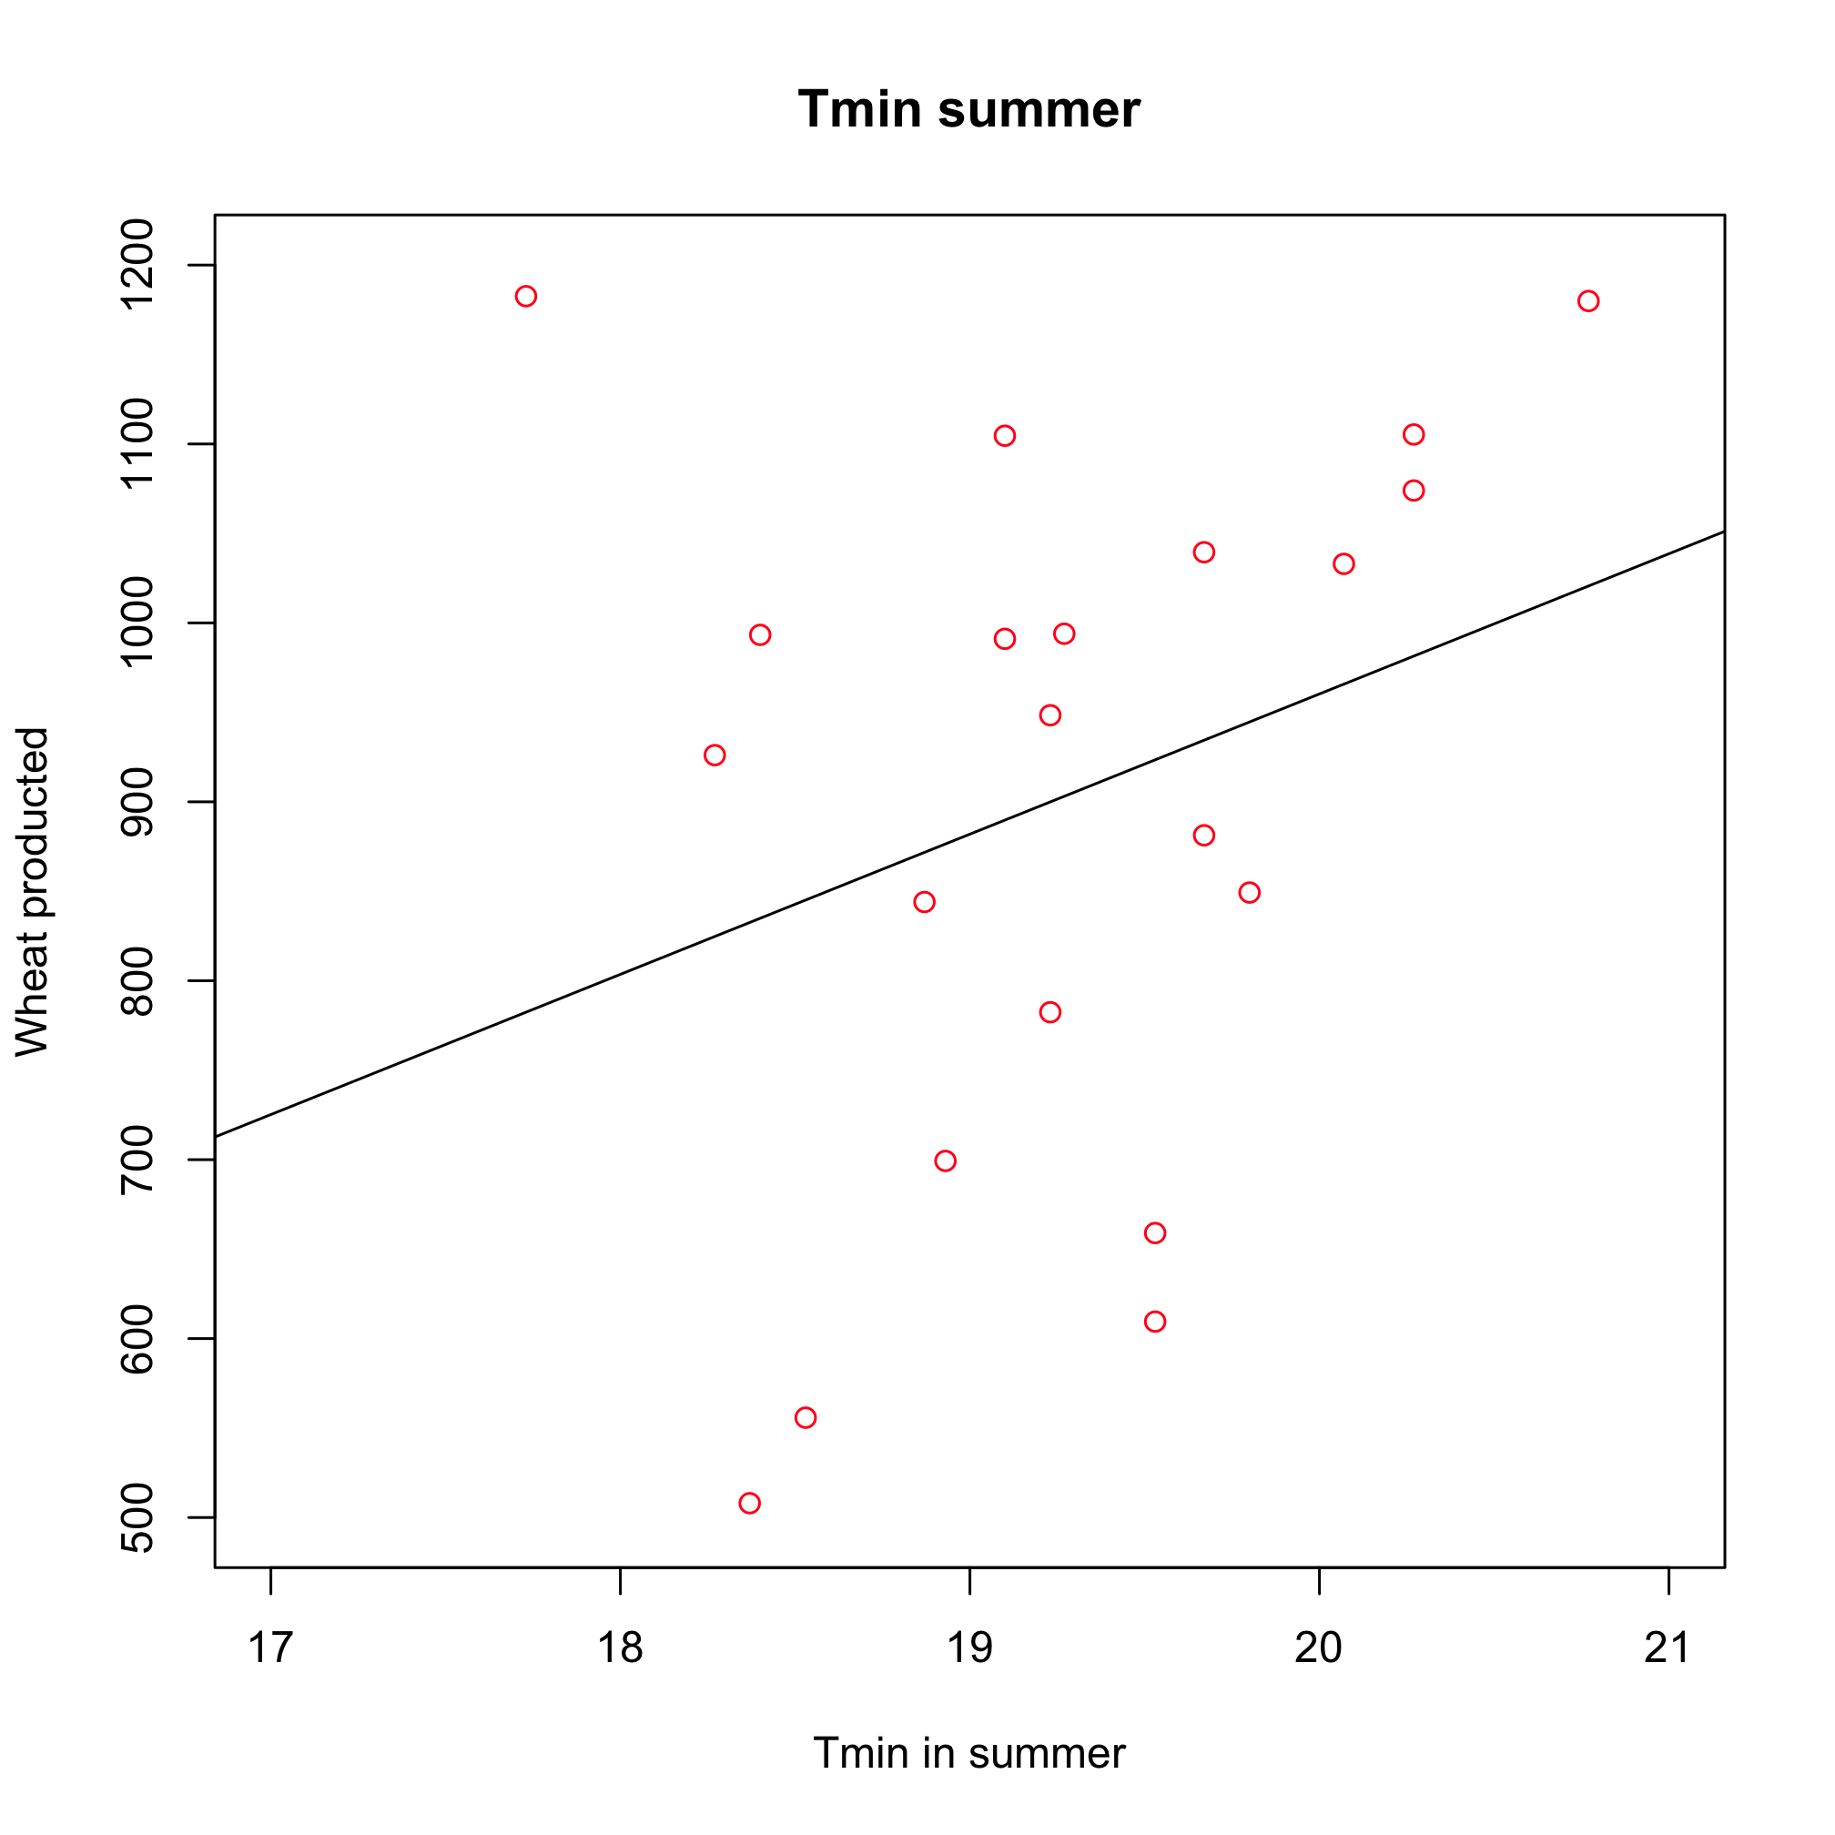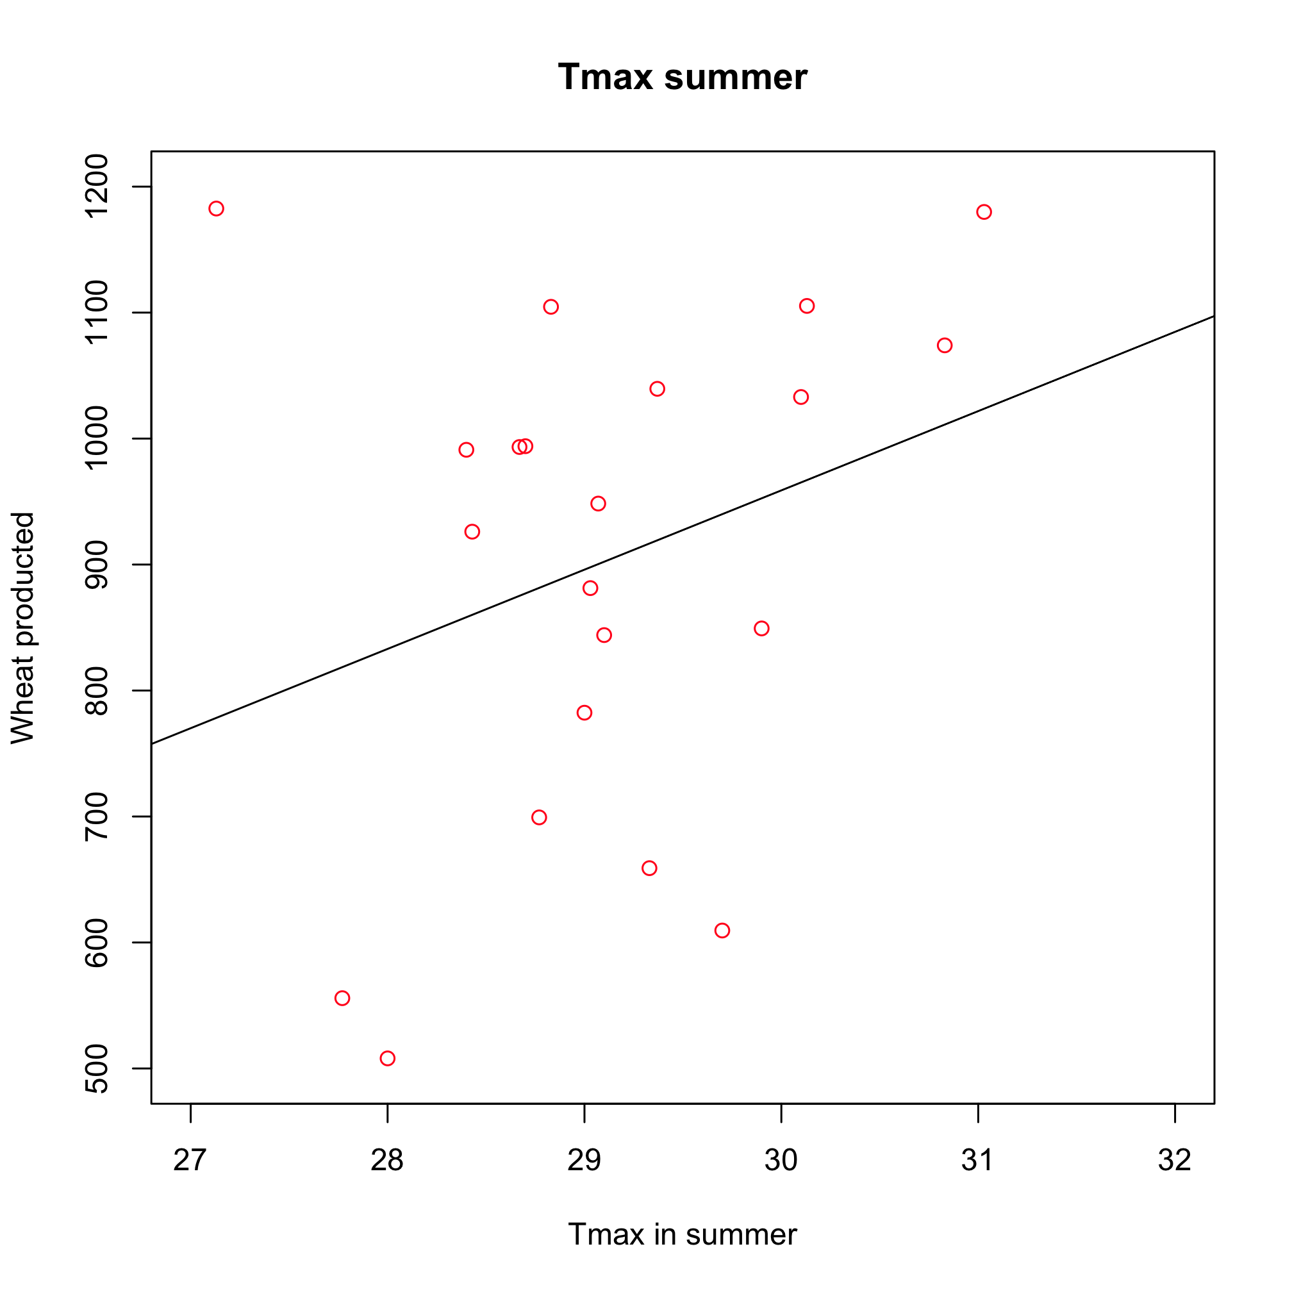
(a) (b)
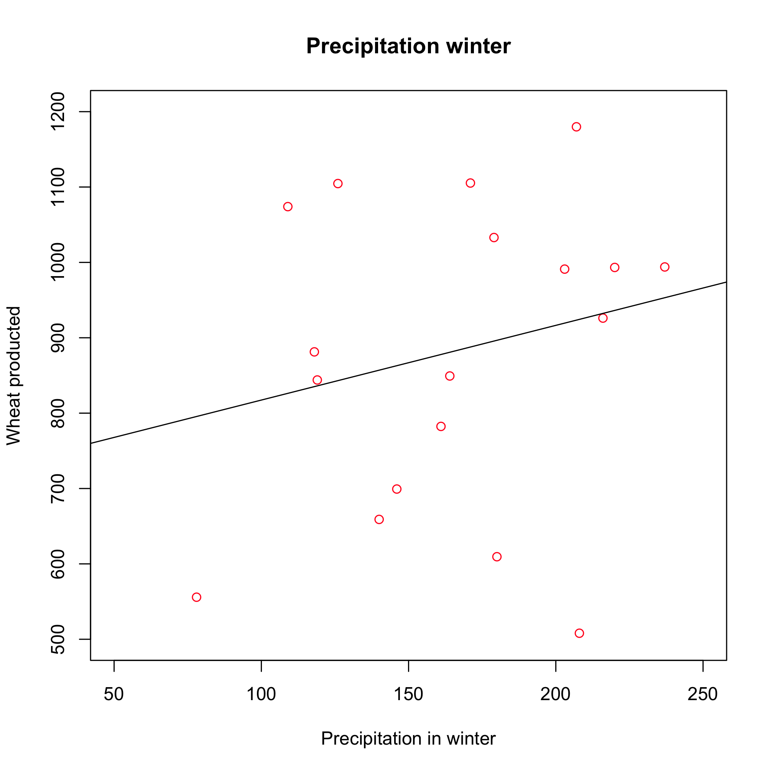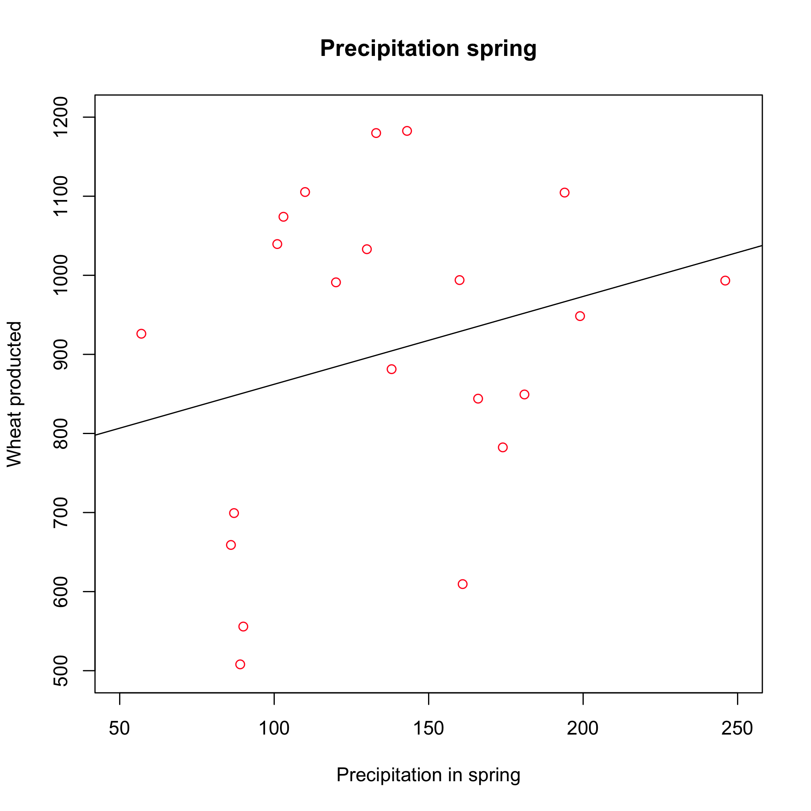
(c) (d)
Figure 4: Linear regression between wheat yield (in 1000 t) and average minimum (a) and maximum (b) temperature in summer and total amount of precipitation in winter (c) and spring (d) in Apulia, 1980-2000, explaining 0.08, 0.08, 0.11, 0.06 of total variance, respectively

What does this show?
Wheat production is weakly and positively correlated with summer minimum, maximum temperature, winter and spring precipitation (Figure 4). Multivariate regression using these variables explains about 27% of the variability in the production (Figure 5).
Why is it relevant?
Wheat is economically comparable to olive oil (the value of production in 2008 was €324 million Euros) for Apulia, which produces 697 10³ tons of wheat on average per year, corresponding about 8.5% of Italian production. Trends towards warmer and drier conditions would have contrasting effects on wheat production, with a net impact depending on the comparative importance of future changes in temperature and precipitation.

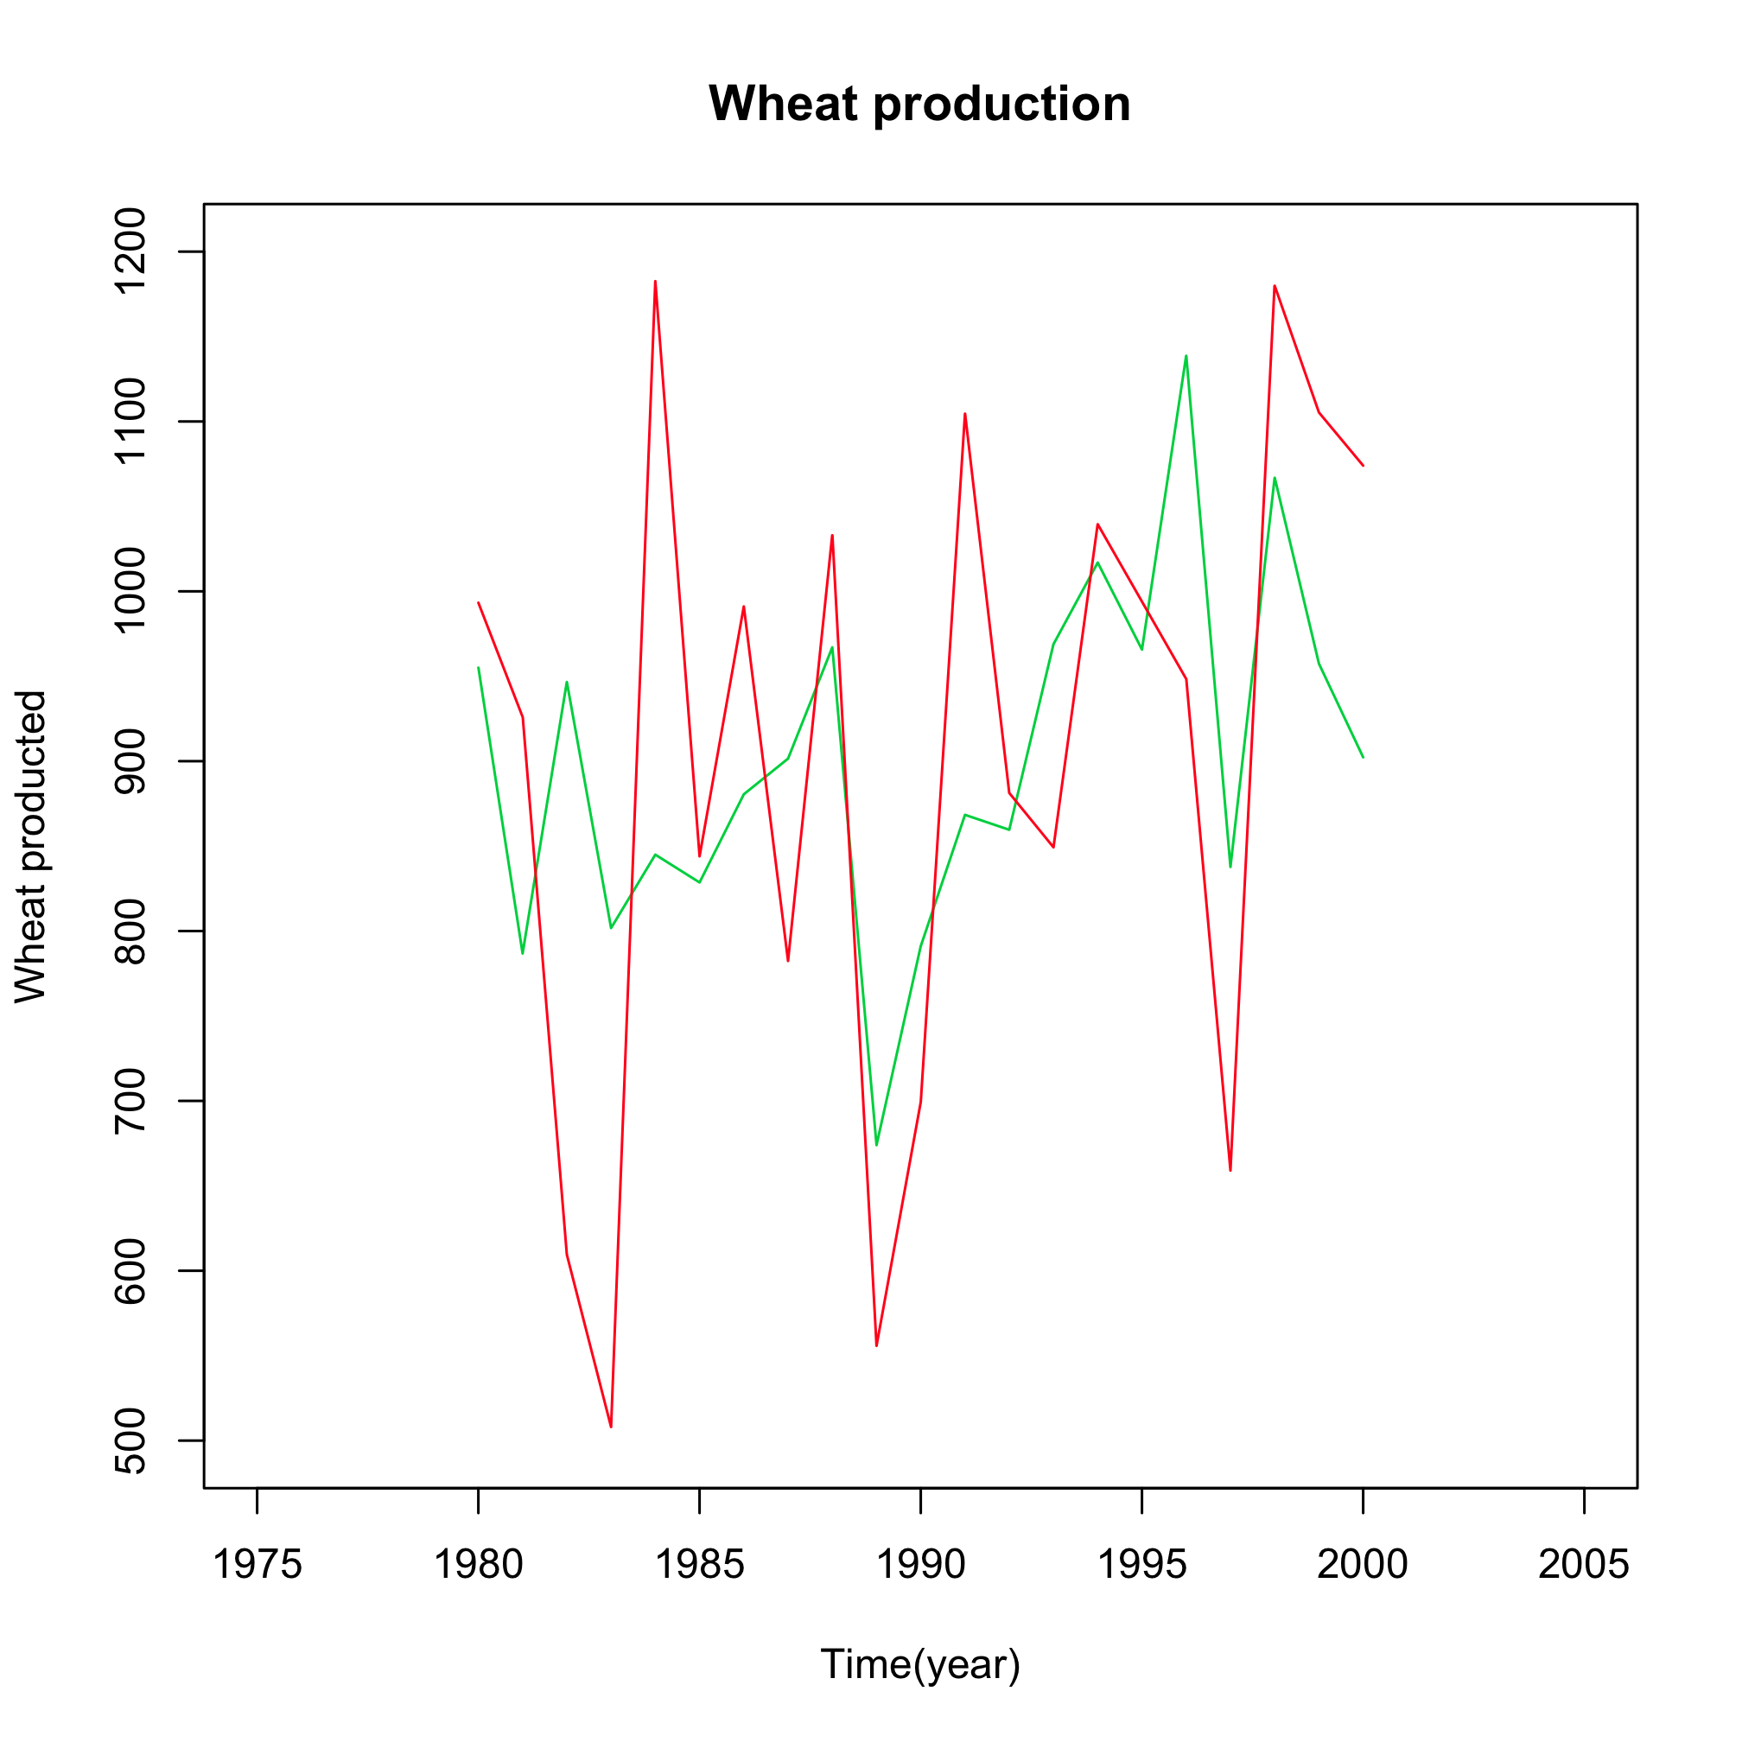

Figure 5: Wheat production (red line), estimated production (green line) using the four climate variables in Apulia, 1980-2000.

3. System vulnerability

Water is a major issue for Apulia. The total annual use is 1.7 billion cubic meters: 32.5% is for domestic use, 8.5% for industrial use, and 59% for agriculture. The situation is critical because 76% of water for domestic use is imported from nearby regions, and 75% of water use in agriculture is extracted from aquifers, for which overexploitation is now already a problem. Population growth and tourism, further increase the demand for water particularly during summer, and are critical factors for increasing the vulnerability of the region to decreasing water availability. Future drier and hotter conditions may also alter the landscape and its use. In addition, increased risk of fire and drought may have dramatic consequences on natural areas, which are particularly vulnerable because of their limited extent.
Vulnerability indicator:
Population growth in Apulia
What is it?
The population of Apulia every ten years, for the period 1921-2008 (data are provided by ISTAT).

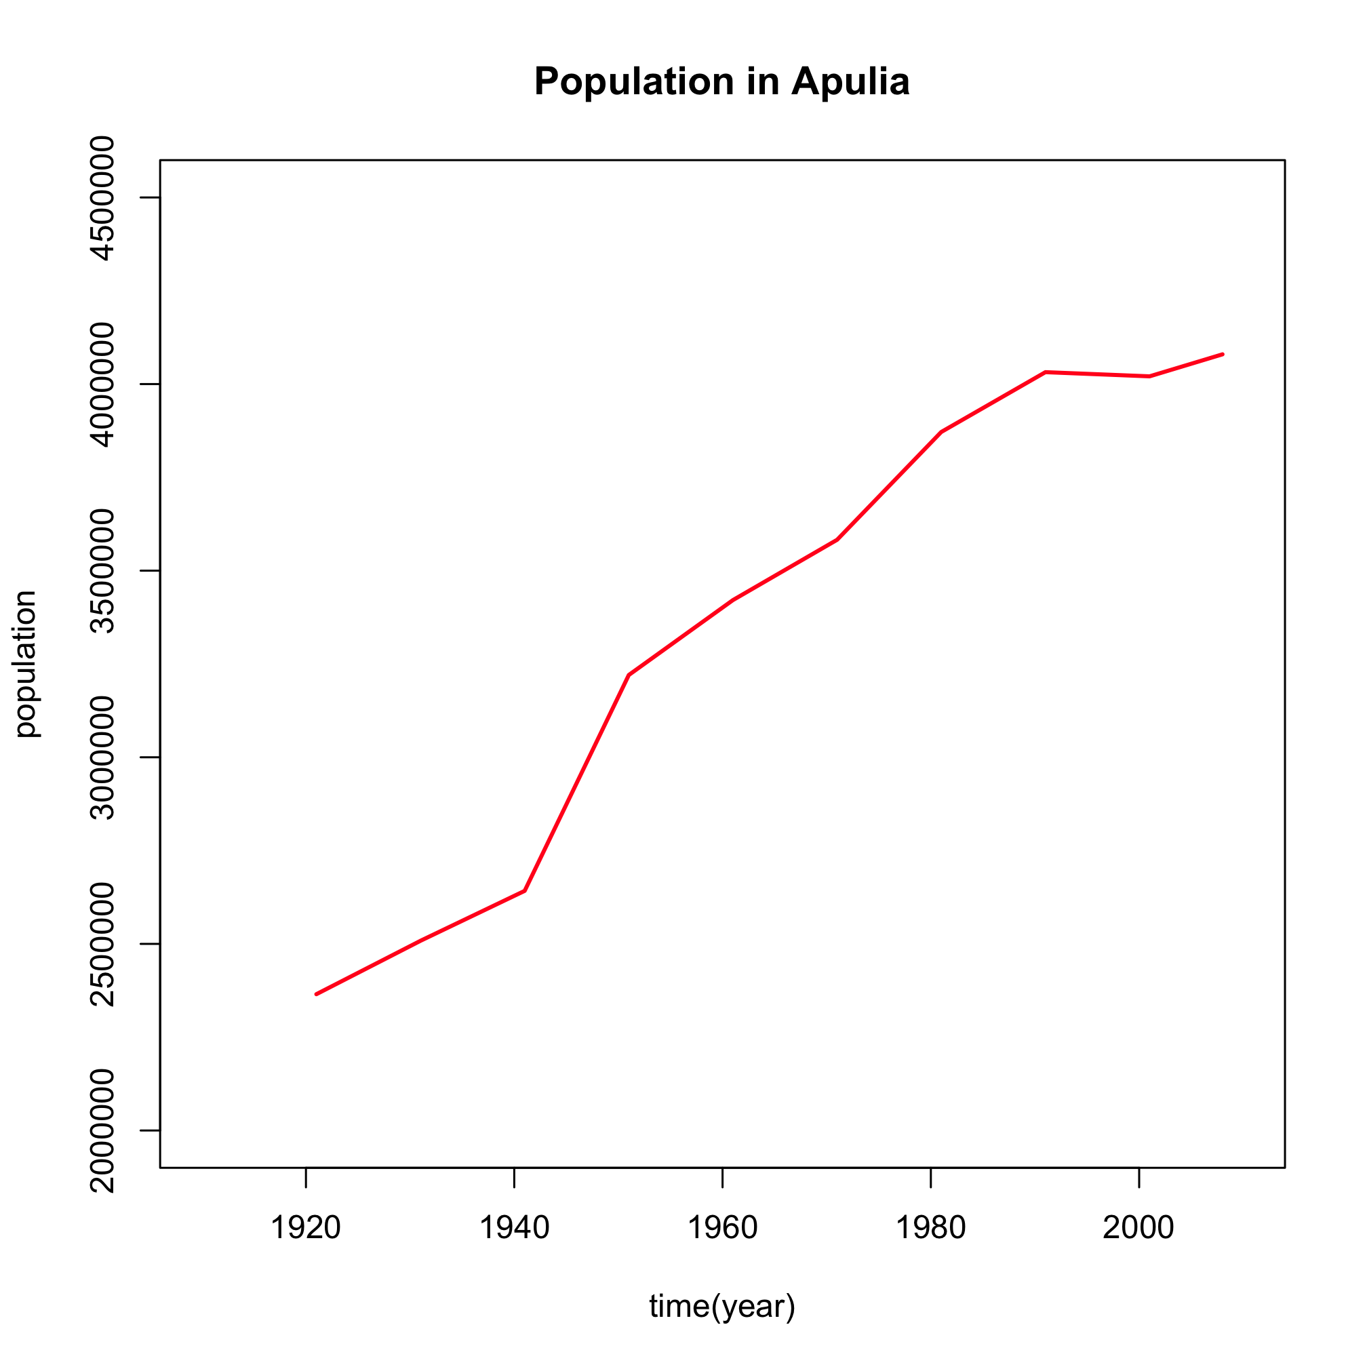
Figure 6: Population every 10 years in Apulia for the period 1921-2008. Source: ISTAT.

What does this show?
Figure 6 illustrates the rapid population increase in Apulia over the period 1921-1991. Since then growth has levelled off and the population has become effectively stable as already observed in Italy in the last twenty years where the natural balance of the population (the difference between births and deaths) has been negative or just about zero due to a negative trend in birth rate. The recent slight increase in total population has been caused by immigration.
Why is it relevant?
Domestic water use accounts for a large proportion of total water demand, and increases with population growth. Any further increase in population, eventually related with immigration could imply a larger water demand, which may be unsustainable considering the large amount of drinkable water that is already imported from nearby regions.

Vulnerability indicator:
Tourism in Apulia
What is it?
This is the total annual number of foreign and domestic tourists in Apulia for the period 1998-2007. Data are from the ‘Ufficio regionale del turismo Puglia’.

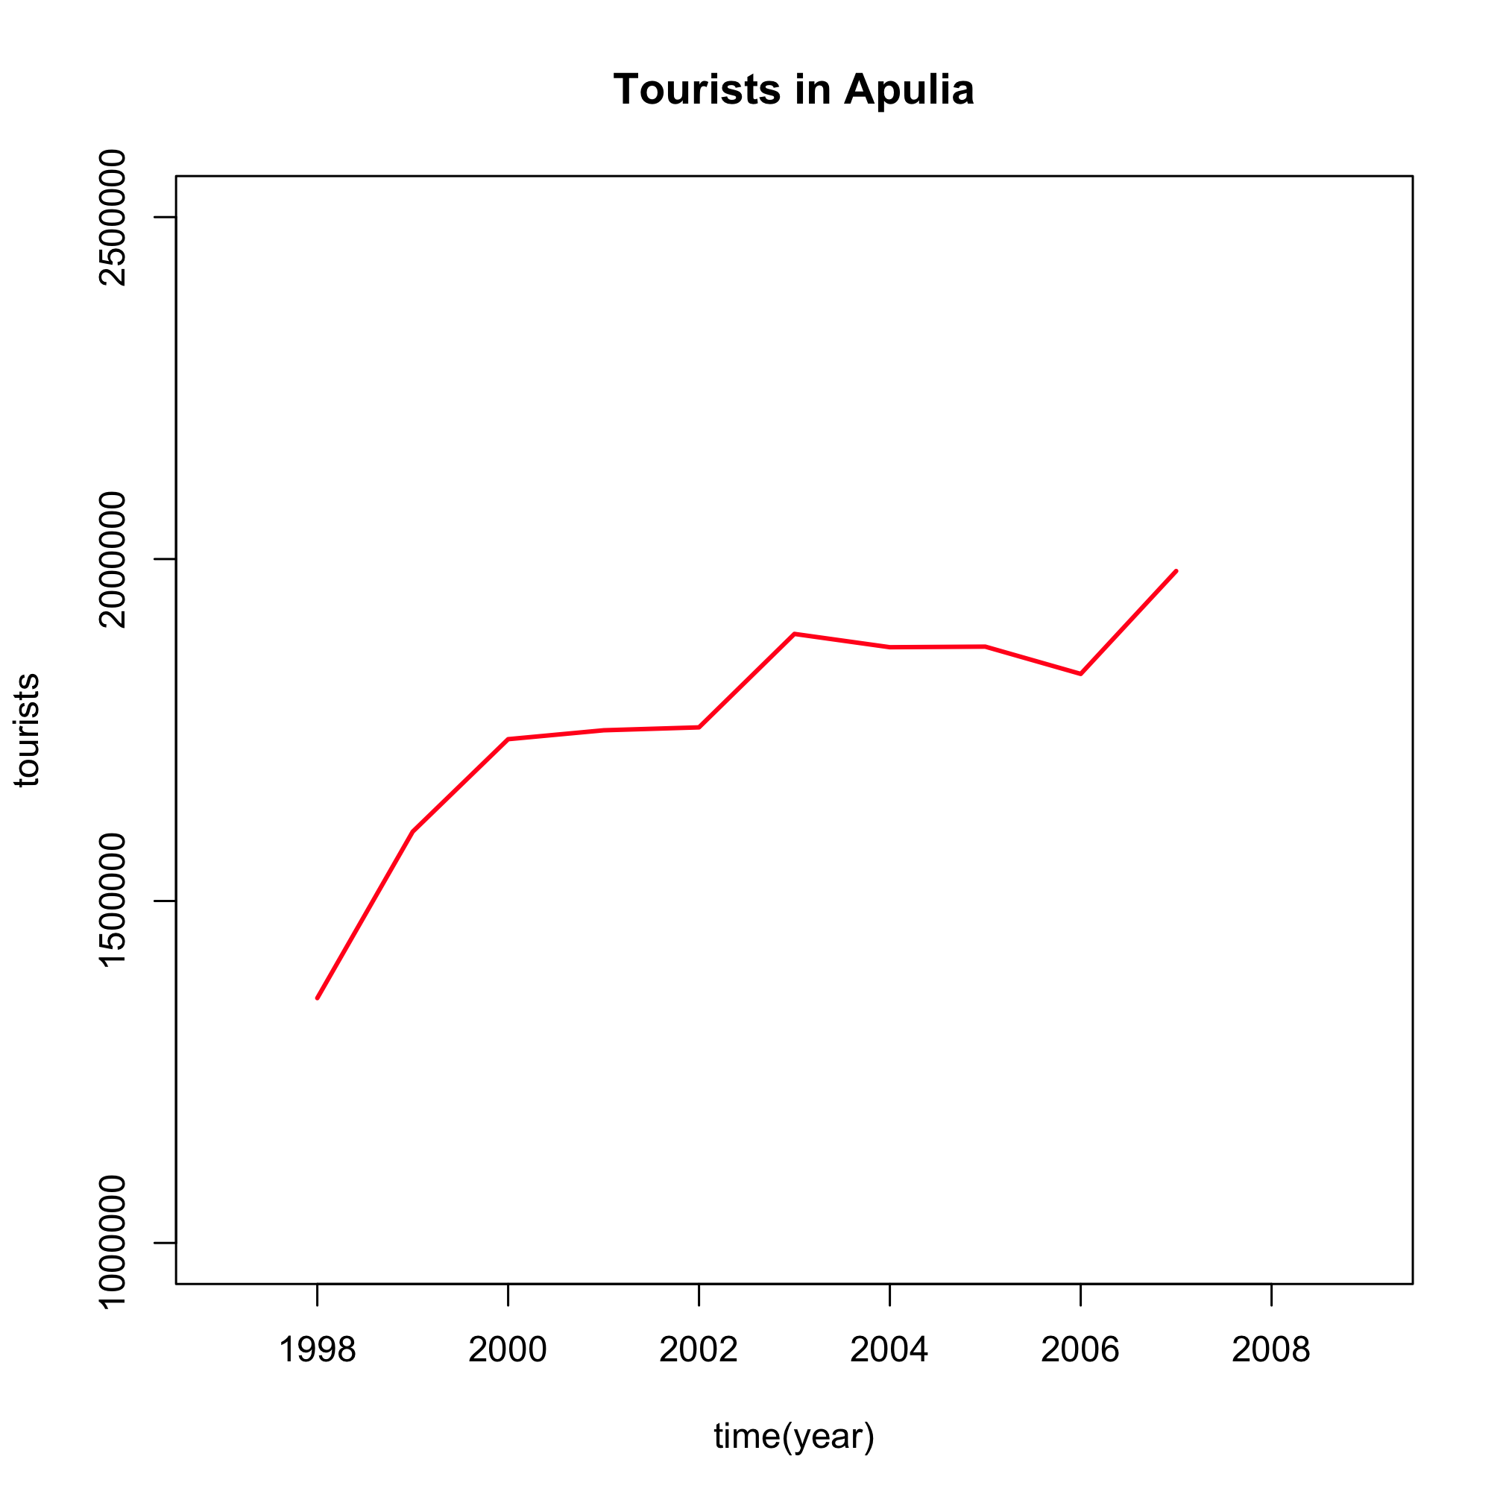

Figure 7: Annual total number of tourists visiting Apulia in the period 1998-2007. Source: Ufficio regionale del turismo Puglia.

What does this show?
Annual tourist visits have increased from 1.36 million to almost 2 million over the period 1998-2007, which corresponds to a 68% increase (Figure 7). Foreign tourism accounts for about 10% of all visits to the region and 0.75% of regional gross domestic product.

Why is this relevant?
Tourism is an increasing resource for the Apulia economy. Numerous initiatives have been launched in recent years to attract both domestic and foreign tourism. Climate change may impact tourism in several ways. For example, higher temperatures in summer could deter both foreign and domestic tourists from visiting Apulia if environmental conditions become too uncomfortable. On the other hand, higher temperatures in winter could encourage more tourists to visit the region. A large increase in tourists, especially during the summer season when the peak of number of tourists usually occurs, would accentuate the demand for water during the most critical time of the year.

Vulnerability indicator:

Water consumption in Apulia
What is it?
Apulia, in an attempt to manage the water shortage problem, has successfully reduced average water consumption (left panel) with all municipalities adopting measures to control and limit water demand.

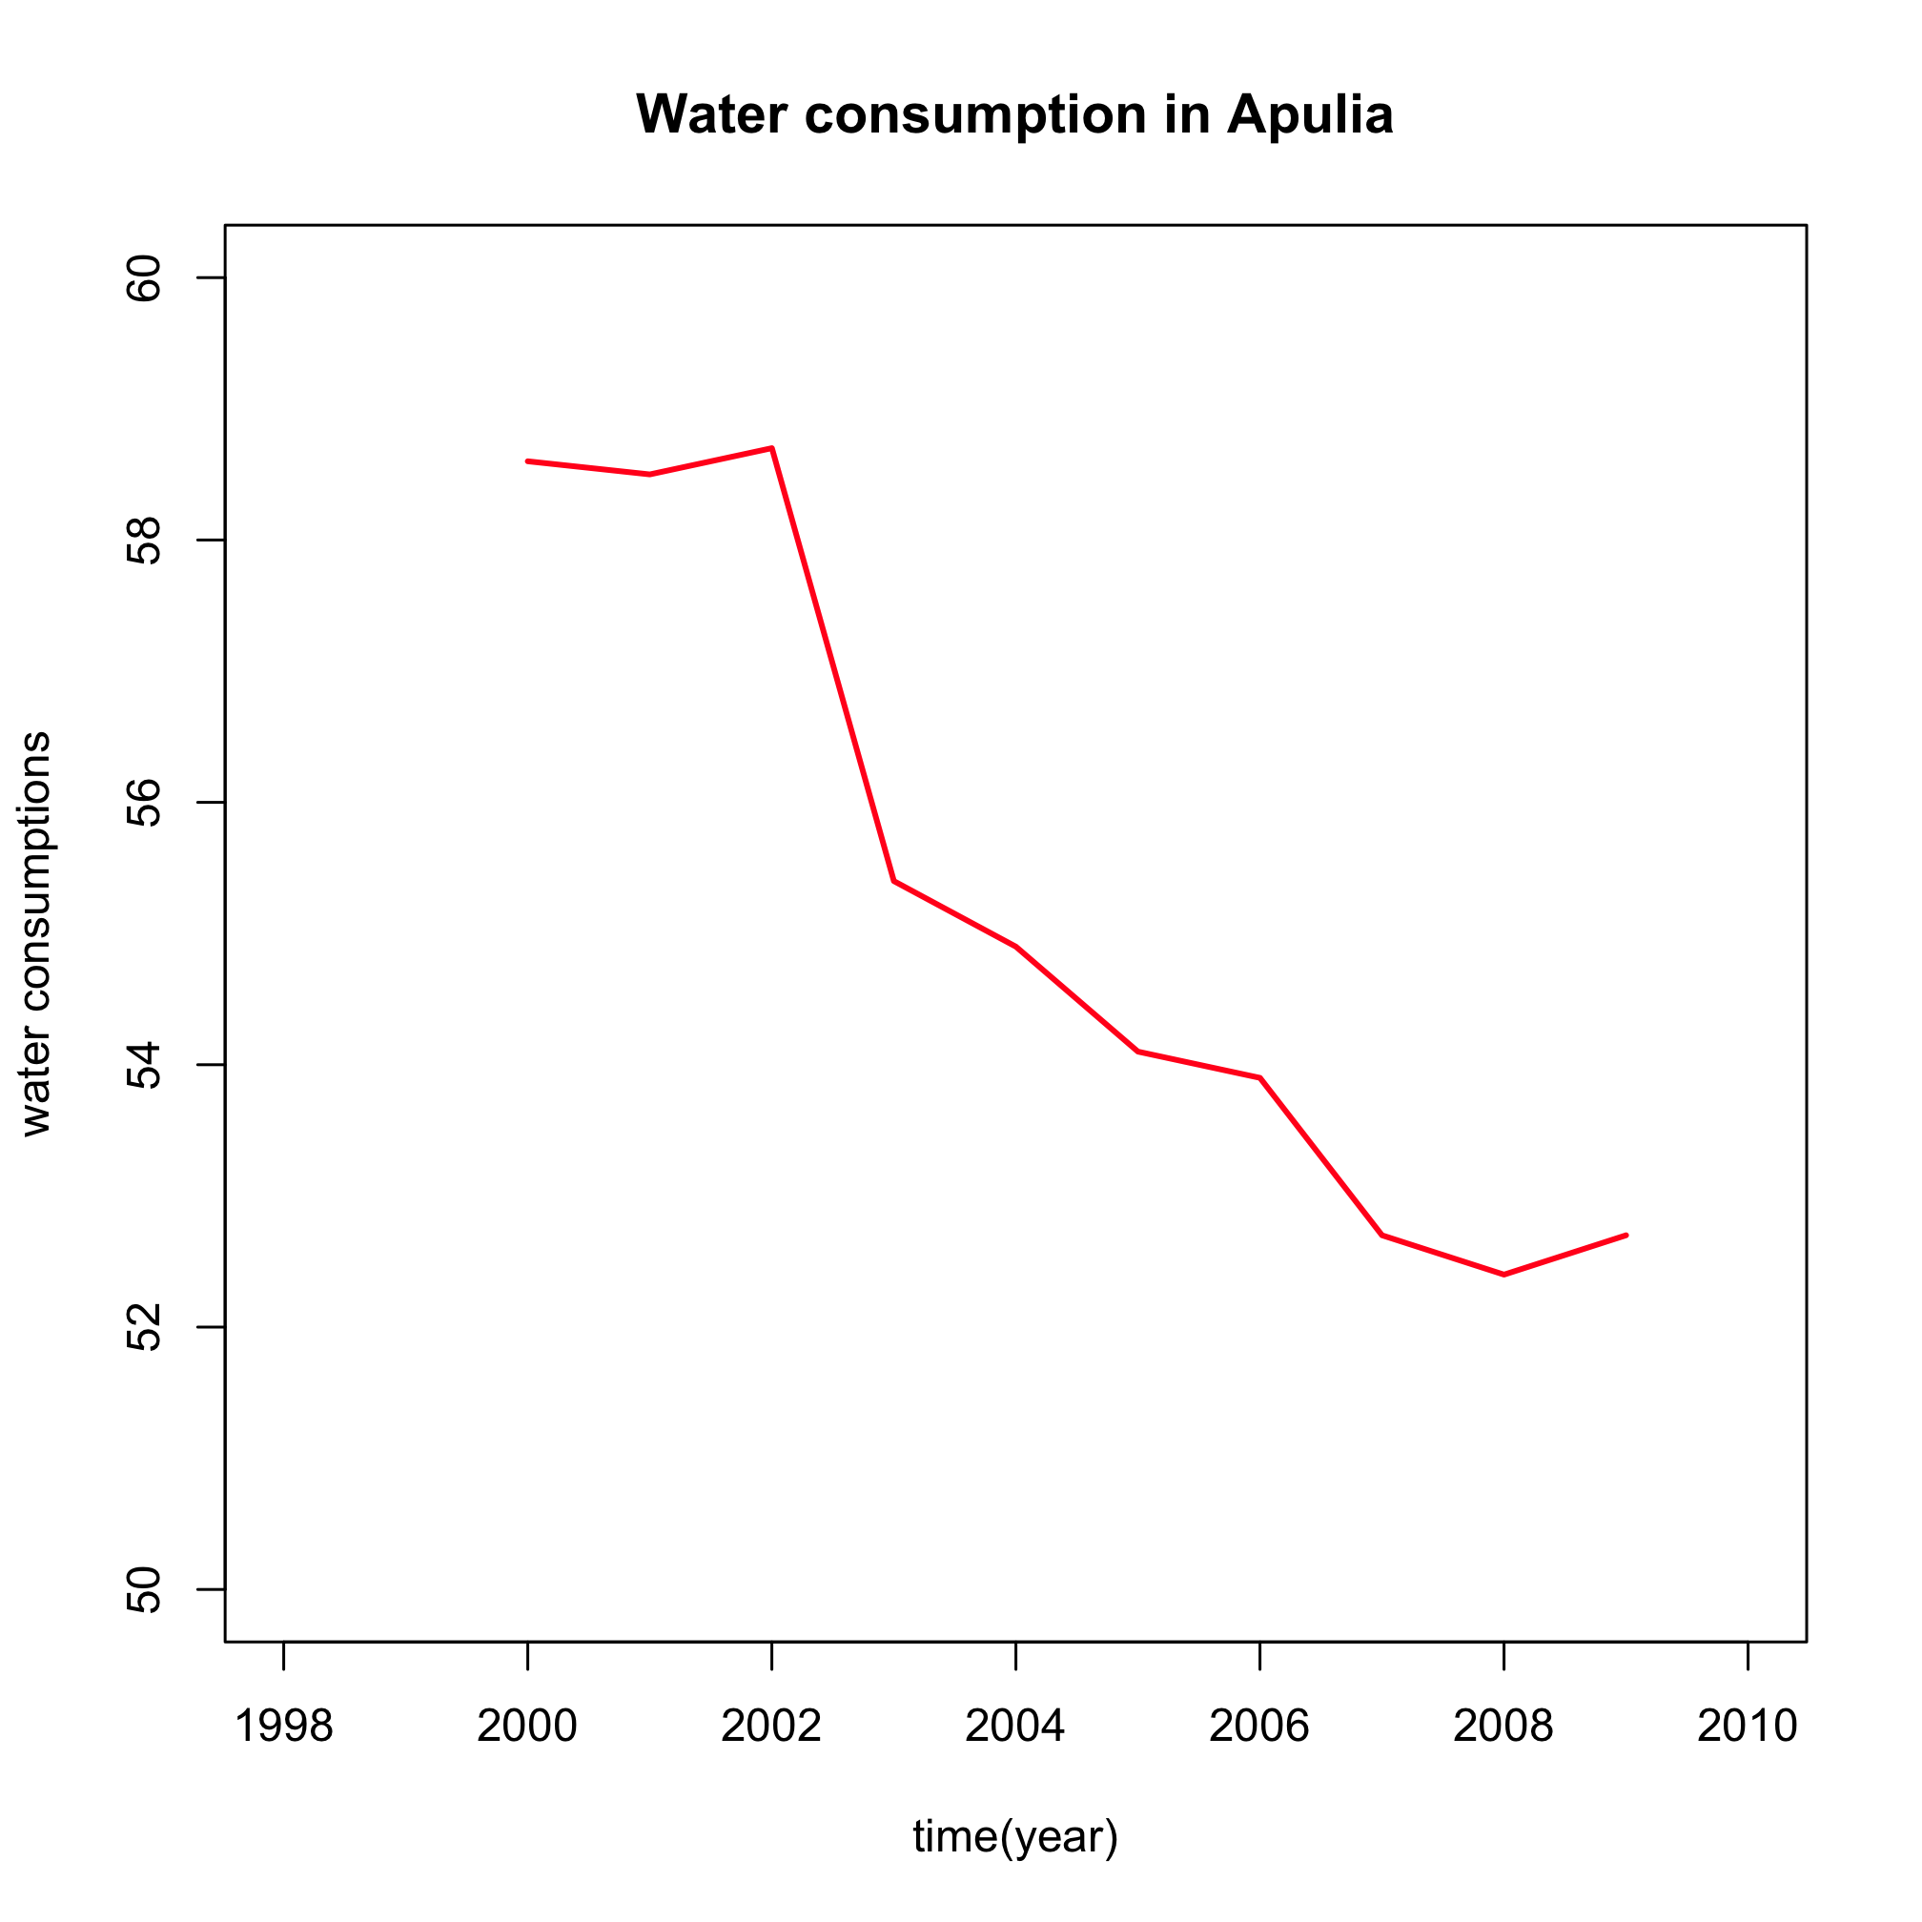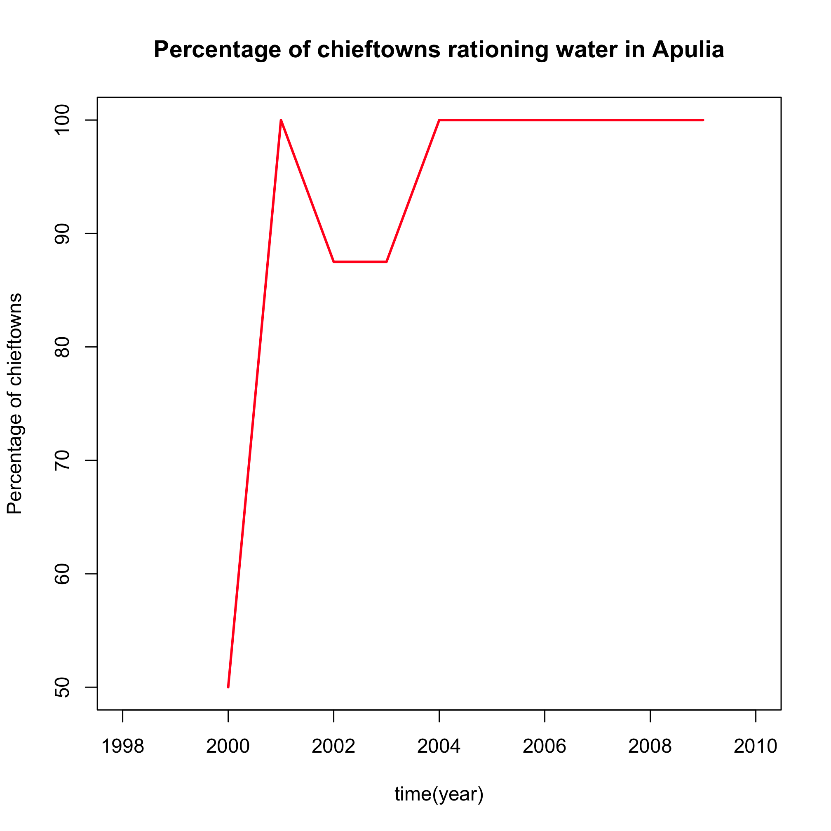
(a) (b)
Figure 8: Annual water consumption (in m³) in main towns per capita (a) and percentage of chief towns adopting measures for rationing water in Apulia, in the period 2000-2008.

What does this show?
Figure 8 shows that as a consequence of regulation and specific policies, a 10% reduction in per capita water use has been achieved over the last decade. All main towns in Apulia have now adopted measures such as interruption of the distribution of water during a fixed time window (Figure 8b).
Why is it relevant?
These measures have been adopted to manage water resources during hot periods, when requests increase and overcome the distribution system capability. Water use regulation can effectively contribute to reducing pro-capita water consumption and help to reduce vulnerability to climate variability and change.

Land use in Apulia
What is it?
This is the proportion of land surface for each major category of use (2005). Data are from Sink Patterns of Disturbance and Cross-Scale Mismatches in a Panarchy of Social-Ecological Landscapes (Zaccarelli et al, 2008). Note that land in Apulia has a wide variety of uses and services that include both natural ecosystems and human systems (e.g., industry, residential, agriculture and forestry).

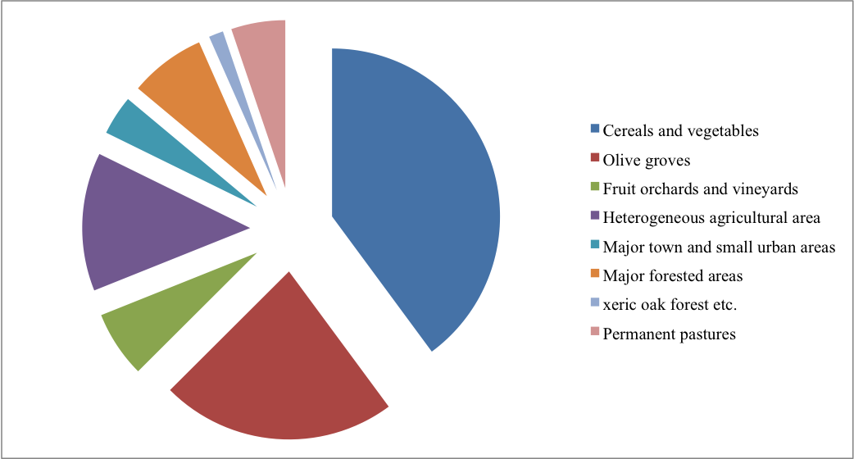
Figure 9: Land use in Apulia, 2005. Data were taken from ‘Sink Patterns of Disturbance and Cross-Scale Mismatches in a Panarchy of Social-Ecological Landscapes‘ (Zaccarelli et al, 2008).

What does this show?
Overall, more than 80% of Apulia comprises agro-ecosystems (Figure 9). The northern and, to some extent, the central part of the region include arable lands (40%) producing cereals and vegetables, while extensive century-old olive groves (23%), fruit orchards and vineyards (6%), and heterogeneous agricultural areas (13%) dominate central and southern Apulia. Major towns and small urban settlements account for only 4% of the entire area. Natural habitats are unevenly distributed with major forested areas (7%) concentrated in the Gargano peninsula. Small remnants of xeric (dry) oak forests are interspersed with olive groves, shrub and herbaceous vegetation associations (~1.5%) and permanent pastures (5%) in Dauno (northwest) and in the Murge Apennines (southwest).
Why is it relevant?
Land in Apulia has a wide variety of uses that encompasses both human systems and a small proportion of ‘natural’ ecosystems. Land use classification is useful for assessing the differential vulnerability of each category to climate change and other factors. A drier climate could have a dramatic direct effect on landscape and ecosystems services, and an indirect effect on other economic activities, such as tourism. With 80% of land cover agricultural, drought has a major impact on rain-fed crops yields, particularly in the northern area. Since many crops are irrigated, drought further increases demand for the already scarce water resources in the region.

In addition, drier conditions could favour fire, which is a major hazard for the limited areas of ‘natural’ landscape remaining in Apulia (Figure 10). In fact Apulia is the second region in Italy most affected by fires each year according to the size of wooded area burnt.

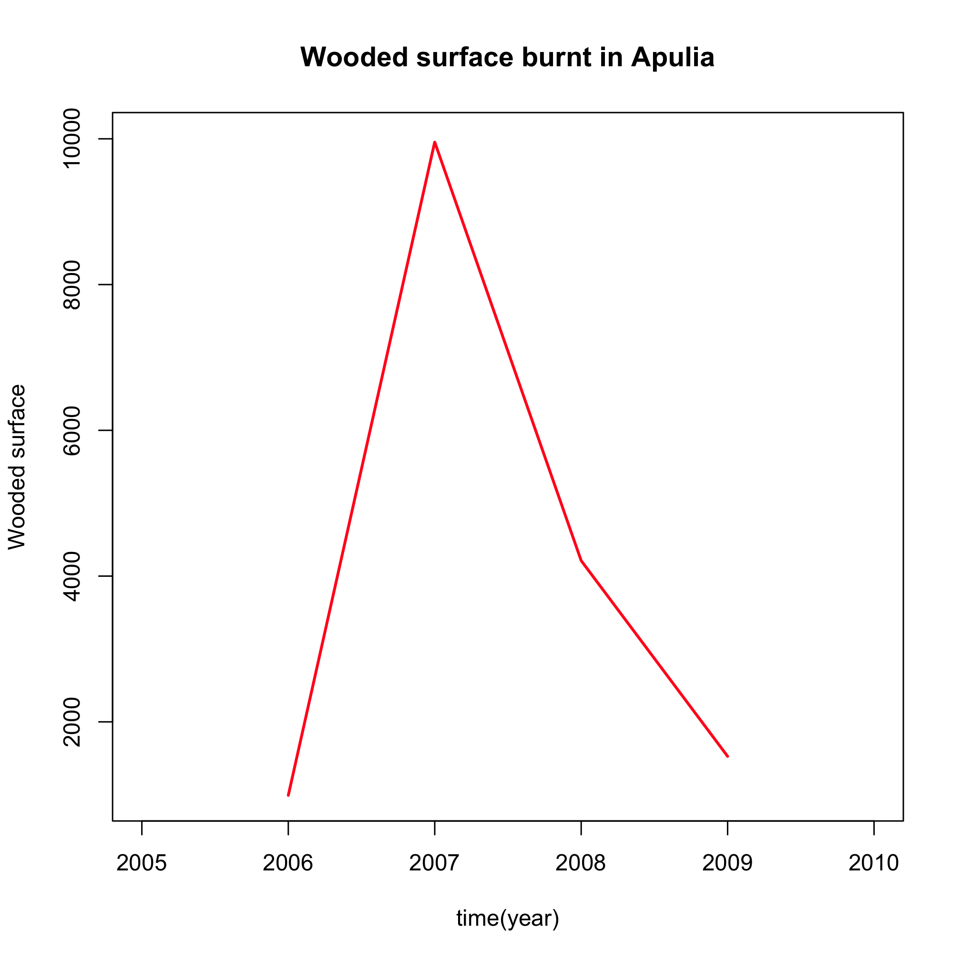
Figure 10: Wooded area affected by fires (in hectares) in Apulia, for the period 2006-2009 (data provided by Corpo Forestale dello Stato).

5. Summary

This information sheet has focused on some key sectors of the Apulia ‘system’ that are vulnerable to climate variability and change (summarised in Table 1). In some sectors, such as agriculture, statistical evidence of a linear association with climate are in general weak and do not account for the influence of extreme climate events, such as heat waves and intense precipitation. Scarcity of data, short time series and difficulties in obtaining information prevent a robust analysis of the links between climate indicators and biogeophysical and social indicators. Furthermore, these variables are also driven by factors related to the economic and political environment which can obscure a smaller climate signal.
Specific issues include:
- Reduced water resources for irrigation
- Salinization of aquifers in coastal areas
- Increased irrigation practices
- Supplemental irrigation for winter crops
- Increased water demand for summer tourism.
It is clear that Apulia is extremely vulnerable to reduced or irregular water availability and that climate change could present a critical challenge to an already problematic situation. A continuation of observed climate trends (warmer temperatures and reduced precipitation) is likely to lower water availability and increase water demand. This will further stress the system in Apulia, forcing increased water imports and threatening the sustainability of aquifers.

Table 1: Summary table of bio-geophysical and social vulnerability indicators to current climate in Apulia
Key impacts indicator | Climate hazards indicator | Vulnerability indicators | System thresholds | Current impacts
Annual yield of wheat, annual production of olive oil and wine | Anomalies of seasonal precipitation, maximum and minimum temperature | Water Availability:  - Apulia largely depends on import of water from nearby regions.  - Aquifers are the main source of water for agriculture use. Regulation and sustainability of their exploitation are major issues.  - A reduction in precipitation or increase in temperature may unbalance present critical conditions and prevent an adequate water supply for agricultural use.  Water Resource Costs:  Reduced agricultural profits are likely produced by increased water costs caused by increased water demand and sector competition. | When costs of cultivation overcome income from production, the present agricultural practices will be abandoned or replaced  Temperature:  Warmer temperature has a negative effect on olive oil and wine, but a positive effect on wheat. Some references report 5°C and 30°C as minimum and maximum temperature thresholds during reproductive development phases for wheat yield in a Mediterranean context: (Dawson and Wardlaw, 1989; Tashiro and Wardlaw, 1990). | There are marginal indications that the current water deficit (~ 350 mm/year) is increasing  Precipitation:  Reduced precipitation in spring and summer has a negative impact on crops  There are indications of a small negative impact of climate trends on the production of wheat and olive oil during the last decades of the 20th century
Tourist arrivals | Precipitation anomalies  Max temperature anomalies  Heat wave duration  Hot days/nights | Water Availability:  - Water resources required for tourism services (i.e., swimming pools, drinking water, recreational water sports) can reduce water availability for other sectors.  - Summer peaks in tourism amplify pressure on water resources during drought periods, endangering the sustainability of the water system  A tourist consumes on average 300 litres of water / day, and up to 880 litres /day in luxury hotels (EEA, 2003). | No quantitative thresholds have been identified:  It is likely that warmer winters and hotter summers are associated with fewer tourist arrivals, whereas higher temperatures in spring and summer increase tourist visits.
Proportion of land covered with natural forests | Annual precipitation anomalies  Max temperature anomalies  Heat wave duration  Hot days/nights  Dry spell | Water Availability:  The major fire risk occurs during the summer when droughts are more frequent, water resources more vulnerable and soil moisture scarcer. In these conditions, plants suffer water deficit and are more inflammable.  Natural forest management:  Only small and sparse areas of land are left to natural forest. Percentage-wise, a single fire produces a disproportionately large amount of damage on an already endangered environment. | No quantitative thresholds have been identified | Fires are currently threatening the small residual ‘natural’ landscape areas of Apulia
Acknowledgements
CIRCE (Climate Change and Impact Research: the Mediterranean Environment) is funded by the Commission of the European Union (Contract No 036961 GOCE) http://www.circeproject.eu/. This information sheet forms part of the CIRCE deliverables D11.4.3 and D11.4.4.The authors thank Dr M.Torodovic for the computation of evapotranspiration and environmental water budget, and Ivan Portoghese for information on water use. Data on forest fires have been provided by “Corpo Forestale dello stato, (http://www3.corpoforestale.it).
Bibliography
- Dawson I.A. and Wardlaw I.F. 1989. The tolerance of wheat to high temperatures during reproductive growth. III. Booting to anthesis. Australian Journal of Agricultural Research 40(5) 965-980.
- EEA 2003. Europe's water: An indicator-based assessment. European Environment Agency, Topic Report, 97 pp.
- EUROSTAT (European institute of statistics) http://epp.eurostat.ec.europa.eu/portal/page/portal/eurostat/home/
- Hargreaves, G.H. and Z.A. Samani 1982. Estimating potential evapotranspiration. J. Irrig. and Drain Engr., ASCE, 108(IR3):223-230.
- ISTAT (Italian institute of statistics) http://www.istat.it/
- ISMEA (Italian Institute of Services for the agricultural and food market) - http://www.ismea.it/flex/cm/pages/ServeBLOB.php/L/IT/IDPagina/1.
- I fabbisogni formativi e l’evoluzione dei profili professionali nelle filiere vino e olio dell’area jonico-salentina-University of Salento-Agriplan S.R.L.
- Tashiro T. and Wardlaw I.F. 1990. The Effect of High Temperature at Different Stages of Ripening on Grain Set, Grain Weight and Grain Dimensions in the Semi-dwarf Wheat ‘Banks’. Annals of Botany 65: 51-61.
- Zaccarelli, N., I. Petrosillo, G. Zurlini, and K. Hans Riitters 2008. Source/sink patterns of disturbance and cross-scale mismatches in a panarchy of social-ecological landscapes. Ecology and Society 13(1): 26.[online] URL: http://www.ecologyandsociety.org/vol13/iss1/art26/
Authors: Marco Reale¹ (reale.marco82@gmail.com), Piero Lionello¹ (piero.lionello@unisalento.it)¹,
¹ Dep. of Material Science, University of Salento, Lecce, Italy.
Editors: Maureen Agnew (m.agnew@uea.ac.uk) and Clare Goodess (c.goodess@uea.ac.uk), Climatic Research Unit, School of Environmental Sciences, University of East Anglia, Norwich, UK
Date: June 2011

