Information sheet on observed climate and marine indicators
for the CIRCE coastal case studies: Gulf of Valencia

Summary
- Annual mean air temperature has been increasing from 1950 up to the present day. The rate of change is significant and varies between +0.17 °C/decade and +0.24 °C/decade, depending on the series. In general, annual mean maximum temperature has been warming at a faster rate (about twice the rate) than minimum temperature.
- The precipitation time series are a very variable characteristic of the Mediterranean climate, showing a slight negative trend for Fabra (Barcelona) and a slight positive trend for Ebro. Neither trends are statistically significant.
- The annual observed and hindcast data for the Gulf of Valencia suggest that there is a slight decrease in the annual mean sea level that is probably attributed to local/regional atmospheric factors. The time series of observed data used for these analyses are very short and the detected trends are not statistically significant. In contrast, the hindcast time series is longer and also indicates (with a significance level of 0.001) a decreasing trend in the mean sea level related to storm surges of about -0.54 cm/decade.
- Sea-water temperatures have increased significantly, especially close to the surface, with maximum temperature showing a clearer warming trend than mean or minimum temperature.

  - Introduction
Within the Gulf of Valencia, the Ebro Delta and Cullera Bay are examples of coastal zones subject to a range of environmental pressures and vulnerable to the impacts of climate change. The Ebro Delta is located on the Spanish Mediterranean coast, about 200 km south of Barcelona. It has an area of approximately 320 km² and a coastline length of about 50 km. It is a low-lying coastal area protecting a deltaic plain with high environmental value and intensive agricultural use. Cullera Bay suffers from problems of coastal pollution. Warming of sea-water due to climate change could accelerate eutrophication and further degrade water quality with deleterious effects to the natural ecosystem. Sea level rise could further degrade the environment through salinization, and coastal erosion.

It is likely that the most critical aspects of climate change will be related to warmer temperatures, and extreme climate events such as storms, flooding or drought.

2. Indicators of observed climate variability
The key indicators presented for the Gulf of Valencia are:
- Mean air temperature (annual)
- Total precipitation (annual; seasonal)
- Storm surges (annual)
- Sea surface temperature (annual)
- Wave storms (annual number and duration)

Air temperature
What is it?
Mean, minimum and maximum air temperature trends are expressed as a rate of change (ºC/decade), with 95% confidence limits. Temperature indicators are derived on an annual and seasonal basis, and data were obtained from the Servei Meteorologic de Catalunya - Catalan Meteorologic Service- (SMC), for the stations Ebro (centre of the study area) and Fabra, Barcelona (north of the study area).

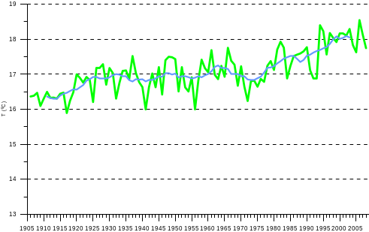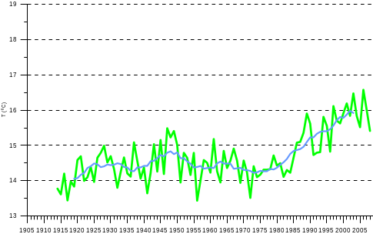
Figure 1: Annual mean temperature (in green) and 11-year running mean (in blue) for the stations Ebro (left) and Fabra (right). Data provided by SMC

What does this show?
The results show that annual mean temperature has been increasing at a rate of warming which ranges between +0.17ºC / decade and +0.24ºC / decade for the whole of the Catalunya area. Particularly significant is the temperature increase from 1950 to 2008 measured at Fabra and Ebro (Figure 1), shown with 95% confidence intervals in Table 1. Moreover, the rate of increase for the annual mean maximum temperature (+0.23ºC to +0.32ºC / decade) has been about twice that for minimum temperature (+0.08ºC to +0.18ºC / decade). In addition, the summer season shows the fastest warming trend, with a mean rate of increase of over 0.3 ºC / decade. Similar results were reported by Miró et al. (2006) for the littoral and surrounding area of Valencia (southern part of the study area), for the years 1958 to 2002. The observed warming trend for Valencia was strongest in summer and spring and weakest in autumn and winter.
Why is this important?
An increase in air temperature is one of the clearest signals of regional and global climate change. The warming trend observed for the two stations representative of the Gulf of Valencia could incur substantial regional impacts, especially during the summer season, when increasing air temperature translates to greater evaporation, and an increase in the use of scarce fresh water resources and energy through a greater use of air conditioning. Atmospheric warming may also contribute to the expected sea-level rise and an increase in sea temperature which can alter the abundance and composition of marine species in coastal ecosystems. In this region, the steric (i.e., temperature) effect appears to be compensated for by enhanced evaporation and decreasing river discharge.

Table 1: Mean annual temperature trends (°C /decade) with 95% confidence interval.
Station | Mean decadal temperature trend | 95% confidence level
Fabra, Barcelona | +0.16 | [0.12-0.20]
Ebro | +0.15 | [0.12-0.18]

Total rainfall
What is it?
Total precipitation is derived on an annual and seasonal basis for the stations Ebro and Fabra, Barcelona. Data were obtained from the Servei Meteorologic de Catalunya - Catalan Meteorologic Service (SMC).

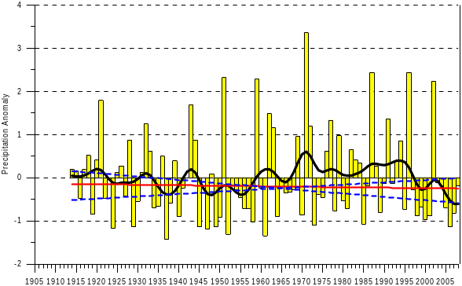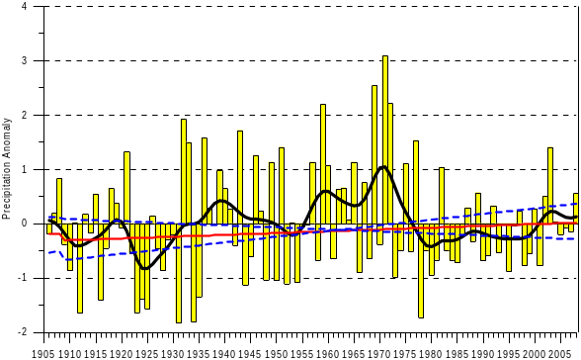
Figure 2: Annual precipitation anomalies for the Fabra (left, 1914-2008) and Ebro stations (right, 1906-2008) with a Gaussian Smooth fit and slope estimate (red line) with the 95% confidence interval (blue dashed line). Data provided by SMC

What does this show?
While a slight decreasing trend in annual precipitation is observed in northern parts of the Gulf of Valencia (Fabra), a slightly increasing trend is observed in central (Ebro) parts (Figure 2). For the complete record these trends are not significant (p > 0.1). Standardized precipitation anomalies for the Catalan Mediterranean system show considerable variability, a characteristic of the Mediterranean climate (Saladié et al., 2004). However, applying Gaussian smoothing to precipitation anomalies suggests that there seems to be a precipitation decrease at Ebro from 1970 to 1980 and a slight increase since then, while at Fabra there is a decreasing trend from 1994 to the present day. These small annual trends mask opposing seasonal trends – wetter in winter and autumn, and drier in summer (see Table 2).
Why is this important?
The observed increase in winter and autumn precipitation, and the decrease in summer precipitation may produce opposing effects. Floods ands droughts may occur in different seasons for the same region and year (e.g., a drought in summer and floods in winter and autumn). Less precipitation in summer could lead to water and soil quality degradation in “dry” river courses and adjacent coastal areas. More intense precipitation events could result in more pulsed river discharge that more easily crosses the continental shelf leading to a higher risk of sediment and nutrient loss to the shelf waters.

Storm surges (sea level)
What is it?
Sea level varies according to a wide range of influences, such as storm surges (closely related to climate), tides and seasonal cycles. Annual mean sea level related to storm surges is presented for three sites: Barcelona to the north (observed, 1992-2007), Valencia in the south (observed, 1992-2006), and the Ebro Delta in the centre of the region (HIPOCAS hindcast model data, 1958-2001).

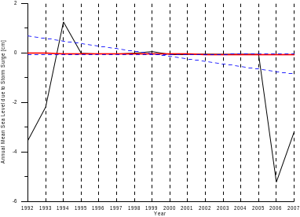
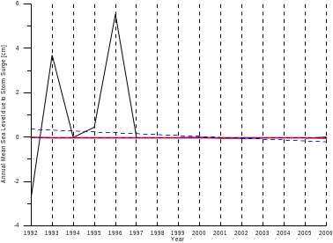

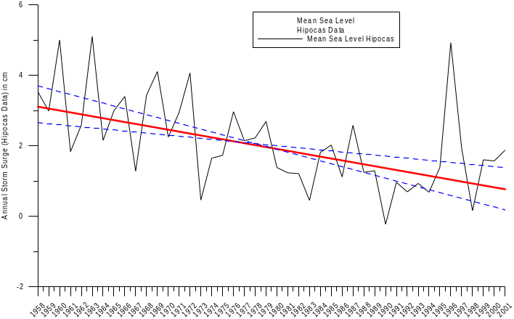

Figure 3: Annual mean sea level due to atmospheric factors at Barcelona, 1922-2007 (top, left), Valencia, 1922-2006 (bottom, left) and Ebro Delta, 1958-2001 (right panel).The slope estimate (red line) with the 95% confidence interval (blue dashed lines). Modified from Mösso et al., 2009

What does this show?
The observed 16-year and 15-year time series of storm surge data for the ports of Barcelona and Valencia respectively (Figure 3, left panel) show that there is a slight overall decreasing trend (-0.04 cm/decade and -0.03 cm/decade) over the time period. However, the series are short, the detected trends are not statistically significant, and there is little annual variation for much of the previous decade. Using the longer hindcast data for the Ebro Delta, the results (Figure 3, right panel) reveal that there is a clear statistically significant decreasing trend of about -0.54 cm/decade – also seen in the hindcast data for Barcelona and Valencia (Table 2).

Why is this important?
The Mediterranean coast is highly vulnerable to variations in sea level. Rising sea level increases the likelihood of storm surges, landward intrusion of salt water and endangers coastal ecosystems and wetlands. Decreasing sea level may impact port operations and coastal structures performance. This is the case of the Gulf of Valencia, where the sea level variations along its coasts are highly variable and there is no correlation between observations for the study sites. This variation could be explained by atmospheric processes governing sea level at a local and regional level. Changes in storm tracks and the variation of sea-air temperatures must also have played a role in this “apparent” local variability, although the available time series length is too short and the detected trends of the observed data are not statistically significant to allow more definitive conclusions.

Sea surface temperature
What is it?
The oceans have a large capacity for storing and redistributing heat. When storing heat, the upper water column expands and increases the sea level. Annual mean, maximum and minimum sea surface temperatures are presented for two sites, at l’Estartit (lat: 42º 03' N; long: 3º 15' 15'' E) for the years 1969 to 2008, and Cap Tortosa (lat: 40º 43.29’ N; 00º 58.89’ E) for the years 1990 to 2008. Data are provided by the Catalan Meteorological Service (SMC).

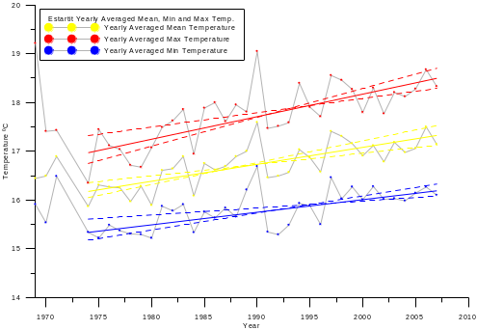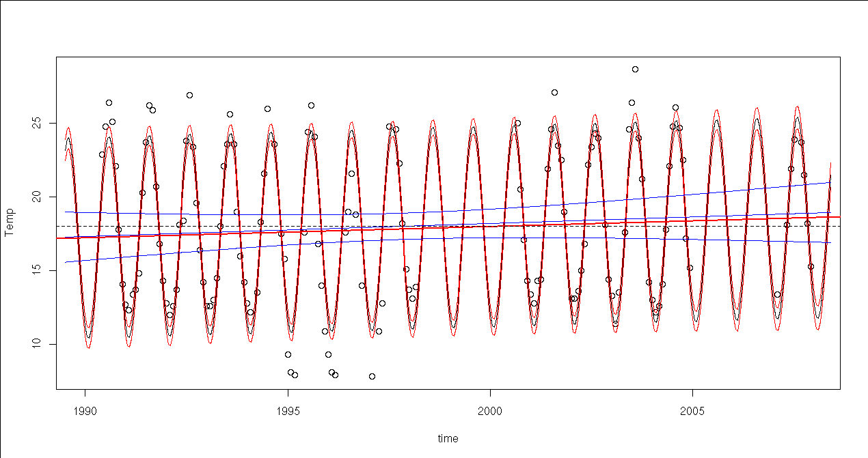
Figure 4: (a) Annual mean (yellow), maximum (red) and minimum (blue) sea surface temperature (SST) at l’Estartit, 1969-2008 – note that 1972/73 values are missing (left) and (b) monthly SST for Cap Tortosa, 1990-2008 (right panel). Data source: SMC

What does this show?
The analysis of annually averaged sea temperature at different depths [surface (Figure 4a), -20, -50, -80 m] at l'Estartit shows a parallel increasing trend to that for air temperature. Although more limited in series length (continuous from 1974) this warming trend (about 0.33ºC/decade) is significant, especially close to the surface. The observed decadal trends, obtained using the Mann-Kendall test are 0.48ºC, 0.28ºC and 0.06ºC (all significant at the 0.001 level) for surface maximum, mean, and minimum temperatures respectively (Figure 4a). An increasing trend of approximately 0.93ºC/decade (significant at the 0.01 level) in the surface monthly averaged mean temperature is also observed at Cap Tortosa, Ebro Delta (Figure 4b). Estimated trends for Ebro are limited by a short time series, missing values, and outliers.
Why is this important?
The increase in sea-water temperature may have a direct impact on the coastal water quality of the Gulf of Valencia. Warmer waters combined with a continuous input of nutrients and pollutants from the densely populated coastal zone may induce a proliferation of jellyfish and other invasive species, which could directly affect tourist activities. An increase in sea-water temperature could lead to more frequent convective flash flood events. This is related to an enhanced occurrence of convective storms due to the difference in sea-air temperatures, and has frequently been observed along the Spanish Mediterranean coast.

Wave storms
What is it?
A wave storm is defined as an event of (a) Hs (significant wave height) ≥ 1.5 m or (b) Hs ≥ 2.0 m with a duration of at least 6 hours. The directional distribution of waves along the coast (Figure 5) shows a predominance of NW and N wave conditions at the southern and northern sections of the Catalan coast, and E and S wave conditions in the central part of the coast. The largest waves come from the E or E-NE, where the largest fetches and stronger winds coincide.

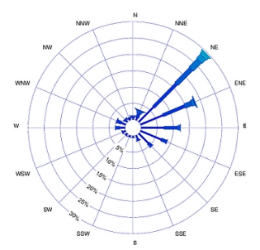
Figure 5: Directional wave distribution along the Catalan coast. The radial axis indicates frequencies of occurrence. (a) Llobregat corresponds to Barcelona, (b) Cap Tortosa corresponds to the Ebro Delta and (c) Cullera Bay (source: Sánchez-Arcilla et al., 2008 (a, b) and Mösso et al., 2007 (c)

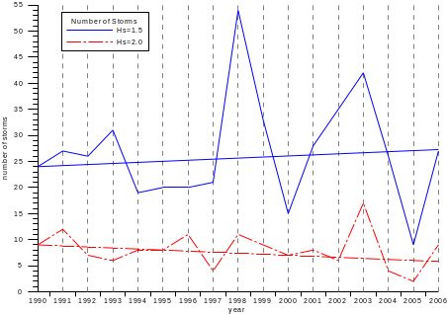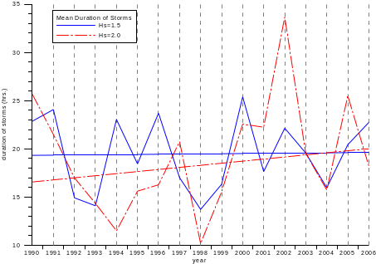
Figure 6:(a) Storm number and (b) mean duration at Cap Tortosa (Ebro Delta), 1990-2006

What does this show?
The mean annual number of recorded storms varies according to the chosen threshold; 27 moderate (Hs ≥ 1.5 m) and 8 severe storms (Hs ≥ 2.0 m). There is a slight net increase in the number of moderate storms (+2/decade), and a slight decline (-2/decade) in severe storm events (Figure 6a). The severe storms tend to be of slightly shorter duration than the moderate storms, but the duration tends to increase (2.16 hrs/decade) over the observation period (Figure 6b). These trends are very moderate in magnitude and are not statistically significant (in all cases, p > 0.1). They could, however, provide an explanation for the “perceived” larger damage experienced by coastal protection works and beaches in recent years.

Why is this important?
Wave climate is a key factor for determining coastal hazards for the Mediterranean where a narrow strip of land supports a wide variety of uses. The available series are too short to allow identification of any long-term trends. Nevertheless, the records suggest that energetic storms are becoming less frequent but of increasing duration. Longer storms translate to higher sediment transport rates, and higher risk of coastal erosion.

3. Risks of current climate and marine hazards

Key climate and marine hazards for the Gulf of Valencia are summarised in Table 2 together with the observed change and associated likelihood. Each indicator is derived for between one and three stations on an annual or seasonal basis. There is an evident significant increase in the air and sea surface temperature (from 1950 and 1969 respectively, to 2008), although there is no solid evidence that it is affecting the precipitation pattern (because of large natural variability) or the sea level (which may be affected more by local climate conditions rather than a change in the Mediterranean climate). There is evidence of a decline in the number of energetic storms per year, although their mean duration shows a significant increase over the observation period.

Table 2: Change in the climate and marine indicators (hazards) for the Gulf of Valencia
Climate Indicator (hazard) | Change (per decade) | Region  (or stations) | Time period | Likelihood§
Air temperature | Warming trend (+0.18 to +0.21°C). Maximum temperature increasing at a faster rate than minimum temperature. The warming is strongest in July. | Fabra (Barcelona), Ebro and Valencia | 1950-2008 | Very likely
Rainfall | Considerable variability in annual precipitation. Seasonal trends (Fabra; Ebro):  winter (+3.6mm; +2.3mm)  autumn (+1.5mm; +2.9mm)  summer (-1.2mm; -0.8mm) | Fabra (Barcelona) and Ebro | 1901-2000 | Likely
Storm surges (sea level) | Overall downward decadal trend in annual hindcast mean sea level:  Barcelona -0.84 cm  Valencia -1.35 cm;  Ebro -0.54 cm | Port of Barcelona Port of Valencia Ebro Delta | 1958-2001 | Likely
Sea surface temperature | Significant increase in mean sea surface temperature:  l'Estartit +0.28°C /decade  Cap Tortosa +0.93ºC/decade. | l'Estartit  Cap Tortosa | 1969-2008  (1972/73 missing)  1990-2008 | Very likely
Wave storms | Number of storms:  Hs ≥ 1.5m has increased +2/decade  Hs ≥ 2.0m has decreased -2/decade.  The mean duration for both has increased:  Hs ≥ 2.0m at a rate of 2.16 hr/decade  Hs≥ 1.5m at a rate of 0.1 hr/decade. | Cap Tortosa, Ebro Delta. | 1990-2006 | Likely
§ The terminology for likelihood of occurrence is based on the standard terms used in the IPCC 2007 report: Virtually certain > 99% probability; Extremely likely > 95% probability; Very likely > 90% probability; Likely > 66% probability; More likely than not > 50% probability; About as likely as not 33 to 66% probability; Unlikely < 33% probability; Very unlikely < 10% probability; Extremely unlikely < 5% probability; Exceptionally unlikely < 1% probability

Climate change in the Mediterranean could enhance the observed trends in hazards:
- Flooding due to an increase in mean sea level associated with higher water temperatures (steric effect) having more serious consequences for micro-tidal areas such as the Mediterranean.
- Erosion from more frequent storms, with waves acting further in-shore due to sea level rise.
- Lengthening of the tourist season due to warmer temperatures, but torrential rain events, river flooding and a deterioration in coastal water quality could detract tourists.
- Water quality degradation due to increasing sea water temperatures (particularly sea surface temperature) and reduced fluvial discharge.
- Reduced agriculture productivity due to salinisation associated with higher sea levels and intruding salt wedges at river entrances.
- Decreasing aquaculture productivity due to diminishing fluvial discharge (and consequent supply of nutrients) and increasing water temperature (reducing water quality).
4. Integrating case-study themes
Key integrating impact sectors for the study area include: human health; sea water quality; coastal erosion; land loss, and saline intrusion. The following are suggested as possible case-study themes integrating the climate and marine hazards outlined above:
- River mouth areas, covering agriculture, fisheries and tourist beaches
- Coastal lagoons and bays, covering aquaculture and tourist beaches
- Narrow urban beaches, particularly vulnerable to increasing sea level and storminess and the focus of tourism and coastal defences
- Regional coastal planning, considering current and future changes in climate and tourism demand.
These factors indicate a progressively more pressurised coastal zone whose compatibility with present day tourism is becoming a challenge. Degradation in the quality of the coastal zone aggravated by climate change could thus pose a serious threat to the sustainability of tourism in the region.

Acknowledgements
CIRCE (Climate Change and Impact Research: the Mediterranean Environment) is funded by the Commission of the European Union (Contract No 036961 GOCE) http://www.circeproject.eu/. This information sheet forms part of the CIRCE deliverable D11.5.2. The following data sources were used: {http://www.boiescat.org and http://www.puertos.es}. Metadata can be accessed from http://www.cru.uea.ac.uk/projects/circe. The research also benefited from the Spanish research project RIMA (Hacia una reducción de riesgos marítimos usando modelado de alta resolución, MEC, TRA2006-05132/TMAR) project.

References
- Miró, J. J., Estrela, M. J. & Millán, M. (2006) Summer temperature trends in a Mediterranean area (Valencia Region). International Journal of Climatology, 26, 1051-1073.
- Mosso, C., Sierra, J. P., Mestres, M., Cupul, L., Romero, I., Falco, S., Rodilla, M., Sánchez-Arcilla, A. & González del Río, J. (2007) The influence of topography on wind-induced hydrodynamics in Cullera Bay. Journal of Coastal Research, 47 SI, 16-29.
- Mosso, C., Mestres, M., Sierra, J. P. Sánchez-Arcilla, A. & Goodess, C. (2009) Waves and surges in the Valencia Gulf. Variability rather than climate change. Journal of Coastal Research, 56 SI, 248-251.
- Saladié, O., Brunet, M., Aguilar, E., Sigró J., & López D. (2004). Variaciones y tendencia secular de la precipitación en el Sistema Mediterráneo Catalán (1901-2000). El Clima entre el Mar y la Montaña. García Codron, J.C.; Diego Liaño, C.; Fdez. de Arróyabe Hernáez, P.; Garmendia Pedraja, C. y Rasilla Álvarez, D. (Eds.). Asociación Española de Climatología y Universidad de Cantabria, Serie A, nº 4, Santander, 399-408.
- Sanchez-Arcilla, A., González-Marco, D, & Bolaños, R. (2008). A review of wave climate and prediction along the Spanish Mediterranean coast. Natural Hazards and Earth System Sciences, 8, 1 1217-1228.
- SMC -Servei Meteorologic de Catalunya- (2008). Bulletí Anual d’Indicadors Climatics. Any 2008. http://www.meteo.cat/mediamb_xemec/servmet/index.html (reviewed 27/03/2009).

Authors: César Mösso Aranda (cesar.mosso@upc.edu) and Agustín Sánchez-Arcilla (agustin.arcilla@upc.edu), Laboratori d’Enginyeria Marìtima (LIM/UPC), Universitat Politécnica de Catalunya, c/ Jordi Girona, Barcelona, Spain
Editors: Maureen Agnew (m.agnew@uea.ac.uk) and Clare Goodess (c.goodess@uea.ac.uk), Climatic Research Unit, School of Environmental Sciences, University of East Anglia, Norwich, UK

Date: April 2010

