INFORMATION SHEET ON OBSERVED CLIMATE INDICATORS
FOR THE CIRCE RURAL CASE STUDIES: Apulia, Italy

Summary
Time series analysis of the Apulia meteorological stations shows moderate trends towards warmer and drier conditions during the second half of the 20th century; this however does not apply to T_{max} (daily maximum temperature). Rates of temperature change have become noticeably more intense during the last 25 years of the century, when T_{max} has also increased significantly. In particular, the following rates of change have been identified for T_{max}, T_{min} (daily minimum temperature) and RR (rainfall) for the period 1951-2000:
- Mean annual T_{max} shows no significant change, and there is significant cooling in December (-0.18° C/decade). However, during the last 25 years of the 20th century annual T_{max} has been warming at a rate of +0.37°C/decade, with a faster rate of increase during the summer (+1.3°C/decade)
- A warming of about 0.11°C/decade in mean annual T_{min}. The increase is particularly large during the warm season and peaks in May and August when values are higher than 0.3°C/decade. During the last 25 years of the 20th century mean annual T_{min} has been increasing at a very high rate (0.4°C/decade)
- A significant decline in total annual RR of -24 mm/decade. The reduction is larger in the period October-January and statistically significant only for January (-5 mm/decade)
- The analysis of extreme temperature indicators in two European gridded datasets shows positive trends in the period 1976-2000 in summer for the frequency of hot days (4.2-5.8 days/decade) and the duration of heat waves (1.2-1.7days/decade), which confirm progressively warmer conditions during the last part of the 20th century. This analysis also provides evidence of continued warming in the first decade of the 21st century.

  - Introduction

Agriculture and tourism are very important sectors for the economy of the region. Apulia has an agricultural area of about 14,700 km² (43% of the region is cultivated with wheat, 32% with olive groves, 9% with grapes, 3% with citrus and 2% with vegetables). The climate is Mediterranean, with mild wet winters and hot dry summers (the coldest month is January, the warmest is July). Rain falls mainly during fall and winter seasons. An understanding of water resources variability and decline in the context of human society and ecosystem adaptation, is of paramount importance to the region, while temperature changes could affect the growth of plants, tourism and energy consumption.

2. Indicators of observed climate variability and datasets
We have considered three key climate indicators for Apulia, for the period 1951-2000:
- mean monthly daily maximum temperature T_{max}
- mean monthly daily minimum temperature T_{min}
- total monthly rainfall RR.
We used the dataset of SIRP (Servizio Idrografico Regione Puglia). Although this contains a large number of stations (83 for temperature and 133 for precipitation, both containing monthly values), in reality temperature data are very irregular in time (Figure 1) and the quality of many time series have not been verified. A series of preliminary tests was carried out to identify suitable stations for further analysis. As a result of this procedure, only 11 temperature stations were retained, which contained no break points and a sufficient amount of data. This procedure was less critical for precipitation, for which, 24 stations have been selected. Missing data (5% of the total for temperature, 3% for precipitation) were replaced assuming a constant bias with respect to the mean of the available stations. The stations are grouped into five areas, labeled A to E (Figure 2), on the basis of geographic location and precipitation climatology.

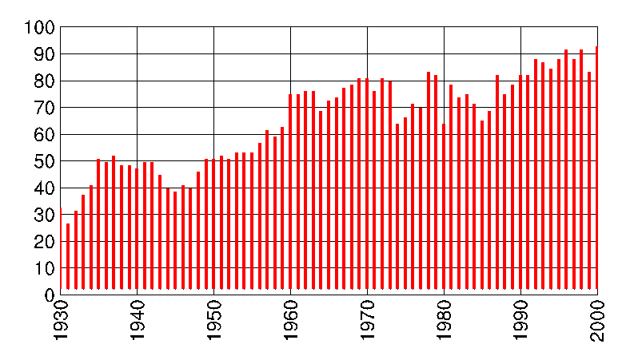
Figure 1: Percentage of data available for temperature from all SIRP stations

A further analysis of two gridded daily temperature datasets is considered: E-OBS (Haylock et al., 2008) and ERA-40 (Uppala et al., 2005). The E-OBS dataset uses spatial interpolation and kriging of daily station data (five stations were used in the case of Apulia). ERA-40 is a reanalysis project developed at the European Centre for Medium-Range Weather Forecast (ECMWF) through which a multi-source data assimilation system provided gridded variables describing the state of the atmosphere, land and ocean-wave conditions. The indicators computed using these two datasets are:
- TN5n, frequency of very cold nights, for which T_{min} <5th percentile,
- TX95n, frequency of very hot days, for which T_{max} >95th percentile,
- CWDI, Cold Wave Duration Index; the number of consecutive days with T_{min} <5th percentile
- HWDI, Heat Wave Duration Index; the number of consecutive days with T_{max} >95th percentile.

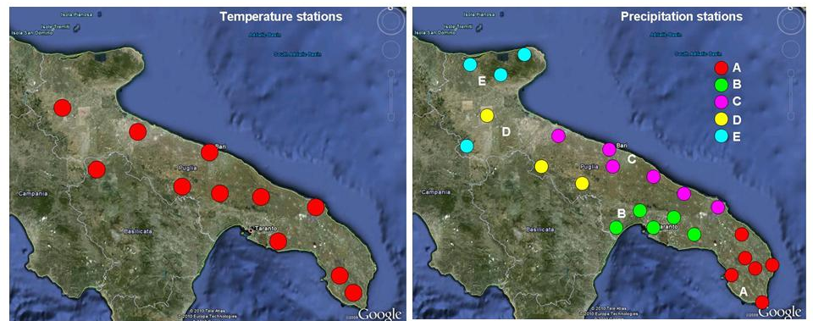

Figure 2: Spatial distribution of temperature (left) and precipitation (right) stations used in this study. Precipitation stations have been grouped into 5 areas, labelled “A” to “E” in the map

Mean annual temperature
What is it?
Time series for annual T_{max} and T_{min} have been obtained by averaging data from the eleven Apulia stations for the period 1951-2000. Linear trends are calculated for the whole period (1951-2000) and for the last 25 years (1976-2000).

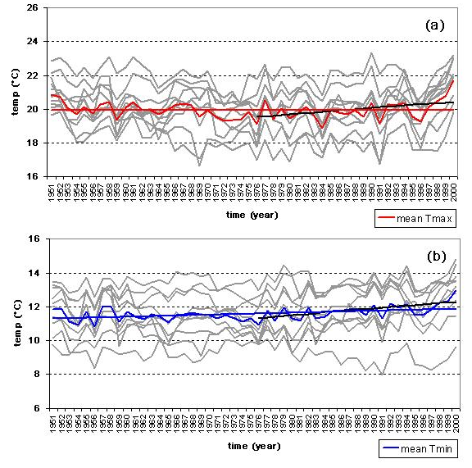
Figure 3: Annual T_{max} (a) and T_{min} (b) for 11 individual Apulia stations (grey lines) and the average of the 11 stations in red (T_{max}) and blue (T_{min}). Linear trends are shown for the whole period 1951-2000 and 1976-2000 (black line).

What does this show?
Figure 3 shows that for the period 1951-2000 mean annual T_{min} has warmed at a rate of about 0.11°C/decade. In contrast, mean annual T_{max} has not changed significantly. This suggests a narrowing of the daily temperature range. Note that the absence of trend in T_{max} reflects the cool period in the central part of the record, after which T_{max} has warmed at a very fast rate. Therefore, the trend estimate depends crucially on the time period considered. Warming trends for T_{max} and T_{min} estimated using the last 25 years of the 20th century are very high: 0.37°C/decade and 0.4°C/decade, respectively.
Why is this important?
Large changes in temperature can result in changes in energy demand associated with heating (lower demand in winter and for shorter periods) and cooling (higher demand in summer and for longer periods) needs. The selection of the most suitable crops can also be strongly affected by temperature.

Mean annual temperature cycle
What is it?
The mean annual cycle of monthly T_{max} and T_{min} is calculated using eleven stations in the Apulia region (Figure 2) for the period 1951-2000 (Figure 4). Figure 5 shows the rates at which mean monthly values are presently changing. Two estimates are provided, using the whole 50-year long record and the last 25-year long period 1976-2000. Figure 6 shows the time series of August temperatures, which shows the fastest rate of warming. The rates of temperature variation are homogenous across Apulia.

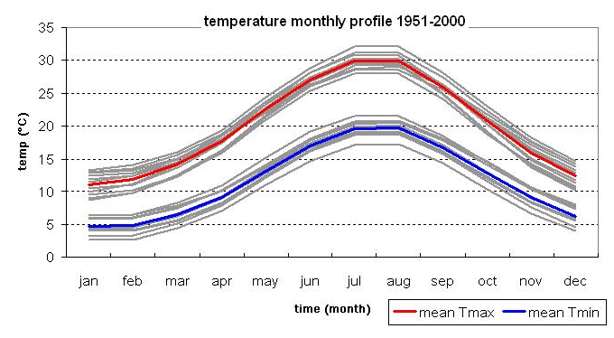

Figure 4: Mean annual cycle of monthly T_{max} (red) and T_{min} (blue) in Apulia, for the period 1951-2000. Grey lines shows the annual cycles for the 11 individual stations.

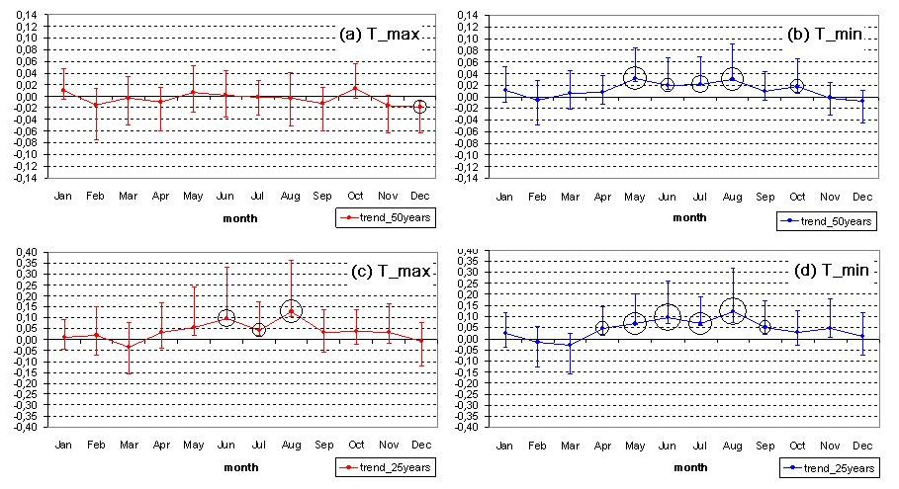

Figure 5: Trends of monthly mean Tmax (a and c) and Tmin (b and d) over Apulia. Trends have been computed for the whole period 1951-2000 (a and b) and for the period 1976-2000 (c and d). Circles with increasing size denote trends statistically significant at the 90%, 95%, 99% level.

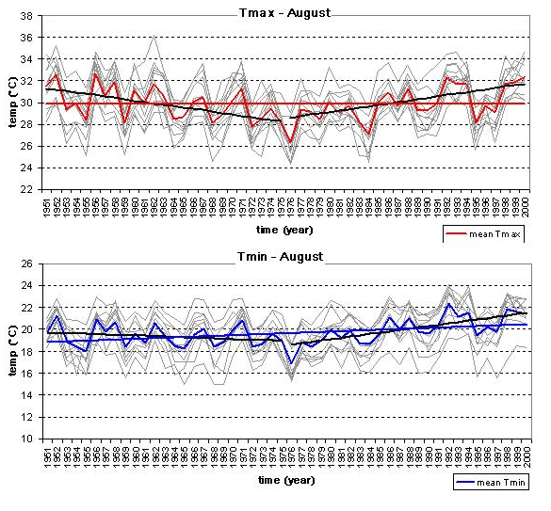
Figure 6: Mean August T_{max} (red) and T_{min} (blue) in Apulia, 1951-2000. Grey lines show time series for individual stations. Linear trends are shown for the whole period 1951-2000 (red for T_{max}, blue for T_{min}), the period 1951-1975 (black) and the period 1976-2000 (black).

What does this show?
The annual temperature cycle for Apulia is typical of the Mediterranean climate, with hot summers and mild winters (Figure 4). The daily temperature range is larger in summer than in winter. Figure 5 shows that for the period 1951-2000 warming has affected only T_{min} from May to October, but for the last 25 years of the record, summer T_{max} (Jun-July-August) has warmed at a rate comparable to that of T_{min} and both have warmed much faster than during the first part of the record, with a peak value of 0.13°C/decade for T_{max} in August (Figure 6). However, if T_{max} trends in August are computed during the first 25 years of the record, large negative values are obtained. This suggests that multidecadal variability strongly affects these trends.
Why is this important?
A regional warming could advance phenological phases, such as flowering dates for olives and grapes. This would increase the probability of exposing these plants to anomalous frosts (still possible at the beginning of spring) during their most delicate phase, with a consequent loss of a large proportion of the crop. Another effect of warming is the shortening of the productive period, with a consequent decrease in yields of wheat, for example. Warming appears to be concentrated in the summer. This implies a large increase in energy demand for air conditioning in summer without a compensating reduction of energy demand for heating in winter.

Annual total rainfall trends
What is it?
The mean annual total rainfall is the average of 24 stations in the Apulia region (the geographic distribution is shown in Figure 2) for the period 1951-2000. The linear trend is given for the whole period. Accumulated RR is also calculated for each of the five areas shown in Figure 2.

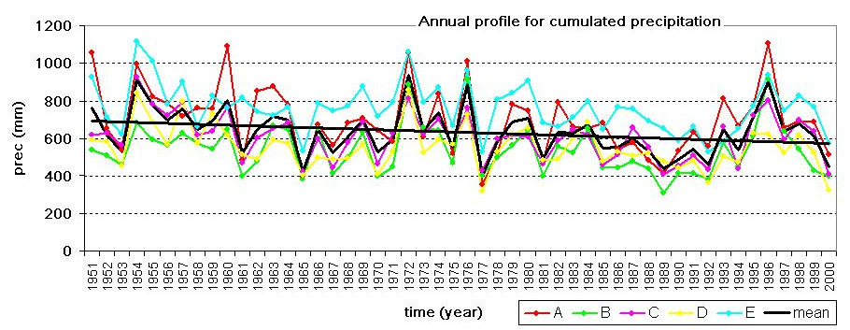

Figure 7 Mean annual total rainfall (mm) and linear trend for Apulia (black line) for the period 1951-2000. Labelled colored lines correspond to each of the five areas shown in Figure 2.

What does this show?
For the period 1951-2000, total annual precipitation (Figure 7) across Apulia has significantly decreased at a rate of 23.9 mm/decade, which would approximately imply a one third reduction of the mean value if this trend would continue for one century. Figure 7 shows that, although areas “E” and “A” have systematically higher values than the other areas and interannual variations are not identical in the five areas, most high and low precipitation years occur simultaneously for all areas. Further, the percentage reduction in precipitation is similar in all areas, but is particularly significant for “A” and “E”.
Why is this important?
A reduction in water resources implies a higher cost for agricultural production, since intense irrigation is required during most of the growing season. In addition, agricultural water demand is likely to increase if the warming trend observed for the period 1976-2000 continues in the future. This could result in the disappearance of some crops, vegetables and trees, because of the reduced market competitiveness of local products.

Mean annual rainfall cycle
What is it?
The mean annual cycle of total monthly rainfall for the period 1951-2000, is computed (Figure 8) using the mean of all 24 rainfall stations (shown in Figure 2) and the mean of stations within the areas “A” to “E”. In addition, trends in monthly total rainfall (Figure 9) are calculated and the time series for January (the month with the most significant reduction) is shown (Figure 10).

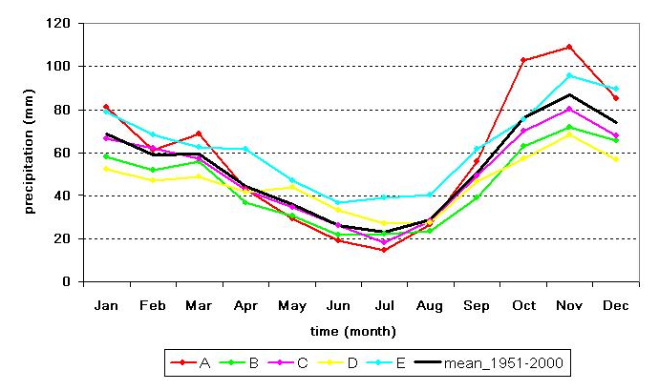

Figure 8: Mean annual cycle of monthly rainfall (mm). Labelled colored lines correspond to each of the five areas in Figure 2. Black line: total monthly rainfall for the period 1951-2000 (mean of 24 stations)
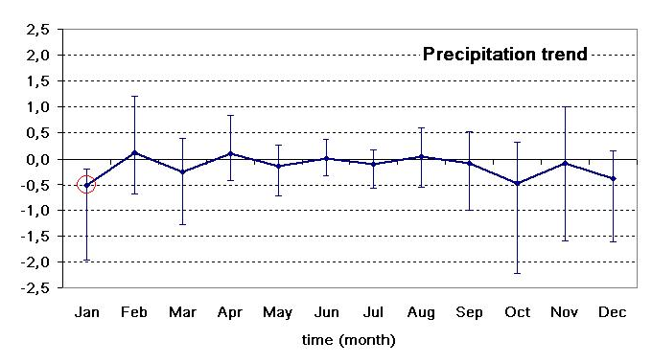
Figure 9: Trends in the monthly mean annual cycle of monthly rainfall (cm), computed for the whole period 1951-2000. The trend is only statistically significant at the 90% confidence level (marked with a circle) in January.

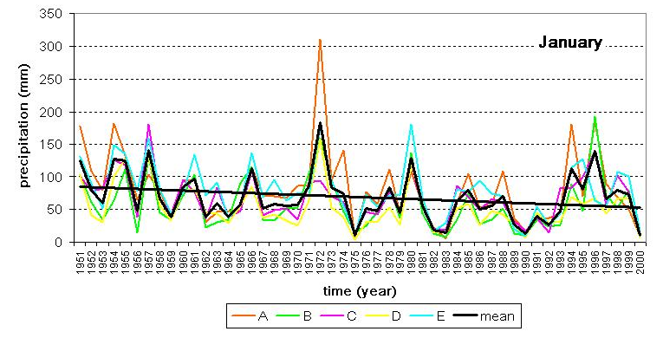
Figure 10: Mean total January rainfall (mm, with linear trend) in Apulia, for the period 1951-2000 (black line). Labelled colored lines correspond to the five areas shown in Figure 2.

What does this show?
Apulia has a typical Mediterranean annual rainfall cycle with an almost dry summer and rain occurring from October to March (Figure 8). Monthly rainfall peaks in October and November. Figure 9 shows that the declining trend in rainfall is concentrated in the months October to January. The maximum decrease (-5 mm/decade) is observed in January, which is the only month for which a statistically significant trend is found. Similar to the trend in annual rainfall, the declining trend in January rainfall is common to all subareas (Figure 10).
Why is this important?
A large reduction in water resources in January could affect some crops, mainly wheat, that are not usually irrigated. Since autumn and winter water resources are important for recharging aquifers and reservoirs that are exploited during the growth season of crops, the observed decline in January rainfall in Apulia is particularly noteworthy.

Summer temperature extremes
What is it?
Figure 11 shows the time series of selected extreme indicators: TN5n (frequency of very cold nights), TX95n (frequency of very hot days), CWDI (Cold Wave Duration Index), and HWDI (Heat Wave Duration Index). The time series refer to the grid point with geographical coordinates 16.75E, 40.75N (in the centre of Apulia) in the datasets E-OBS (Haylock et al., 2008) and ERA-40 (Uppala et al., 2005). Data shown here are outputs from the climate extremes CIRCE research line (Efthymiadis et al., 2010) and cover the period from 1950 to 2009 for the summer season. Trends have been computed for the periods 1951-2000 and 1976-2000 for consistency with the previous sections.

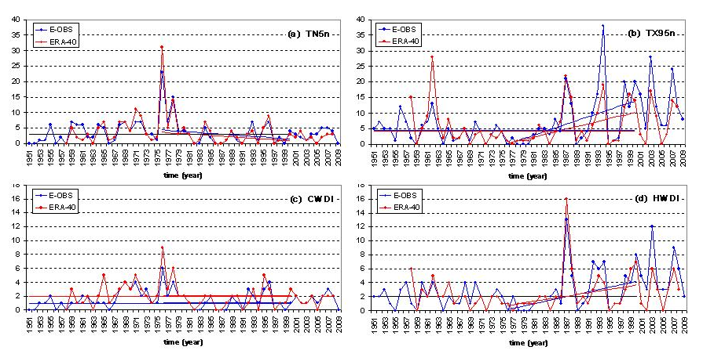
Figure 11: Mean August TN5N (a), TX95N (b), CWDI (c), HWDI (d) for Apulia, for the period 1951-2009 using E-OBS (blue) and ERA-40 (red) data. Linear trends are shown for the periods 1951-2000 and 1976-2000.

What does this show?
For the period 1951-2000, no indicator shows a statistically significant trend. If the analysis is limited to the second half of the record (1976-2000), TX95n and HWD show statistically significant and positive trends which continue during the first decade of the 21st century. Trends are similar in the E-OBS and ERA-40 data; respectively 5.8 and 4.2 days/decade for TX95n, 1.7 and 1.2 days/decade for HWDI. Therefore, these two indicators support the evidence provided by the Apulia monthly station data of a strong warming trend during latter decades of the 20th century.
Why is this important?
These extreme temperature indicators are based on gridded datasets which are the result of a homogeneous analysis at the European scale. Therefore, although some regional station observations have been used for producing E-OBS and ERA-40, the gridded data sets are not exclusively dependent on them. Their qualitative consistency with the station observations provides supporting evidence of increasing trends in temperature during the last two decades of the 20th century, together with new evidence of continued warming during the first decade of the 21st century.

3. Risks of current climate hazards

Low to moderate topography and high population density have led to an intensification of arable farming in Apulia, and a successive replacement of existing natural vegetation with agricultural land. A progressive increase in irrigation practices (with a commensurate improvement in productivity) has extended agricultural production from vegetables to tree crops. Intensive irrigation is used to grow table grapes and emergency irrigation is used to grow olive crops with little concern for the long-term sustainability of water resources.
Table 1 shows the observed changes for five key climate indicators that are important for agriculture productivity in Apulia. If the temperature trends computed for the observed period are representative of future tendencies, substantial changes in crops and in the organization of the whole agricultural sector at a regional scale would be needed and present crop areas would be very different in the future. The combination of increased water demand due to higher air temperatures with a significant decrease in rainfall would increase the need for importing water from nearby regions. The maintenance of present agricultural practices could become questionable in terms of competitiveness and ultimately, viability. A decrease in rainfall during the cool rainy season would pose specific problems of acquiring sufficient recharge of aquifers and reservoirs, given current abstraction rates.

Table 1: Change in the climate indicators (hazards) for Apulia
Climate Indicator (hazard) | Change | Region | Time period | Likelihood§
Mean monthly T_{max} | No significant trend over the whole period, but a significant warming (0.37°C/decade) trend if only the last 25 years are considered | The whole region  (11 stations) | 1951-2000 | Very likely (last 25 years)
Mean monthly T_{min} | Warming of about 0.11°C/decade, and a sudden increase (0.4°C/decade) during the last 25 years of the 20th century | The whole region  (11 stations) | 1951-2000 | Very likely for the whole period (virtually certain for last 25 years)
Total monthly rainfall | Significant decline in annual rainfall  (-24mm/decade). Most of the decline occurs in the period Oct-Jan, but the monthly negative trend is only significant in January (-5mm/decade) | The whole region  (24 stations) | 1951-2000 | Likely
Frequency of very hot days | No significant trend over the whole period, but a significant positive trend (4.2-5.8 days/decade) if only the last 25 years (1976-2000) are considered, which has continued to 2009 | Central grid point of the Apulia region | 1951-2000(2009) | Very likely to extremely likely during the last 25 years
Duration of heat waves | No significant trend over the whole period, but a significant positive trend (1.2-1.7 days/decade) if only the last 25 years (1976-2000) are considered, which has continued to 2009 | Central grid point of the Apulia region | 1951-2000(2009) | Very likely during the last 25 years
§ The terminology for likelihood of occurrence is based on the standard terms used in the IPCC 2007 report: Virtually certain > 99% probability; Extremely likely > 95% probability; Very likely > 90% probability; Likely > 66% probability; More likely than not > 50% probability; About as likely as not 33 to 66% probability; Unlikely < 33% probability; Very unlikely < 10% probability; Extremely unlikely < 5% probability; Exceptionally unlikely < 1% probability

4. Integrating case study themes

An understanding of water resource variability and temperature variation in Apulia is of paramount importance for the future economic growth of this region. The competitiveness of agriculture products and the region’s capability of attracting tourism (a growing economic resource in Apulia) could be affected by a decline in water resources and warmer temperatures, especially warm extremes in summer.
The analysis of the present climate state and trends in Apulia sets the premises for analysing general themes common to the other rural CIRCE case studies (Tuscany, Judean Foothills and Tel Hadya) including agriculture and the rural economy. The identification of features linking the time series of crop indicators (yields and prices) and climate indicators (RR, T_{max}, T_{min}) is a key area of investigation that could provide useful information for the Apulia case study. However, other factors (social and economics) are likely to play a major role, and may dominate the effects of climate trends and variability. In addition, the interplay between climate and external factors is likely to be very different from the present one if large climate change occurs.
Model projections of future climate at regional scales will be considered to assess the likelihood of observed trends resulting in substantially different climate conditions in the middle of this century. In relation to declining precipitation trends, it will be important to assess whether neighbouring areas are also affected, since this would substantially affect the present water import policy.

Acknowledgements
CIRCE (Climate Change and Impact Research: the Mediterranean Environment) is funded by the Commission of the European Union (Contract No 036961 GOCE) http://www.circeproject.eu/. This information sheet forms part of the CIRCE deliverable D11.4.2. The authors thanks Ivan Portoghese and Michele Vurro (IRSA-CNR Bari) for useful suggestions, SIRP for providing monthly datasets, D. Miglietta (univ of Salento) for a preliminary analysis of precipitation climatology, and D. Efthymiadis (UEA) for the information on extreme indicators provided as contribution to RL6 of CIRCE.
Bibliography
Efthymiadis D, C. M. Goodess, P. D. Jones, M. Baldi, P. Coccimiglio, A. Toreti (2010), D6.2.1 - Report on extreme temperature events, Internal report of Project FP6 No. 036961 – CIRCE
Haylock M. R., N. Hofstra, A. M. G. Klein Tank, E. J. Klok, P. D. Jones, and M. New (2008) A European daily high-resolution gridded data set of surface temperature and precipitation for 1950–2006, Journal of Geophysical Research, 113, D20119, doi:10.1029/2008JD010201.
Uppala, S. M and 45 others (2005), The ERA-40 Reanalysis, Quart. J. Roy. Meteorol. Soc., 131, 2961-3012, doi:10.1256/qj.04.176.

Authors: Piero Lionello (piero.lionello@unisalento.it)¹, Cosimo Pino (pino@le.infn.it)¹, Annalisa Tanzarella (annalisa.tanzarella@unisalento.it) ¹
¹ Dep. of Material Science, University of Salento, Lecce, Italy.
Editors: Maureen Agnew (m.agnew@uea.ac.uk) and Clare Goodess (c.goodess@uea.ac.uk), Climatic Research Unit, School of Environmental Sciences, University of East Anglia, Norwich, UK

Date: November 2010

