Information sheet on future climate and impacts
for the CIRCE Rural case studies: Apulia, Italy

Summary
- Climate projections for the Apulia region are analysed considering the results of three CIRCE project simulations and comparing them with the results of the ENSEMBLES project.
- Results are consistent among models. All models show an acceleration of the warming rate in the period 2001-2050 with respect to the period 1951-2000. In addition, models consistently show a decrease of precipitation in the period 2001-2050, which was not present in the period of the simulation prior to this.
- Models are consistently projecting an increase in evapotranspiration which will increase the water deficit. For these variables there is a significant difference between the period 1951-2000, which shows little change over time, and the period, 2001-2050 which shows a significant trend towards a progressively larger water deficit and dry conditions
- The projected temperature increase produces a lengthening of the warm season, with both a progressively earlier onset and later termination during the period 2001-2050.
- The impact on crops has been estimated on the basis of a simple linear regression model. Results (considering no adaptation) suggest a future decrease in wine and olive oil production and an increase in wheat production.

  - Introduction
In this final sheet we present a set of indicators describing climate projections for Apulia in the first half of the 21st century. Information for this evaluation is provided by the ENSEMBLES European project (Hewitt and Griggs, 2004 and http://www.ensembles-eu.org/) and by three simulations carried out during the CIRCE project (Gualdi et al. 2011): the INGV global model with a 80 km resolution, the PROTEUS system of ENEA with a 30 km resolution, and the REMO model of MPI with a 25 km resolution. All the CIRCE model simulations included a two-way coupling with a circulation model of the Mediterranean Sea, which is a unique feature of this project. The MPI and ENEA models are RCMs (Regional Climate Models), which were driven by the ECHAM5 ‘non-CIRCE’ global model and by the INGV model, respectively. The ENEA simulation is therefore a dynamical downscaling of the INGV simulation and this explains the parallel behaviour of time series from these two models. Seven ENSEMBLES models (the institute that produced the simulations is shown in brackets) are used in this analysis: RegCM (ICTP), RACMO (KNMI), REMO (MPI), RCA (SMHI), which use boundary and initial conditions provided by ECHAM5, CLM (ETHZ), HIRHAM (METNO), PROMES (UCLM), which use boundary and initial conditions provided by HadCM3Q0.
The indicators presented are:
- Climate model projections: average annual, maximum and minimum temperature; precipitation
- Environmental water budget
- Potential evapotranspiration
- Seasonal shift Index
- Crop yield

Climate model projections
What is it?
The CIRCE climate model runs (Gualdi et al. 2011) are used to assess climate projections in Apulia for the period 1950-2050. The simulations adopt the A1B emission scenario for greenhouse gases and aerosol concentrations. Figure 1 show projections for average annual / maximum and minimum daily temperature, and total annual precipitation, comparing results from the CIRCE and ENSEMBLES projects.

a 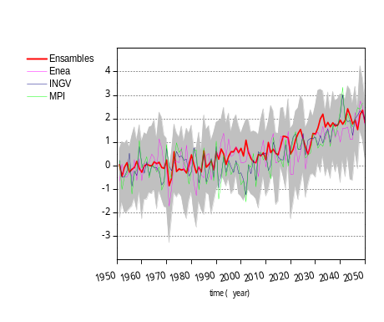 b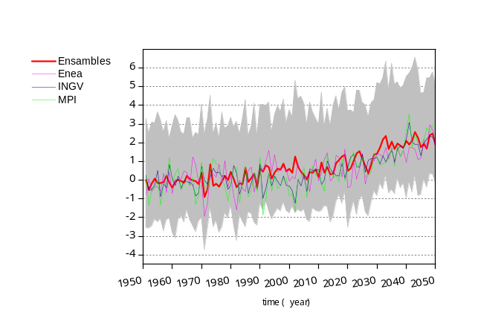

c 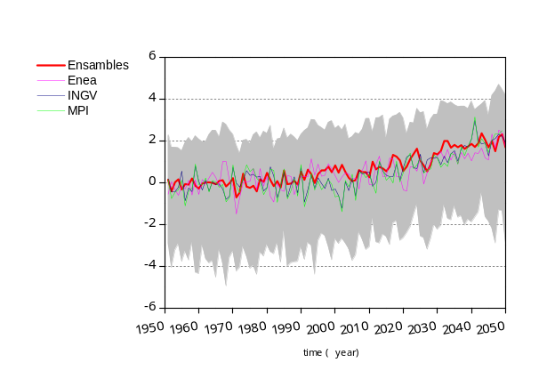 d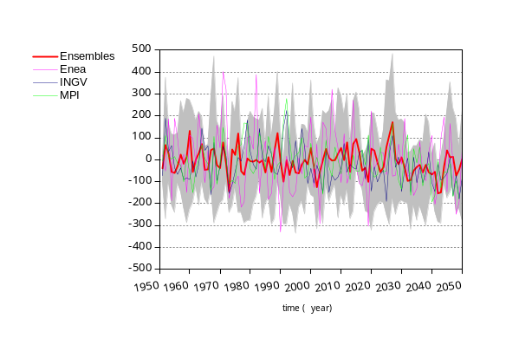
Figure 1: Time series of (a) annual average (b) daily maximum (c) daily minimum temperature (°C), and (d) total annual precipitation (mm) for Apulia. Values are anomalies with respect to the mean baseline period 1961-1990. Lines show the CIRCE climate models: ENEA (pink), INGV (blue), REMO (green). The grey area shows the area delimited by maximum and minimum values produced by the set of models used in the ENSEMBLES project, the red line - ensembles mean.

What does this show?
The grey area represents an estimate of the uncertainty due to the ENSEMBLES models. It is delimited by the maximum and minimum yearly values among the seven ENSEMBLES model simulations considered in this study. The CIRCE model results are very close to the ENSEMBLES mean (red) and are inside the uncertainty range associated with the ENSEMBLES simulations. Note the parallel behaviour of the INGV and ENEA model (the ENEA RCM represent a dynamical downscaling of the INGV GCM). Figure 1 shows substantial inter-model agreement. All projections suggest progressively warmer and drier conditions over the next few decades, despite large inter-annual variability. By the mid 21st century, regional temperatures are projected to be about 2ºC warmer than the period 1961-1990. A decrease in precipitation (about 100 mm/year) is less clear because of comparatively larger inter-annual variability.

Why is it relevant?

Substantial inter-model agreement suggests that results are robust. The introduction of a dynamically interacting Mediterranean Sea does not introduce a systematic change in trends with respect to the ENSEMBLES project. The consensus among results of different models and different projects increases confidence in the reliability of these regional climate projections. However, model results present systematic biases, which cast some doubt on the magnitude of the climate change presented (see Table 1 and Section 5 of this report).

Simulated climate trends
What is it?
The trends derived from the CIRCE simulations and from the ENSEMBLES simulations are shown. Trends are computed separately for the two periods 1951-2000 and 2001-2050. Bars in the four panels show trends (values per decade) of: average annual temperature, average maximum and minimum daily temperature, and total annual precipitation in Apulia. Colours denote the level of statistical significance of the trends.

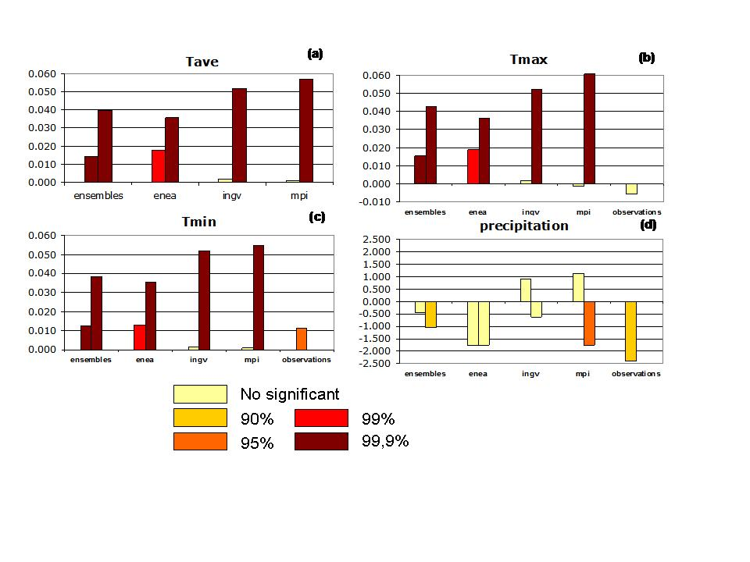
Figure 2: Trends of annual average temperature (a), maximum daily temperature (b), minimum daily temperature (c; °C/year), and total annual precipitation (d; mm/year) for Apulia. Values have been separately computed for the 1951-2000 (left bar of each pair) and 2001-2050 (right bar in each pair) periods. Bars show the CIRCE models and the mean of ENSEMBLES project simulations (red). Colours denote the level of statistical significance of trends (not significant, 90%, 95%, 99%, and 99.9%). In panels b, c, d the single bar on the right shows the observed trend in the period 1951-2000

What does this show?
There is substantial agreement among models. All model simulations suggest small and not statistically significant trends during the second half of the 20th century, and larger, significant trends during the first half of the 21st century. There is substantial consistency between the observed model trends in the 20th century for minimum daily temperature and for precipitation, while two models show a statistically significant positive trend for maximum temperature, which is not present in the observations. However, the consistency also extends to maximum daily temperature if observed trends are computed for the period 1976-2000, when they are stronger. The different models show similar behaviour for the first half of the 21st century. Considering the whole 100-year period, average annual, and minimum and maximum daily temperatures are projected to increase at similar rates (the mean of the CIRCE models are 0.21 °C/decade, 0.20 °C/decade and 0.22 °C /decade, respectively). Precipitation projections show a general trend towards a reduction of about 3.14 mm /decade.

Why is it relevant?
These results indicate an acceleration of climate change in the next few decades which is likely to produce measurable impacts in Apulia. The agreement between observed and simulated trends during the second half of the 20th century increase confidence in the models’ capability to reproduce the pace of climate change.

Potential evapotranspiration and environmental water budget
What is it?
Figure 3a shows the potential evapotranspiration (in mm/year) computed using the formula of Hargreaves-Samani (Hargreves and Samani, 1982) that has been specifically calibrated for Apulia. Values are based on the results of the CIRCE models and ENSEMBLES models for the period 1951-2049. Figure 3b shows the total water budget (in mm/year) as it results from the difference between the positive contribution of precipitation and the loss due to evapotranspiration. All series show anomalies with respect to the 1961-1990 average values.

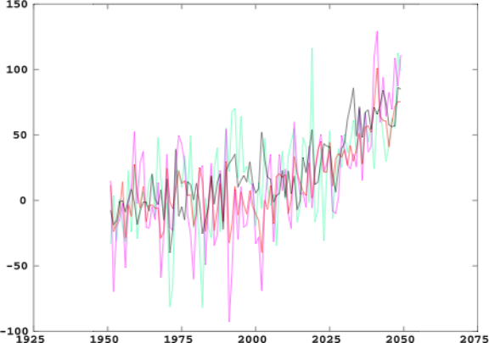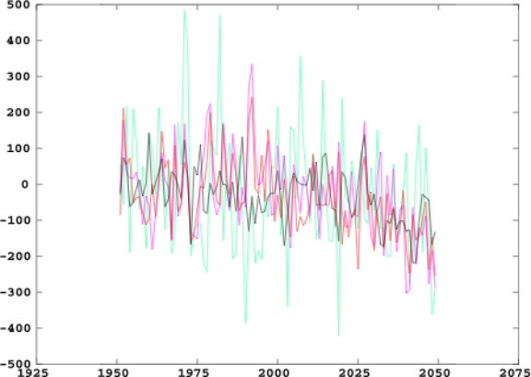

(a) (b)
Figure 3a. Potential evapotranspiration (in mm/year) from the different CIRCE models for the period 1951-2049; ENEA (green), INGV (violet), MPI (red) and mean of the ENSEMBLES models (black line). Values are anomalies from the 1961-1990 mean value. Figure 3b: as for Figure 3a except it shows the environmental water budget.

What does this show?
Figure 3a shows the progressive increase in evapotranspiration and of the water deficit, with the onset of drier conditions in the first half of the 20th century. Compared to Figure 1, the decreasing precipitation and increasing evapotranspiration provide comparable contributions to the increasing dryness of Apulia in the 21st century. Considering the ensemble mean of the three CIRCE models and the whole 1951-2049 period the evapotranspiration trend is 7.6 mm/decade. Figure 3b shows the water deficit for the whole Apulia and its progressive increase at a rate about -14.4 mm/decade. Both evapotranspiration and water deficit trends are significant at the 90% level. The trends are clearly becoming larger in the 21st century with respect to the 20th century. For the ENSEMBLES models mean, evapotranspiration increases at a rate of about 5 and 15 mm/decade for the periods 1951-2000 and 2001-2050, respectively. Water deficit increases at a rate of about 10 and 29 mm/decade for the periods 1951-2000 and 2001-2050, respectively.
Why is it relevant?
Increasing water deficit implies that water imports from nearby regions would have to be augmented in order to sustain present levels of water supply for agriculture. More intense exploitation of aquifers may pose additional problems and may not be sustainable. Increased costs and water limitations could have large negative impacts on in the regional agricultural sector.

Seasonal Shift Index
What is it?
The Seasonal Shift Index tracks changes in the start day and the end day of the summer season. Summer is assumed to start when the daily mean air temperature reaches 23°C for the first time and ends when it is lower than 23°C after the end of summer period (defined as 230th day of the year).

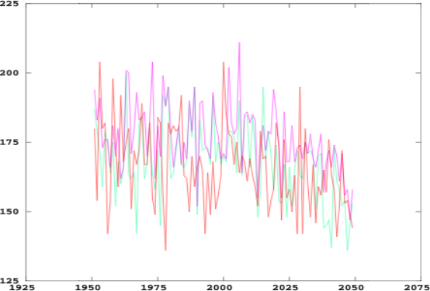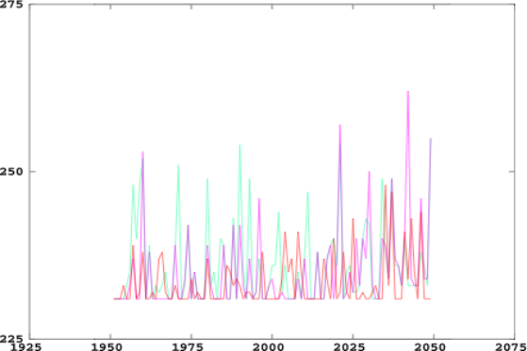

- (b)
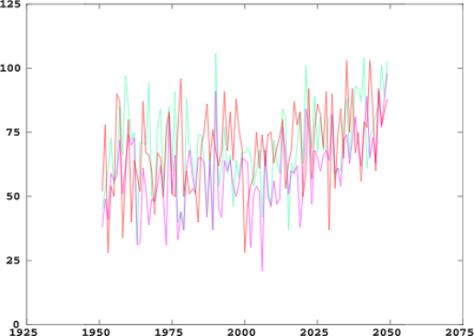
(c)
Figure 4: Seasonal Shift Index (T>23°C): start (a) and end (b) of the summer season, total length of the summer season (c), from three different CIRCE models for the period 1951-2050;ENEA (green line), INGV (violet line), MPI (red line)

What does this show?
The different models show a tendency for an earlier start (about 2 days/decade) and a later end to the summer season (about 0.3 days/decade). The summer season is therefore expected to become longer by about 2.2 days/decade. The rate of change is larger during the 21st that the 20th century.
Why is this important?
The results show that in the 21st century the period when local conditions are attractive for tourists will initiate earlier and terminate later than the present day. This has the potential to offer new opportunities to the regional tourism.

Climate change effects on crops
What is it?
The economy of Apulia is characterised by a large emphasis on agriculture and services with a smaller part played by industry. A multivariate regression (see the previous sheet on biogeophysical vulnerability indicators for more details about the methodology and variables selected), based on the output from three CIRCE models, has been used to evaluate tendencies in the production of key crops in Apulia, such as wine, olive oil and wheat. The climatic variables used are
- Winter and summer maximum temperature, summer minimum temperature and spring precipitation for wine,
- winter and summer minimum temperature and summer precipitation for olive oil
- summer minimum and maximum temperature, winter and spring precipitation for wheat

(a) (b)
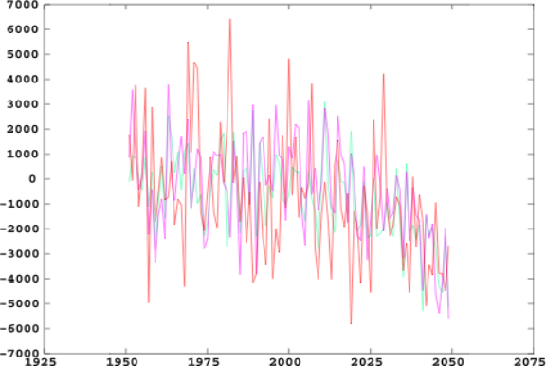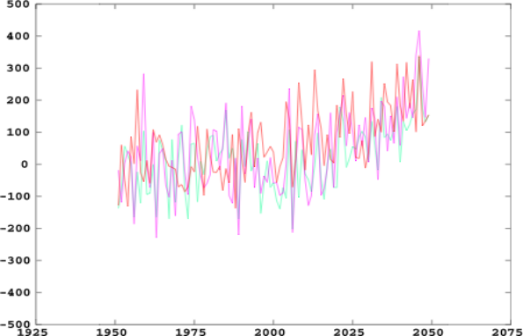

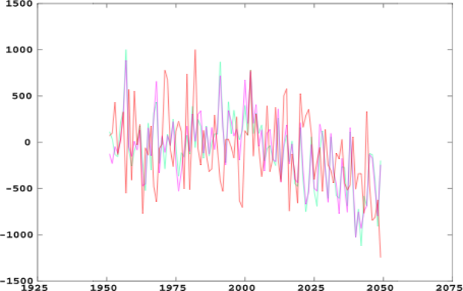
(c)

Figure 5. Crop yield: wine (a, in thousand hl), wheat (b, in thousand tons), olive oil (c, in 10⁸ kg ), reconstructed through a multivariate regression using climate data from three different CIRCE models for the period 1951-2049; ENEA (green), INGV (violet), MPI (red). In all panels, values are anomalies with respect to the 1961-1990 mean.

What does this show?

Figure 5 a-c show that wine and olive oil production will be affected in a negative way by drier and hotter conditions characterizing Apulia in the first half of 21st century (as shown in Figure 1). Considering the ensemble mean of the three CIRCE models for the whole 1951-2049 period, the wine production trend is about -327 thousand hl/decade and the olive oil production trend is about -5.7 billion kg/decade. In contrast, wheat production trends are positive and equate to about 20 thousand tons/decade. All trends computed are significant at the 90% level, and all are much larger in the period 2001-2050 than in the previous fifty years (1951-2000). Note that the regression relationships used cannot explain a large fraction of the observed variance and are in this sense weak. Qualitatively these results are sound in terms of the future direction of change, but caution is needed in terms of the magnitude of change.

Why is it relevant?

Agriculture is an important component of the Apulia economy (see previous information sheet on biogeophysical vulnerability indicators). Any reduction of productivity or loss of competitive capacity with respect to other regions can have negative impacts on economic conditions in Apulia.

Table 1: Bias in the climate models used in this study with respect to the observed values of maximum temperature, minimum temperature and precipitation for Apulia, for the period 1961-1990.

5. Uncertainties

Though it is certainly true that uncertainties are present in all stages of the CIRCE case-studies, some results appear rather robust.

Considering present climate trends, observation data cover the whole of Apulia with no gaps since 1950. It would be very surprising if the behaviour described at a monthly scale in the Observed Climate Indicators Information Sheet for Apulia were significantly modified by including time series not yet considered. However, further work is required on the analysis of daily values and the characterization of weather extremes such as extreme precipitation, dry periods and heat waves.

Climate projections for the first half of the 21st century show substantial consensus among models. Note also that the CIRCE simulations, despite the novelty of including an interactive Mediterranean Sea, confirm the trends of previous uncoupled regional climate models. Note that the models adequately reproduce the observed trend for the period 1951-1990, with the exception of maximum temperature in summer. However, most models underestimate precipitation and maximum temperature, and overestimate minimum temperature. In some cases (see Table 1) the bias is large and casts some doubt on the capability of the models to reproduce the Apulian climate.

Evidence of regional vulnerability is also clear, although, in this case the strongly nonlinear dynamics of social-economic dynamics and the potential for adaptation action prevent a deterministic assessment of climate change impacts on regional economy and society. Specifically, considering the crop yield models, they are based on regression relationships that are rather weak, tuned for the present climate and ignore adaptation strategies that could compensate for the negative effects of climate change. The regression models correctly show the sensitivity of crops to climate, but the reliability of the estimated magnitude of response to climate change is quite limited.

6. Integrated assessment

There is robust evidence from in situ time series of Apulia meteorological stations that during the second half of the 20th century Apulian climate has become moderately warmer and drier. Rates of temperature change have become noticeably more intense during the last 25 years of the century. Mean annual Tmax in particular, shows no significant change when the whole period 1951-2000 is considered, but during the last 25 years of the 20th century annual it has been warming at a rate of +0.37°C/decade, with a faster rate of increase during the summer (+1.3°C/decade). The analysis of extreme temperature indicators in two European gridded datasets confirms progressively warmer conditions during the last part of the 20th century.

Vulnerabilities for Apulia are mainly related to its permanent water budget deficit (about 350mm/year), which requires water imports from nearby regions and exploitation of aquifers. Wheat, olive oil and wine production (the three main agricultural products in Apulia) are critically dependent on sufficient and cheap water availability. Records support climate being responsible for a proportion of the inter-annual variability (16% for wheat and 15% for olive oil) and suggest that future climate change could have a negative impact on these products. Climate change may have mixed impacts on tourism, which has become a progressively more important component of the regional economy.

Climate projections are substantially consistent with present trends and confirm factors that are responsible for present vulnerabilities, showing that these vulnerabilities are likely to increase in the next few decades. A general important point is the increased pace of both climate and vulnerability indicators in the 21st century with respect to the previous 50 years. In the next decades, different model projections consistently show that climate will become much warmer and marginally drier.

A substantial increase in the water deficit is a major consequence of future climate trends, which calls for efficient management of water resources and imports from nearby regions. A longer summer season requires intelligent adaptation policies to exploit the benefits for tourism and compensate for the hotter conditions of the warmest months with potentially lower tourist inflows. Changes in crop productivity could be significant and suggest a negative impact on olive oil and wine, but a potentially positive impact on wheat. All the evidence in this analysis highlights climate change as an important factor to be accounted for by social, economic and political activities and administration in Apulia over the coming decades.

Acknowledgements
CIRCE (Climate Change and Impact Research: the Mediterranean Environment) is funded by the Commission of the European Union (Contract No 036961 GOCE) http://www.circeproject.eu/. This information sheet forms part of the CIRCE deliverables D11.4.5. The authors thank Dr M. Torodovic for the computations of evapotranspiration.

References
- Hargreaves, G.H. and Samani, Z.A., 1982. Estimating potential evapotranspiration. J. Irrig. and Drain Engr., ASCE, 108(IR3):223-230.
- Hewitt, C.D and Griggs, D.J., 2004. Ensembles-based predictions of climate changes and their impacts. Eos, 85, 566.
- Kendall, M. G., 1975. Rank Correlation Methods, Charles Griffin, London, UK.
- Mann, H. B., 1945. Nonparametric tests against trend, Econometrica, 13, 245– 259.
- Report of Working Group III of the Intergovernmental Panel on Climate Change. Cambridge University Press, Cambridge, United Kingdom and New York, NY, USA, 599 pp.
- UNEP, 1992. World Atlas of Desertification
- Gualdi S., Somot S., May W., Castellari S., Déqué M., Adani M., Artale V., Bellucci A., Breitgand J.S., Carillo A., Cornes R., Dell’Aquilla A., Dubois C., Efthymiadis D., Elizalde A., Gimeno L., Goodess C.M., Harzallah A., Krichak S.O., Kuglitsch F.G., Leckebusch G.C., L’Heveder B.P., Li L., Lionello P., Luterbacher J., Mariotti A., Nieto R., Nissen K.M., Oddo P., Ruti P., Sanna A., Sannino G., Scoccimarro1 E., Struglia M.V., Toreti1 A., Ulbrich U., and Xoplaki E. 2011. Future Climate Projections. In Regional Assessment of Climate Change in the Mediterranean: A. Navarra, L. Tubiana (eds.), Springer, Dordrecht, The Netherlands.

Authors: Marco Reale¹ (reale.marco82@gmail.com), Letizia Congedi² (letizia.congedi@cmcc.it), Annalisa Tanzarella (annalisa.tanzarella@unisalento.it), Piero Lionello^{1,2} (piero.lionello@unisalento.it)¹
¹ Dep. of Material Science, University of Salento, Lecce, Italy.
¹ CMCC (Centro Euro-Mediterraneo per i Cambiamenti Climatici, Lecce, Italy.
Editors: Maureen Agnew (m.agnew@uea.ac.uk) and Clare Goodess (c.goodess@uea.ac.uk), Climatic Research Unit, School of Environmental Sciences, University of East Anglia, Norwich, UK
Date: July 2011

